**SSMS – Security Service Management System**

**Final Project Report**



Sri Lanka Institute of Information Technology

Information Technology Project (IT2080)

**Group ID: ITP24R_B1_W22**

**October 2024**

**Declaration**

This project report is our original work, and the content is not plagiarized from any resource, References for all the content taken from external resources are correctly cited. To the best of our knowledge, this report does not contain any material published or written by third parties, expect as acknowledged in the text.

**Authors:**

|  |  |  |
| --- | --- | --- |
| **Author SID** | **Author Name with Initials** | **Signature** |
| IT22325228 | Fernando K. K. C |  |
| IT22907998 | Sadisha R. M. M |  |
| IT20145552 | Dissanayaka D. M. S. M |  |
| IT22257086 | Randiw E. Y |  |
| IT22293480 | Jayodhya J. D. H |  |
| IT22127082 | Medawatte W. W. M. T. N. B |  |
| IT22132628 | Kusumsiri P. A. S. S |  |
| IT22197146 | Ranasinghe R. A. R. V. C |  |

**Date:** 12.10.2024

# Abstract

The Security Service Management System is a web-based application developed to enhance the operational effectiveness of security service providers through the automation of various critical processes. To this effect, the different roles of SSMS include user management, client management, booking management, payment management, operation management, inventory management, and leave management. SSMS will ensure smooth communication among its stakeholders, which are managers, clients, and employees or security officers, and hence in providing better service and improving operational effectiveness.

The system requirements, functionalities, and considerations of design are reflected in the following report in detail. The report then outlines the importance of each management function in contributing toward a cohesive workflow that makes sure all aspects of security services are well coordinated. It also emphasizes how user role integration ensures the establishment of customized access and functionalities for various stakeholders, thereby enhancing usability and effectiveness.

The SSMS will incorporate robust non-functional requirements: concerns about security, performance, and usability. Performance benchmarks are provided to guarantee that the loading of components within the system is quick and fast, interactions with the database are optimized for quick retrieval, and such system processes that authenticate users are efficient. Detailed and stringent testing methodologies are put in place to confirm functionality, reliability, and security within the system, meeting high standards by a user.

This report also looks into the probable impact of SSMS on customer satisfaction and resource utilization for the purpose of showing how such a system can be further developed in improving interaction with clients and smoothen business operations. Finally, SSMS places itself among the innovative solutions targeted at improving security operations with the purpose of total business success and solution of disadvantages characteristic of the security service industry. Findings and recommendations from this report provide guidance on how the system is to be developed and adapted in response to the emergence of new needs within industry.

# Acknowledgement

We are indebted to everyone who made it possible to present this report on the SSMS successfully.

First and foremost, our thanks go out to our lecturer in charge, Dr. Samantha Rajapakshe, whose guidance, encouragement, and insightful feedback were very important during this development process. Your expertise and support mean so much to us, and you have enriched us with the finer details of the project.

We would also like to thank our group members, who cooperated very well, showed dedication and put in hard work right from ITP24R_B1_W22 to complete this project. Each one of them contributed to the different parts of the system in its development and refinement.

We would extend special thanks to all the stakeholders of RALL, including managers and employees, for their valuable insights and feedback provided during the requirement-gathering phase. This was essential to shape the functionalities for the system to work within the requirement of the organization.

We would also wish to thank resources and tools provided by [any other departments/institutions/individuals], which were helpful in doing this project.

Finally, we would like to express special thanks to our families and friends for their incessant support and understanding during the project timeline, as this enabled us to use as much time and effort as was needed.

This report testifies to the joint effort of all who participated, and we look forward with confidence to the continued success of the Security Service Management System.

**Contents**

Abstract 3

Acknowledgement 4

List of Tables 9

List of Figures 10

List of Abbreviations 11

Chapter 1: Introduction 12

1.1. Background 12

Company Background 12

Introduction to Web Application 12

1.2. Problem and Motivation 13

Problem 13

Motivation 13

1.3. Literature Review 14

1.4. Aim and Objectives 15

Aims 15

Objectives 15

1.5. Methodology 16

1.6. Tools and Technologies 17

1.7. Git Repository Link 18

Chapter 2: Requirements 19

2.1. Stakeholder Analysis 19

2.2. Requirements Analysis 20

User Management 20

Training Management 20

Client Management 20

Booking Management 20

Payment Management 21

Operation Management 21

Inventory Management 21

Leave Management 21

2.3. Requirements Modeling 22

User Management 22

Training Management 22

Client Management 22

Booking Management 22

Payment Management 23

Operational Management 23

Inventory Management 23

Leave Management 23

Chapter 3: Design and Development 24

3.1. Union Diagram of Actors 24

3.2. System Diagram 24

3.3. Diagrams of Components 25

IT22325228 – Fernando K. K. C – User Management 25

Use Case Scenario 25

Use Case Diagram 27

Class Diagram 28

Activity Diagram 29

Sequence Diagram 30

IT22907998 – Sadisha R. M. M – Training Management 31

Use Case Scenario 31

Use Case Diagram 33

Class Diagram 34

Activity Diagram 35

Sequence Diagram 36

IT20145552 – Dissanayaka D. M. S. M – Client Management 37

Use Case Scenario 37

Use Case Diagram 38

Class Diagram 40

Activity Diagram 41

Sequence Diagram 42

IT22257086 – Randiw E. Y – Booking Management 43

Use Case Scenario 43

Use Case Diagram 44

Class Diagram 45

Activity Diagram 46

Sequence Diagram 47

IT22293480 – Jayodhya J. D. H – Payment Management 48

Use Case Scenario 48

Use Case Diagram 49

Class Diagram 50

Activity Diagram 50

Sequence Diagram 50

IT22127082 – Medawatte W. W. M. T. N. B – Operation Management 51

Use Case Scenario 51

Use Case Diagram 52

Class Diagram 53

Activity Diagram 54

Sequence Diagram 55

IT22132628 – Kusumsiri P. A. S. S – Inventory Management 56

Use Case Scenario 56

Use Case Diagram 57

Class Diagram 58

Activity Diagram 59

Sequence Diagram 60

IT22197146 – Ranasinghe R. A. R. V. C – Leave Management 61

Use Case Scenario 61

Use Case Diagram 62

Class Diagram 63

Activity Diagram 64

Sequence Diagram 65

3.4. Non-Functional Requirements 66

3.5. Performance Requirements 67

3.6. High Level Architecture Diagram 68

3.9. ER Diagram 69

3.10. Relational Schema 69

3.11. Processes 70

3.12. User Interfaces 72

IT22325228 – Fernando K. K. C – User Management 72

IT22907998 – Sadisha R. M. M – Training Management 82

IT20145552 – Dissanayaka D. M. S. M – Client Management 86

IT22257086 – Randiw E. Y – Booking Management 90

IT22293480 – Jayodhya J. D. H – Payment Management 94

IT22127082 – Medawatte W. W. M. T. N. B – Operation Management 97

IT22132628 – Kusumsiri P. A. S. S – Inventory Management 100

IT22197146 – Ranasinghe R. A. R. V. C – Leave Management 103

Chapter 4: Testing 106

4.1. Test Cases and Results 106

IT22325228 – Fernando K. K. C 106

IT22907998 – Sadisha R. M. M 107

IT20145552 – Dissanayaka D. M. S. M 108

IT22257086 – Randiw E. Y 109

IT22293480 – Jayodhya J. D. H 110

IT22127082 – Medawatte W. W. M. T. N. B 111

IT22132628 – Kusumsiri P. A. S. S 112

IT22197146 – Ranasinghe R. A. R. V. C 113

Chapter 5: Evaluation and Conclusion 114

Work Distribution 115

References 116

# List of Tables

# List of Figures

# List of Abbreviations

SSMS: Security Service Management System

CRUD: Create, Read, Update, Delete

UI: User Interface

UX: User Experience

DB: Database

API: Application Programming Interface

HTTP: Hypertext Transfer Protocol

SSL: Secure Sockets Layer

OTP: One-Time Password

MERN: MongoDB, Express.js, React, Node.js

HR: Human Resources

ROI: Return on Investment

KPI: Key Performance Indicator

TLS: Transport Layer Security

SLA: Service Level Agreement

IoT: Internet of Things

VPN: Virtual Private Network

RFID: Radio-Frequency Identification

# Chapter 1: Introduction

## 1.1. Background

### Company Background

Rakna Arakshaka Lanka Ltd. is the spearhead in providing security solutions in Sri Lanka, covering all aspects of security services from mere security consultancy to involved risk management services for both the private and public sectors. Formed with the goal of providing professional and effective security services, RALL has grown its operations into a steadfast partner in guarding assets, people, and property all over the country. The operations of the company also cover every vertical of the corporate, residential, and government sectors. RALL has been synonymous with well-trained security officers, state-of-the-art security technology, and dedication to service delivery. Much emphasis has been placed on stringent recruitment processes, continuous training, and proper workforce management. However, in recent years, as part of its expansion into operations, RALL faced challenges related to managing a growing workforce of security personnel and multiple service requests. RALL thus embarked on developing a web-based SSMS that would facilitate addressing such challenges with the economy, efficiency, and effectiveness.

### Introduction to Web Application

SSMS is a web-based integrated system designed to provide automation and integration for major functions related to the operation of a security service provider. The MERN stack, comprising MongoDB, ExpressJS, React, and NodeJS, has been used to customize the SSMS according to the specific requirements of Rakna Arakshaka Lanka Ltd. efficiently managing security officers, clients, and services.

**Key management areas covered by the SSMS are as follows:**

* **User Management:** The system encompasses user registration, login, and role-based access control in a secure manner. It supports various kinds of users, which include but are not limited to managers, clients, and security officers. Besides, it has user profile management, password reset with OTP functionality, and in-system notifications.
* **Training Management:** This module concerns training management of the security officers.
* **Client Management:** This facility will provide the management of client accounts, maintain records of their information, document the requirements of services needed, and keep client feedback.
* **Booking Management:** This module will facilitate the clients booking security services.
* **Manage Payments:** The system generates invoices of services provided, tracks payments from clients, and enables managers to monitor the financial transaction activity with efficiency.
* **Operation Management:** This module assigns security officers to the locations of the client in line with their availability and the requirements of the operation.
* **Inventory Management:** Ensures security officers are geared up for their various postings. It maintains the inventory of uniforms, communication gadgets, and other ancillary security tools that are required to be distributed and replenished from time to time.
* **Leave Management:** The security officers can apply for leave, which may be approved or rejected by the managers depending upon the availability of the workforce.

## 1.2. Problem and Motivation

### Problem

As Rakna Arakshaka Lanka Ltd.-RALL continued to grow, the company started facing difficulties in managing security officers, clients, and its operations properly. The company was doing workforce deployment, client bookings, management of training, and tracking of inventories manually, which introduced delays and errors, thereby raising administrative work. These inefficiencies trickle down to the quality of service, and this could have led to operational bottlenecks.

### Motivation

The motivation for SSMS development was based on the needs of smooth operations, reduction of manual work, and enhancement of service delivery. Automation in basic processes for user management, booking, payment, inventory control was RALL's aim in enhancing efficiency, officer preparedness, better client experiences, while keeping pace with growth.

## 1.3. Literature Review

In our literature review, we analyzed three existing web-based security service management systems: TechCERT, NobleProg, and Gajashakthi. Our analysis revealed that most platforms offer basic functionalities such as user account management and employee management but often lack advanced features like detailed recruitment processes and comprehensive supplier management. While payment processing and client interaction functions are commonly included, enhanced capabilities such as customizable training schedules and robust inventory management are less prevalent. Our system seeks to bridge these gaps by incorporating a streamlined users management process, detailed leave management, integrated supplier and inventory management, and customizable training features, aiming to provide a more complete and efficient solution for security service operations.

*Table 1.3.1: Literature Review*

|  |  |  |  |  |
| --- | --- | --- | --- | --- |
| **Functions** | **Our App** | **TechCERT** | **NobleProg** | **Gajashakthi** |
| **User Management** |  |  |  |  |
| **Training Management** |  |  |  |  |
| **Client Management** |  |  |  |  |
| **Operation Management** |  |  |  |  |
| **Booking Management** |  |  |  |  |
| **Payment Management** |  |  |  |  |
| **Inventory Management** |  |  |  |  |
| **Leave Management** |  |  |  |  |

## 1.4. Aim and Objectives

### Aims

The primary objective of the Security Service Management System is to offer RALL an integrated, web-based system that can automate and thus optimize its security services management. The SSMS shall be developed for smooth operations of security officers, clients, and service management to efficiently deploy the workforce, effectively interact with clients for higher efficiency in operational aspects.

**This shall be achieved as follows:**

* Operational efficiency enhanced, reduced manual intervention.
* Allow real-time visibility into workforce, client, and service management.
* Ensure a greater level of service delivery, therefore increasing customer satisfaction.

### Objectives

**The main focuses of SSMS will be the following:**

* Automate User Management: Design a secure user registration, login, and access control system that shall also support role-based functionality for the managers, clients, and security officers.
* Improve Client Management
* Account Management: It needs to provide a portal for customers and make account, booking, and interaction management as smoothly as possible so that customers can easily book the required services, and in the meantime, support them on time.
* Ease Bookings and Payment Systems
* Automate booking operations for security services, ensuring efficient processing and deployment of officers, integrating payment management to facilitate invoicing and financial transaction tracking.
* Smarter Operational and Inventory Management
* Facilitate efficient deployment through real-time scheduling of security officers. Proper inventory management should be ensured regarding equipment distribution and tracking.
* Leave Management: Allow for easy processing of leave requests and approval by security officers to assist managers in always ensuring that work coverage is adequately maintained.

If these are achieved, then the SSMS shall help RALL conduct its growing operations efficiently, minimize administrative burdens, and raise service delivery to clientele.

## 1.5. Methodology

Agile Software Engineering Methodology

Agile means the iterative and incremental approach to software development, emphasizing flexibility, cooperation, and fast time-to-market with working software. The core of the Agile manifesto has five values for the methodology: people and interaction over processes and tools; working software over comprehensive documentation; close customer collaboration; responsiveness to change over following a plan. Agile teams operate according to short iterations or sprints, which could last from one to four weeks; in each period, a team sets a set of tasks or user stories, plans, executes, and reviews. Since the tasks are processed in iterations, it enables continuous feedback and adaptation in a way that ensures the final product reflects dynamically changing customer needs. These will be agile development methodologies, collaboration, emphasizing flexibility, and iterative development. They include Kanban, Scrum, Extreme Programming, and other types of methodologies.

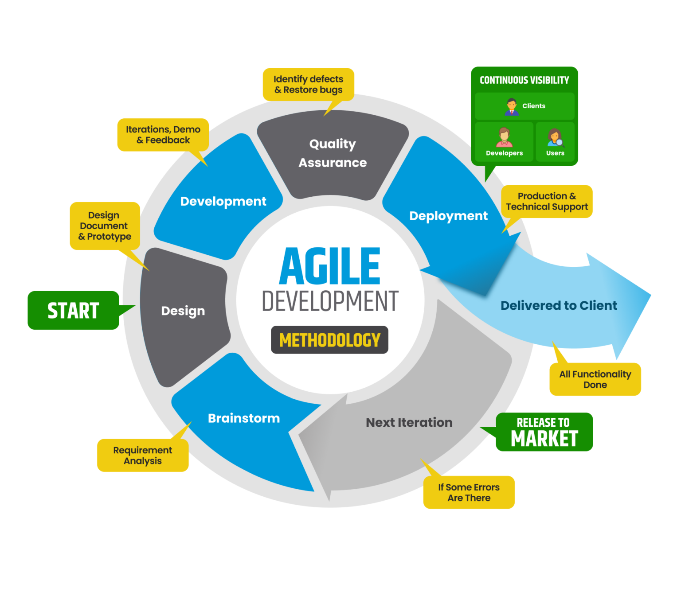

*Figure 1.5.1: Agile Methodology*

## 1.6. Tools and Technologies

The MERN stack is a well-known web development framework of four key technologies: MongoDB, ExpressJS, ReactJS, and NodeJS. This stack enables the development of full-stack JavaScript applications by independent developers: MongoDB serves as the database, ExpressJS as the web server framework, ReactJS for the frontend user interface, and NodeJS for the runtime environment of the backend. This stack is interesting because it provides a single, efficient workflow from client to server to database.



MongoDB is a NoSQL database that provides both flexibility and high performance to data-driven applications. This document-oriented data model—where data is stored in flexible, JSON-like documents rather than rigid tables—permits rapid iteration and adaptation to changing data requirements, so it's popular in agile development environments.



Express is a lightweight and flexible web application framework for Node.js, offering essential features for building web and mobile applications, such as routing and middleware support. It streamlines server-side development by simplifying request handling and server logic.

Node.js is a cross-platform, open-source runtime environment that enables developers to build fast, scalable server-side and networking applications. It uses a single-threaded, event-driven architecture, which allows for efficient handling of concurrent operations.

React is a JavaScript library for creating dynamic and responsive user interfaces. It allows developers to build reusable UI components with a declarative approach, making it efficient for managing complex state and rendering updates.

Apart from MERN Stack we use the following tools and technologies in our project.



Visual Studio Code is a lightweight code editor that supports development tasks such as debugging, task management, and version control integration.



GitHub is a platform for version control and collaboration, allowing developers to work together on projects from anywhere.

## 1.7. Git Repository Link

*Table 1.7.1: Literature Review*

|  |  |
| --- | --- |
| **Project Title** | SSMS – Security Service Management System |
| **Project ID** | ITP24R_B1_W22 |
| **GitHub Repository** | https://github.com/CharuniFernando/Security-Service-Management-System |

# Chapter 2: Requirements

## 2.1. Stakeholder Analysis

Some major stakeholders in the SSMS project include Security Service Providers - the owners of RALL mainly interested in smoothing operations and increasing profitability. They seek a system that would enhance the delivery of service and improve client satisfaction. It will be used by security officers who are employees offering on-site security services for managing their schedules, leave requests, and notifications. Their feedback will be imperative in ensuring usability and functionality. The role of the client manager entails maintaining relationships with clients and will need an efficient system for tracking interactions, managing feedback that goes directly to impacting client retention. The Booking Managers will take care of the scheduling and assigning of security officers. This process should be very smooth, while availing real-time visibility into officer availability. Payment Managers will be responsible for invoicing and processing payments; hence, the system should provide easy billing and financial reporting capabilities. Operation Managers will manage daily operations and thus look into the system for insights and improvements in efficiency. Inventory Managers will want the best tools in tracking security equipment and supplies to ensure readiness. Leave Managers control leaves of employees, for which fair processes of management are necessary to realize adequate staffing. Clients are the customers who use security services and therefore their satisfaction with the effectiveness of the system is of essence as far as business reputation is concerned. Finally, there is a Regulatory Body that shall monitor the system for its compliance to legally set standards and hence need for the system to meet relevant regulations. Each stakeholder group brings different interests and influences that are important to consider throughout the SSMS development process for its successful execution.

## 2.2. Requirements Analysis

### User Management

* The requirement is to have user registration for new clients and employees, basically requiring name, email, phone number, and password. Provide secure login for all users, including password recovery using OTP to be sent on email.
* User Roles and Permissions: Clearly define the roles of Managers, Clients, and Employees and define permissions for each role to access different aspects of the system.
* User Profile Management: Provide users with an interface to modify personal information, change contact data, and alter passwords.
* Access Control: Control the visibility of sensitive information by job roles in such a way that only authorized users can access it.
* Notification System: Build a notification feature for specific important events of the system, such as new bookings or changes in the system.

### Training Management

* Managing the Training Program: The admin shall be allowed to add, edit, and delete any training program for security officers.
* Enrollment: It should be able to enroll security officers into different training programs and keep track of their progress as pertains to their training.
* Training Feedback: A feedback mechanism should be introduced for the officers to assess the training provided and suggest areas of improvement.
* Certification Management: It shall handle the certifications and completion of training by the security officers.

### Client Management

* Client Registration: This module allows the registering of clients and the creation of an account for access to the services.
* Service Documentation: The ability of the client to document their security requirements and preferences.
* Feedback and Communication: A feedback system to be utilized for sharing experiences and communicating with the management.
* Tracking of Client History: The system will maintain the history of the client's interaction or services rendered for future reference.

### Booking Management

* Bookings - Creation: Client should be able to create a new booking for security services, specifying date and time, location, and the number of officers.
* Bookings - Assignment: Facility to assign by the manager a security officer to a particular booking, depending on his availability and skillset.
* Bookings - Confirmation: Notifications confirming the bookings are sent to the clients and the officers concerned with details of the booking.
* Bookings - History: Past history is kept regarding previous bookings by clients and officers.

### Payment Management

* Invoicing: Bill clients on services performed with detailed breakdowns of charges.
* Processing of Payments: Offer credit card, bank transfer amongst others payment methods to clients.
* Payment Tracking: Keep track of status against all payments - payments made, pending or overdue-and notify the client appropriately.
* Financial Reporting: Reports should be generated for management to study for revenue and cash flow analysis.

### Operation Management

* Resource Allocation: Facilitate resource allocation by managers in tune with operational requirements and client needs.
* Performance Monitoring: Follow the performance of the security officers and, in general, service delivery using metrics and KPIs. Incident Reporting: Include a feature that can allow incident reporting or any issue arising during service delivery. Operational Insights: Reports and dashboards that will aid managers in analyzing operations for efficiency and making informed decisions. 7. Inventory Management Requirements: Inventory Tracking-Record all security equipment and supplies with their respective quantities and locations.

### Inventory Management

* Replenishment Alerts: Inform managers when the level of stock reaches a threshold below the preset so that replenishment may be done in time.
* Equipment Assignment: Provide functionality for equipment assignments to different security officers when there is a booking. 8. Leave Management Requirements:

### Leave Management

* Leave Requests: The system should provide facilities for security officers to submit leave requests.
* Approval Workflow: The system should provide a workflow for line managers to approve or reject requests for leave.
* Leave Tracking: The system tracks and updates the leave balances of every officer through records, while officers are informed of the remaining days of their leave.
* Leave History: The system stores past leave requests and approvals for future reference.

## 2.3. Requirements Modeling

### User Management

1. The system should be able to create user accounts for clients and employees by admins.
2. The system should provide different user roles, namely Admin, Client, and Employee, each with specific permissions.
3. The system allows users to modify their personal information, including contact details and passwords.
4. The system shall implement a secure login and authentication mechanism, including password recovery options via OTP sent to the registered email.

### Training Management

1. The system shall provide rights to the admin for creating and managing training programs that security officers shall undergo.
2. The system shall provide functionality to the security officers to enroll in the available training programs.
3. The system shall provide the rights to the security officers to give feedback about the training sessions.
4. The system shall maintain records of the training programs attended by each security officer along with certifications received.

### Client Management

1. The system should allow the client to register and create accounts with a view to have access to the services.
2. The system should allow the clients to update their profiles and requirements of services.
3. The system should give the client an opportunity to provide feedback on the services provided.
4. The system should keep a history of interactions made by the client and service requests.

### Booking Management

1. The system shall provide the ability for the client to create bookings for security services, specifying at least date, time, and location.
2. The system shall be able to allow booking managers to allocate security officers for specific bookings based on their availability.
3. Bookings shall immediately be confirmed to clients and officers assigned upon creation of the booking.
4. All bookings shall be kept within the system's history for both clients and security officers.

### Payment Management

1. The system shall generate an invoice for the services offered, with a comprehensive breakdown of the charges accrued.
2. The system shall facilitate the payment process by clients through different payment options.
3. The system should provide facilities to keep track of the status of payments and prompt the client in case any amount is due for payment.
4. The system should provide financial reporting to allow management to evaluate income and expenses.

### Operational Management

1. The system should enable the managers to effectively do resource allocations based on operational needs.
2. The system should provide for performance monitoring tools that would aid in assessing effectiveness amongst the security officers.
3. The system should allow for incident or issue reporting by managers while delivering the service.
4. The system should develop operational insights and analytics for managerial review.

### Inventory Management

1. The system should maintain an updated inventory of all the security equipment and consumables.
2. When stock reaches a certain threshold that has been specified, the system should notify inventory managers.
3. The system should allow inventory managers to track supplier information and place orders against them.
4. The system should allow booking-specific assignment of equipment to security officers.

### Leave Management

1. Security officers should have access to the system, where they can apply for leave.
2. The system shall introduce an approval workflow where managers approve or decline the leaves of officers.
3. The system will calculate leave balances for each security officer and notify them of the remaining leave days.
4. The system shall retain all history of leave requests along with their statuses for future reference.

This requirement modeling lists the main functionalities required for a Security Service Management System in a manner that ensures the needs of all stakeholders will be met while providing a clear framework toward which the system must be developed.

# Chapter 3: Design and Development

## 3.1. Union Diagram of Actors

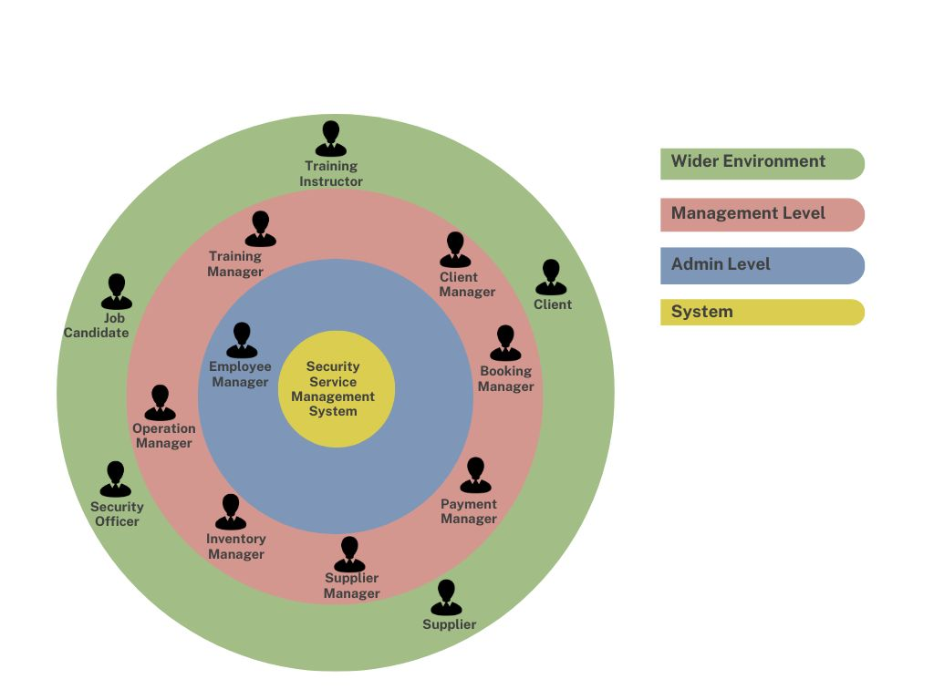

*Figure 3.1.1: Union Diagram of Actors*

## 3.2. System Diagram

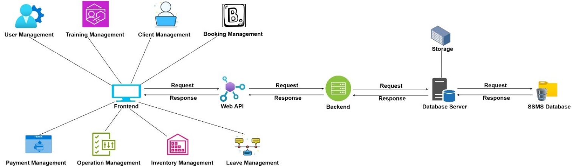

*Figure 3.2.1: System Diagram*

## 3.3. Diagrams of Components

## IT22325228 – Fernando K. K. C – User Management

### Use Case Scenario

*Table 3.3.1: Use Case Scenario in User Management*

|  |  |  |
| --- | --- | --- |
| **Name** | Password Reset | |
| **Summary** | This use case describes password reset procedures in case a user forgets their password. This includes requesting a password reset by a user for his or her account password, followed by an email with the link for reset and setting a new password. | |
| **Precondition** | * The user must have an existing account in the system. * The user must have access to the email address associated with their account. * The user must not be logged into the system. | |
| **Postcondition** | * The user's password is successfully reset, allowing them to log in with the new password. * A notification of the password change is sent to the user’s registered email address. | |
| **Primary Actor** | * Client * Employee * User Manager (Indirectly involved) | |
| **Trigger** | The user clicks on the **Forgot Password?** link on the login page. | |
| **Main Scenario** | **Step** | **Action** |
| 1 | The user opens the Login page. |
| 2 | The user clicks on the Forgot Password? link. |
| 3 | The system asks the user to provide his/ her Email address used for registration. |
| 4 | User inputs the email address and submits the form. |
| 5 | The system verifies the email address and sends a password reset link to the provided email. |
| 6 | The user receives the email and clicks on the password reset link. |
|  | 7 | The system asks the user to enter a new password. |
|  | 8 | The user enters the new password and confirms the same. |
|  | 9 | The system validates the password and changes the new password of the user's account. |
|  | 10 | A confirmation message appears to the user, showing the password reset successfully. |
|  | 11 | ow, the user can log in using the new password. |
| **Extensions** | **Step** | **Action** |
| 3.1 | In case a user provides an e-mail address that doesn't belong to any account, then in that case, the system shows a failure message: "No account found with that email address. Please try again." |
| 4.1 | In case of an error in the system while sending the password reset email, for instance, a problem with the server, it flashes an error message saying, "Unable to send password reset email. Kindly try again later." |
| 8.1 | When the system cannot meet the password criteria - password too short or doesn't contain special characters, it will flash an error message stating the requirements for the new password. |
| 9.1 | In case the password update fails due to some error in the system, like a problem with the database, it shall flash an error message saying, "An error happened while resetting your password. Please try again".  Step 10: User Notification Failure |
| 10.1 | If system was unable to send a confirmation email then upon password reset it displays Unable to send confirmation email. Your password has been reset, but you will not receive an email notification. |

### Use Case Diagram

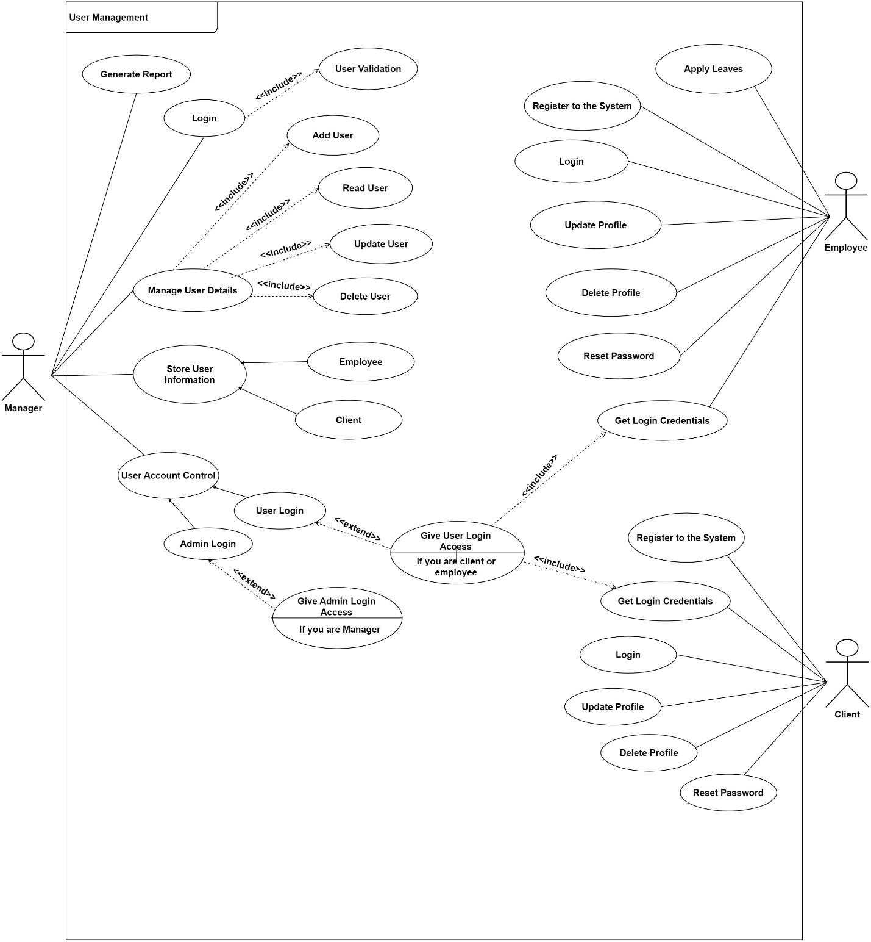

*Figure 3.3.1: Use Case Diagram in User Management*

### Class Diagram

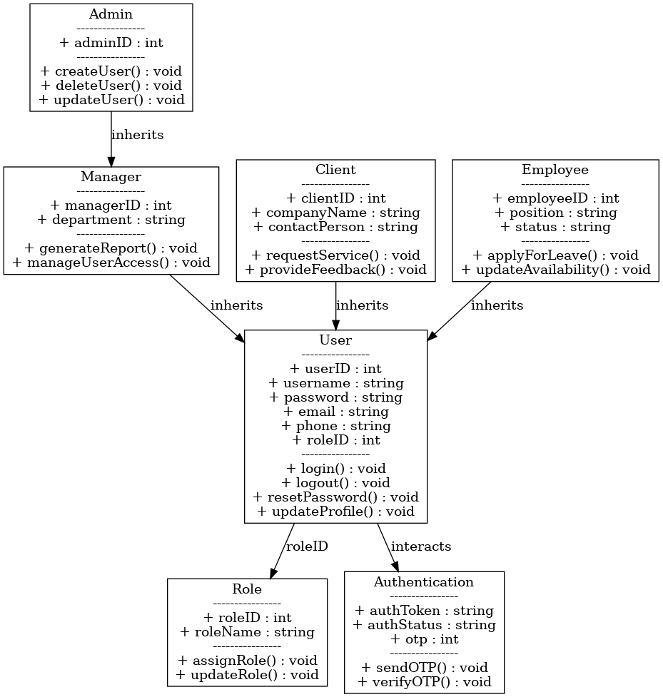

### Activity Diagram

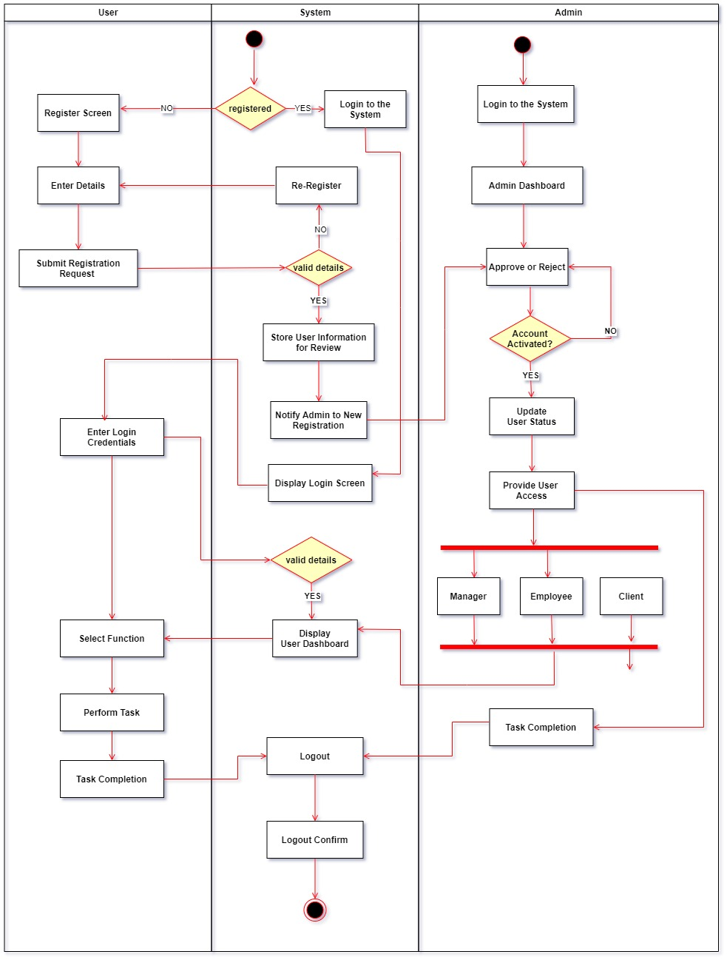

### Sequence Diagram

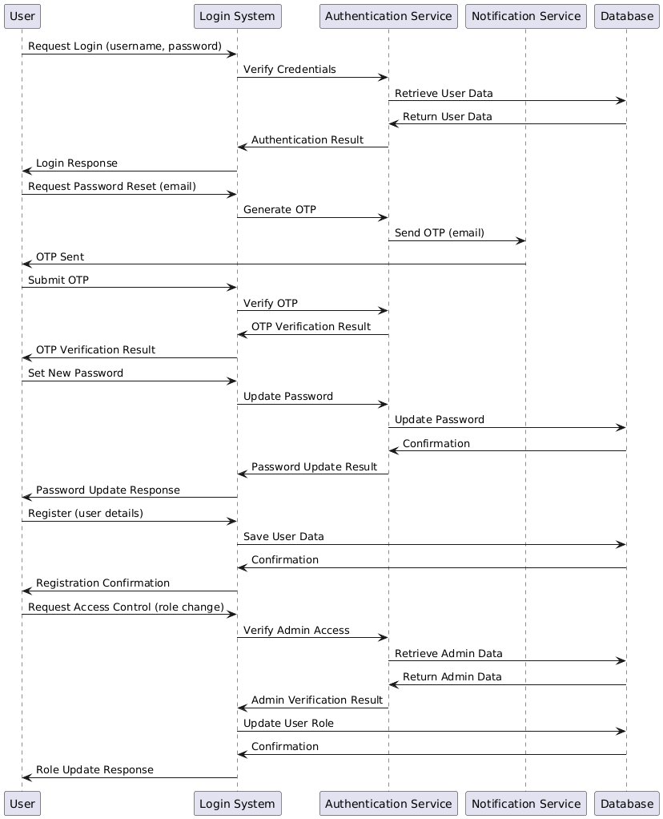

## IT22907998 – Sadisha R. M. M – Training Management

### Use Case Scenario

*Table 3.3.2: Use Case Scenario in Training Management*

|  |  |  |
| --- | --- | --- |
| Name | Training Course Management System | |
| Summary | A Training Manager logs into the system, creates training courses, schedules them, generates reports, manages the training cart, and collects feedback from the security officer. | |
| Precondition | * The Training Manager must have a valid login ID and Password. * The system must be accessible and operational. * Necessary permissions must be granted to the Training Manager for creating courses, managing schedules, generating reports, managing the cart, and accessing feedback from the security officer. | |
| Postcondition | * New training courses are created and visible in the system. * Training schedules are updated and available for trainees. * Reports are generated and stored for review. * The training cart is managed and updated. * Feedback from the security officer is recorded and accessible. | |
| Primary Actor | * Training Manager * Security Officer * Trainees (Indirectly involved) | |
| Trigger | The need to update or create new training courses and schedules, generate reports, manage the training cart, and review feedback from the security officer. | |
| Main Scenario | Step | Action |
| 1 | The Training Manager logs into the system using valid credentials. |
| 2 | * Navigates to the course creation module. * Enters details for each of the four courses (title, description, duration, etc.). * Saves the courses to the system. |
| 3 | * Accesses the scheduling module. * Assigns dates, times, and trainers to the newly created courses. * Ensures there are no conflicts with existing schedules * Saves the updated schedule. |
| 4 | * Navigates to the report generation module. * Selects the desired criteria (course completion, attendance, performance, etc.). * Generates and reviews the report. * Saves or prints the report for records. |
| 5 | * Accesses the training cart module. * Adds or removes courses from the cart as necessary. * Ensures the cart is up-to-date with the latest training offerings. * Saves changes to the cart. |
| 6 | * Reviews feedback submitted by the security officer regarding the training programs. * Makes any necessary adjustments to the courses or schedules based on the feedback. * Records the feedback in the system. |
| Extensions | Step | Action |
| 1.1 | * If the login fails due to incorrect credentials, the system prompts the Training Manager to re-enter the credentials. * After multiple failed attempts, the account may be temporarily locked, and the Training Manager will need to follow the account recovery procedure. |
| 2.1 | If there are issues with course creation (e.g., missing information or system errors), the system highlights the problem areas and prompts the Training Manager to correct them. |
| 3.1 | If there is a scheduling conflict, the system notifies the Training Manager and suggests alternative slots. |
| 4.1 | If report generation fails due to system errors, the Training Manager is notified and can retry the process. |
| 5.1 | If there are problems with managing the cart (e.g., system errors or unavailable courses), the system alerts the Training Manager to resolve the issues. |
| 6.1 | If the feedback from the security officer is unclear or incomplete, the Training Manager may need to seek clarification before making changes. |

### Use Case Diagram

*Figure 3.3.5: Use Case Diagram in Training Management*

### Class Diagram

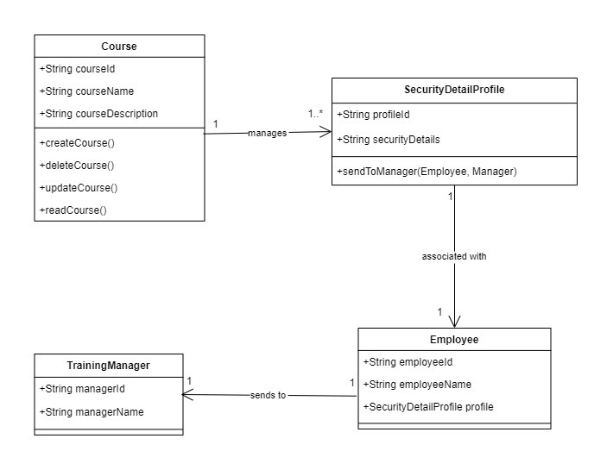

### Activity Diagram

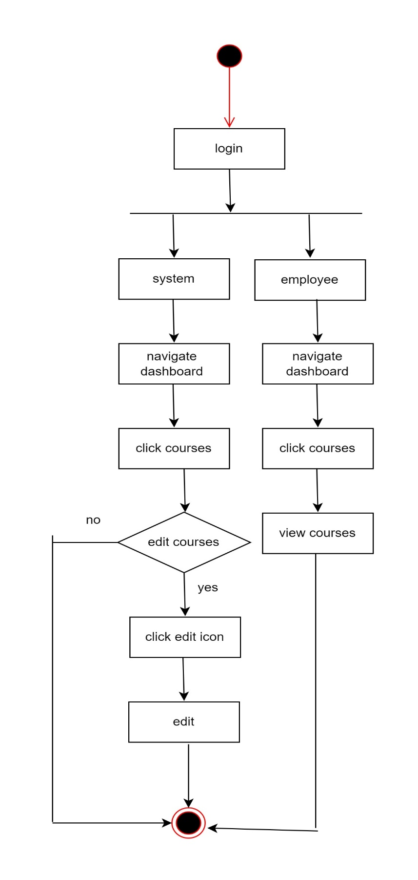

**

## IT20145552 – Dissanayaka D. M. S. M – Client Management

### Use Case Scenario

*Table 3.3.3: Use Case Scenario in Client Management*

|  |  |  |
| --- | --- | --- |
| **Name** | Gather Client Requirements | |
| **Summary** | This use case describes the process by which the Client Manager gathers specific service requirements from a client for an upcoming event. | |
| **Priority** | High | |
| **Pre-condition** | * The Client is logged into the system with an active account. | |
| **Post-condition** | * The client's requirements are accurately documented in the system. * The system is updated with the event details, and the next steps for service provision are initiated. | |
| **Primary actor** | Client Manager | |
| **Secondary Actor** | Client | |
| **Trigger** | The Client contacts the Client Manager to request security services for an upcoming event. | |
| **Main scenario** | **Step** | **Action** |
|  | 1. | The Client logs into the system and initiates a request for security services by contacting the Client Manager. |
|  | 2. | The Client Manager contacts the Client to discuss the service requirements for the upcoming event. |
|  | 3. | The Client provides specific details about the event, including the date, time, location, type of event, and any special considerations (e.g., VIP protection, number of guests). |
|  | 4. | The Client specifies the number of security officers required, any preferred qualifications or special training (e.g., first aid, crowd control), and any specific gender preferences |
|  | 5. | The Client Manager and Client discuss any additional services needed, such as equipment rental, and logistic details like entry and exit protocols. |
|  | 6. | The Client Manager reviews the collected information with the Client for accuracy and completeness. Both parties confirm the documented requirements. |
|  | 7. | The Client Manager generates a preliminary service agreement based on the gathered requirements and sends it to the Client for review. |
| **Extensions** | **Step** | **Branching Action** |
|  | 3a | If the Client provides incomplete information, the system prompts the Client Manager to request additional details. |
|  | 3b | The Client Manager contacts the Client to gather the missing information. |
|  | 4a | If the Client decides to change the requirements after providing initial details, the Client Manager updates the records accordingly. |
|  | 4b | The Client Manager revisits the requirements with the Client. |

### Use Case Diagram

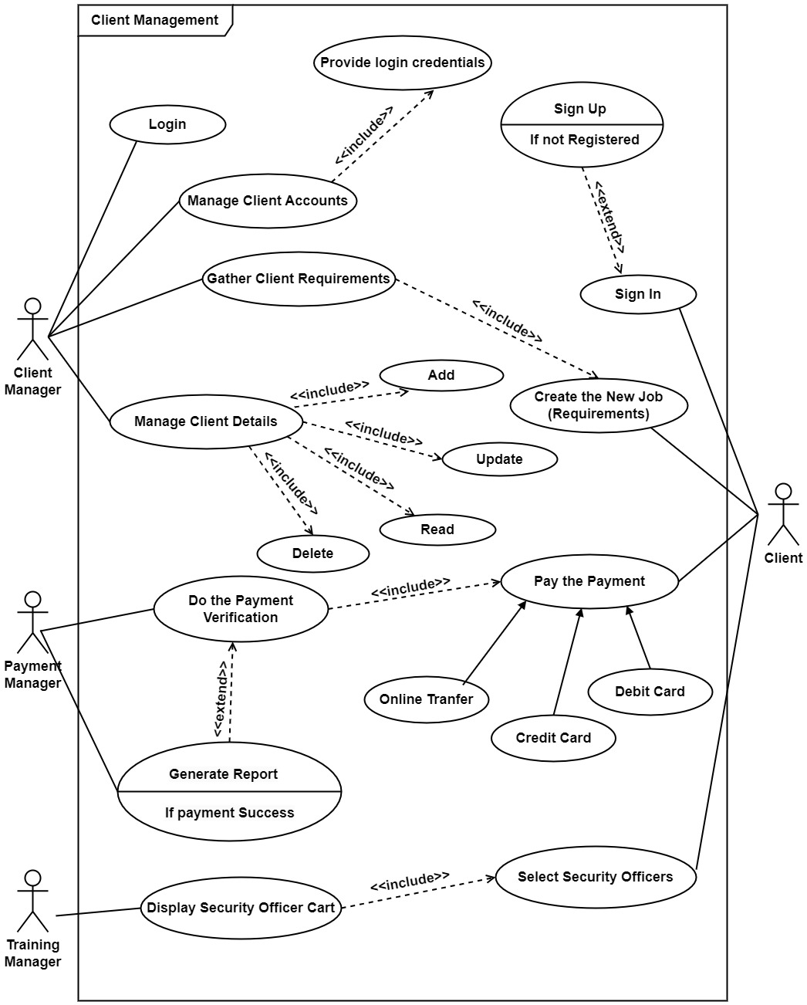

*Figure 3.3.9: Use Case Diagram in Client Management*

### Class Diagram

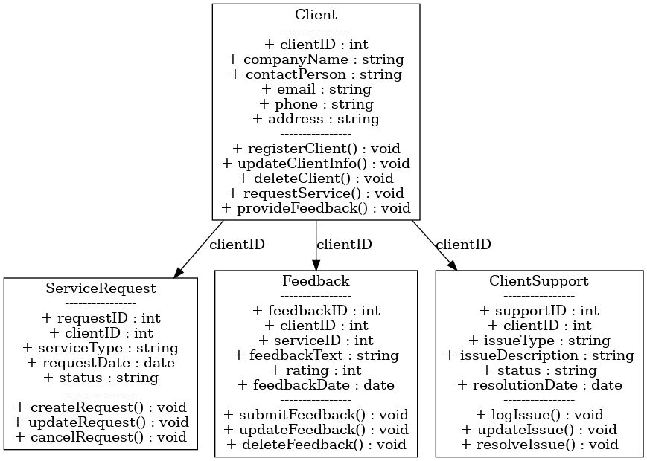

### Activity Diagram

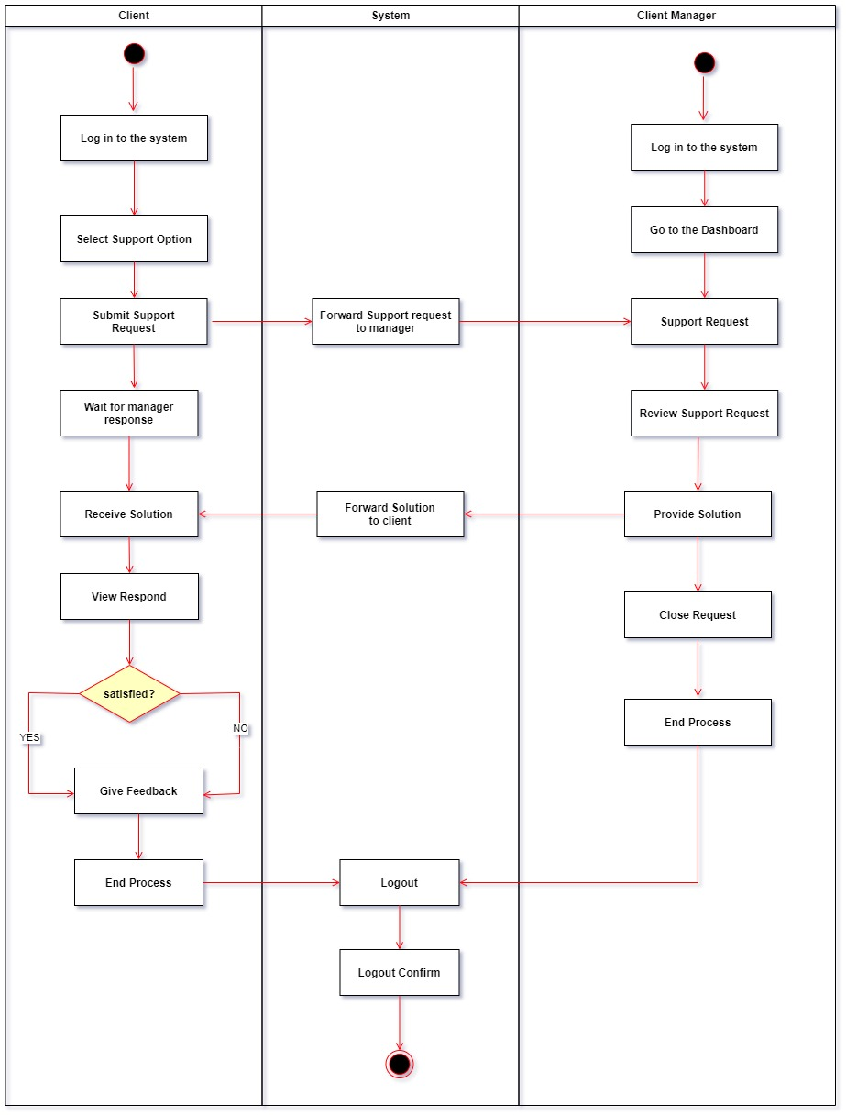

### Sequence Diagram

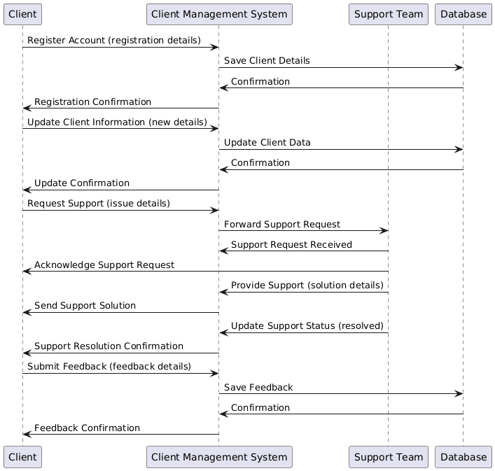

## IT22257086 – Randiw E. Y – Booking Management

### Use Case Scenario

*Table 3.3.4: Use Case Scenario in Booking Management*

|  |  |  |
| --- | --- | --- |
| Name | Manage Bookings | |
| Summary | A Booking Manager checks for new bookings, updates their statuses, and allocates necessary resources to handle client requests efficiently | |
| Priority | 1 | |
| Pre-conditions | • The Booking Manager is logged into the system.  • There are new bookings in the system awaiting review | |
| Post-conditions | • Bookings are updated with the appropriate status.  • Security officers are allocated to the events.  • Notifications are sent to clients regarding the status of their bookings | |
| Primary Actors(s) | Booking Manager | |
| Secondary Actor(s) | Client | |
| Main Scenario | **Step** | **Action** |
| 1 | The Booking Manager logs into the system using their credentials. |
| 2 | The Booking Manager navigates to the bookings section in the system dashboard. |
| 3 | The system displays a list of new bookings that need attention. |
| 4 | The Booking Manager updates the status of each booking (e.g., approved, pending, rejected) based on the review. |
| 5 | The system records the updates and allocations made by the Booking Manager. |
| 6 | The system automatically sends notifications to clients about the status of their bookings and any assigned security officers. |
| Extensions | **Step** | **Branching action** |
| 5a | The Booking Manager updates the booking once the required information is received. |
| 6a | The Booking Manager informs the client of any changes to the original booking. |

### Use Case Diagram

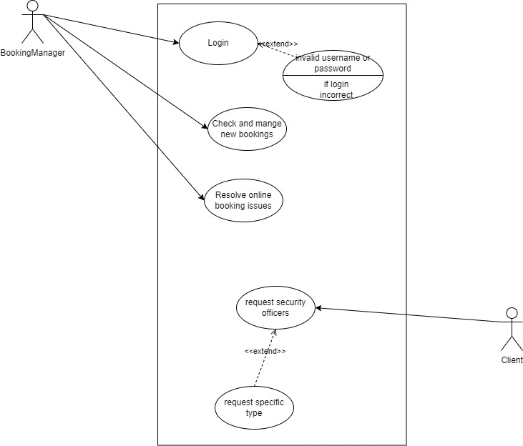

*Figure 3.3.13: Use Case Diagram in Booking Management*

### Class Diagram

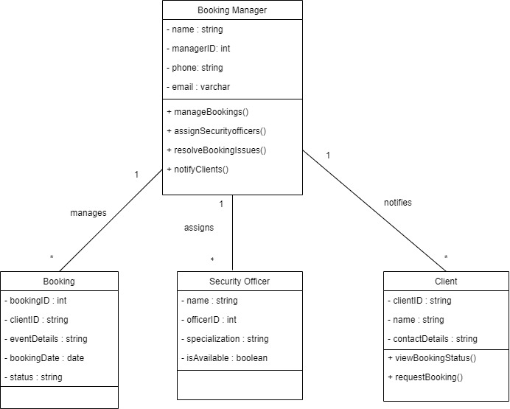

### Activity Diagram

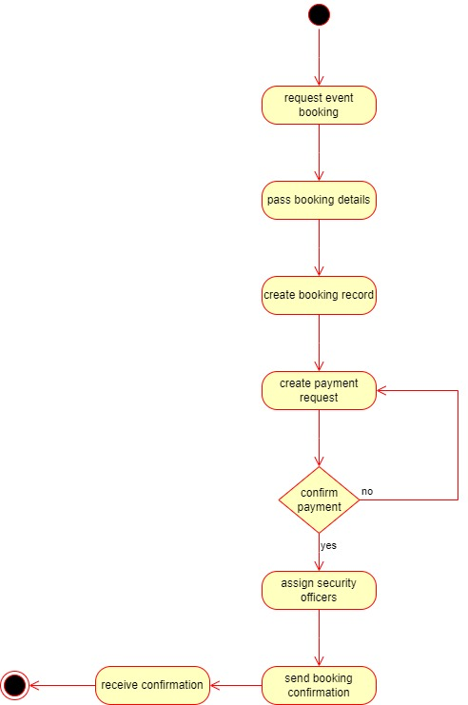

### Sequence Diagram

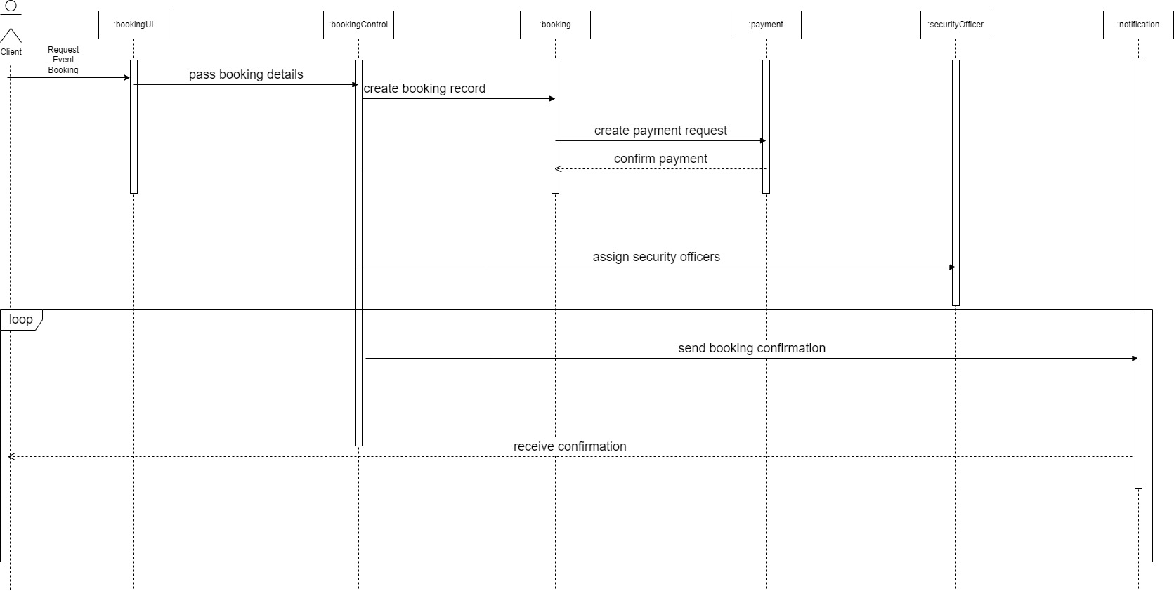

## IT22293480 – Jayodhya J. D. H – Payment Management

### Use Case Scenario

*Table 3.3.5: Use Case Scenario in Payment Management*

### Use Case Diagram

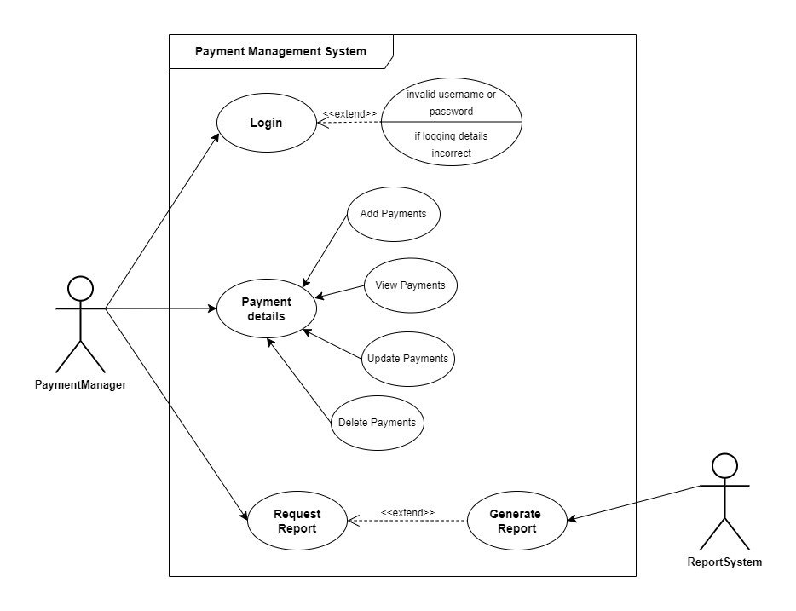

*Figure 3.3.17: Use Case Diagram in Payment Management*

### Class Diagram

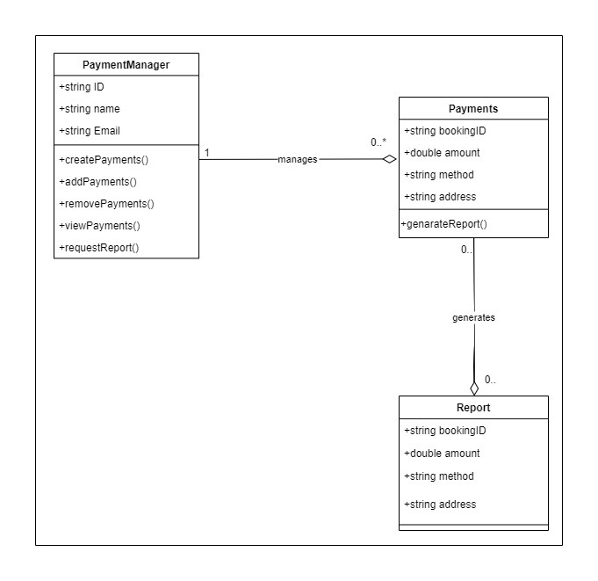

### Activity Diagram

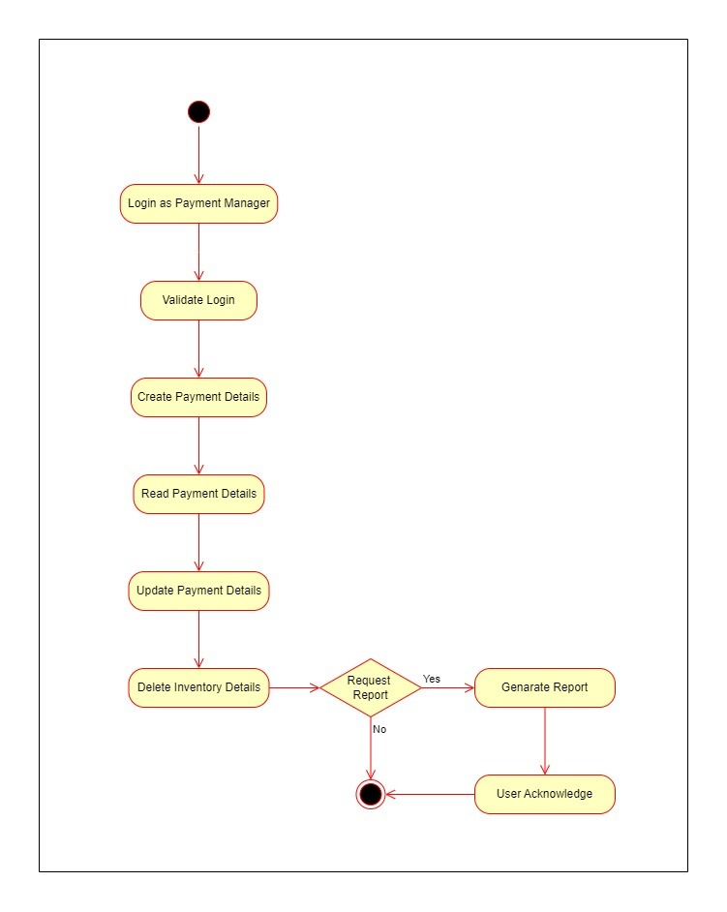

### Sequence Diagram

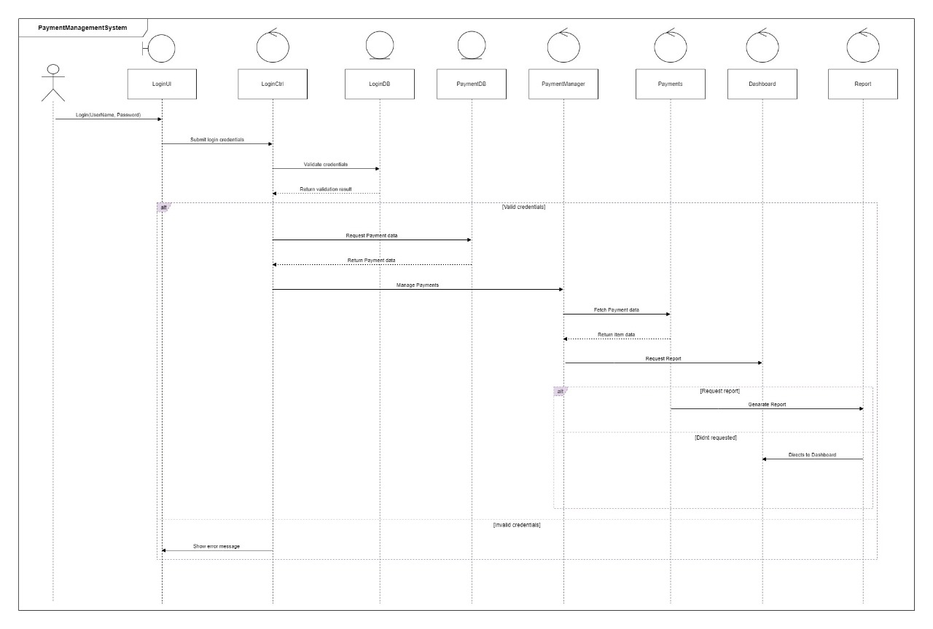

## IT22127082 – Medawatte W. W. M. T. N. B – Operation Management

### Use Case Scenario

*Table 3.3.6: Use Case Scenario in Operation Management*

|  |  |  |
| --- | --- | --- |
| **Name** | Manage Operations | |
| **Summary** | The Operations Manager manages security deployments and communication tasks. | |
| **Priority** | High | |
| **Preconditions** | The operations manager is logged into the system and has access to operation management features. | |
| **Postconditions** | All scheduled operations are updated, incidents are addressed, and security officers are informed of their duties. | |
| **Primary Actor** | Operation manager | |
| **Trigger** | A scheduled shift changes or incident report is detected by the system | |
| **Main Scenario** | **Step** | **Action** |
| 1 | Operations Manager logs into the system using credentials. |
| 2 | System verifies login details. |
| 3 | Manager checks and views security officers' statuses. |
| 4 | Manager updates and saves the current schedule. |
| 5 | Manager communicates schedule changes or updates to officers. |
| 6 | System logs all communications between manager and officers. |
| 7 | Manager reviews and responds to reported incidents. |
| 8 | Manager assigns officers based on availability and needs. |
| 9 | System records assignments and updates officer statuses. |
| 10 | Manager coordinates with Booking Manager for event details. |
| 11 | System stores booking details from Booking Manager. |
| 12 | Manager monitors operations and addresses new issues or incidents. |
| **Extensions** | **Step** | **Action** |
| 2a | The system prompts the Operations Manager to re-enter the credentials. After three failed attempts, access is temporarily locked. |
| 5a | The system retries sending the message and logs the failure. An alert is sent to the Operations Manager to manually contact the officer. |
| 7a | The system escalates the issue to senior management and logs all actions taken in response. |
| 8a | The Operations Manager reschedules or reallocates existing officers based on priority needs. The system suggests possible options. |
| **Open issues** | 1 | Unresolved security incident at the main entrance. |

### Use Case Diagram

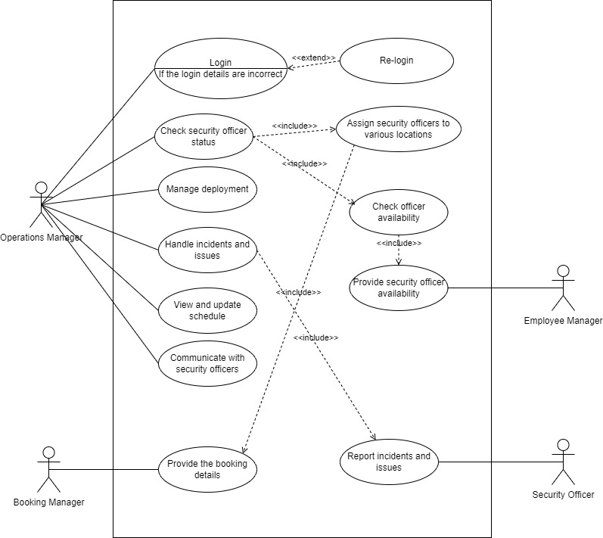

*Figure 3.3.21: Use Case Diagram in Operation Management*

### Class Diagram

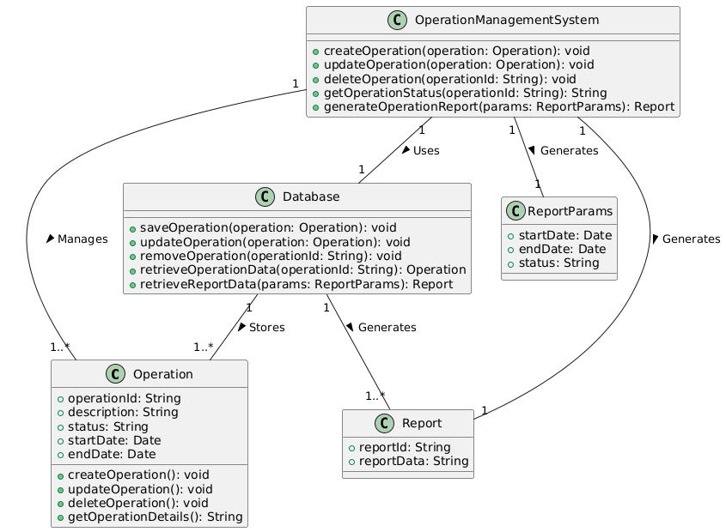

### Activity Diagram

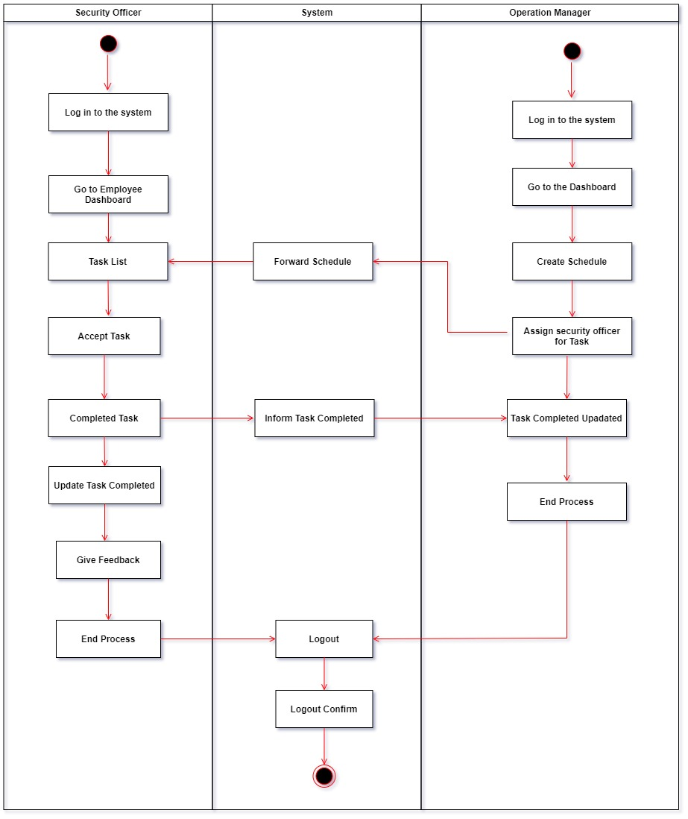

### Sequence Diagram

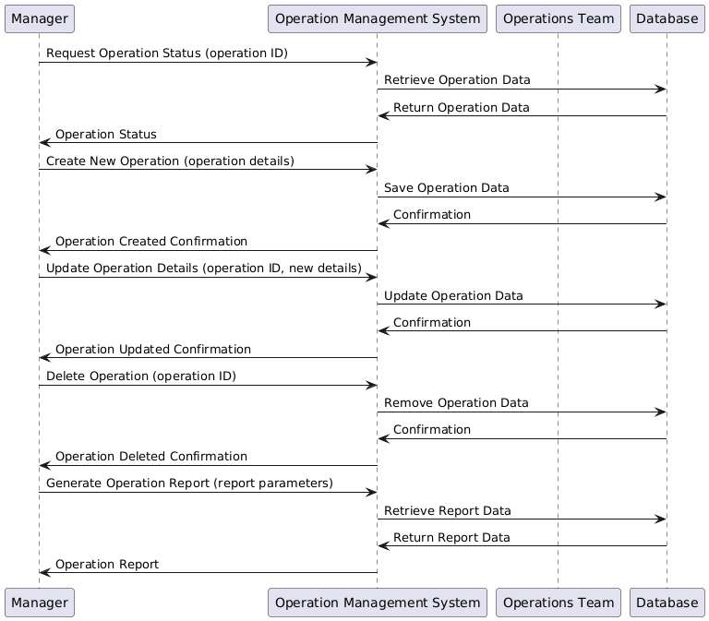

## IT22132628 – Kusumsiri P. A. S. S – Inventory Management

### Use Case Scenario

*Table 3.3.7: Use Case Scenario in Inventory Management*

|  |  |  |
| --- | --- | --- |
| Name | Manage Inventory Details | |
| Summary | Managing the inventory and interacting with the system to add, view,  Update and delete items. | |
| Priority | 1 | |
| Pre-conditions | The Inventory Manager must be logged into the system. | |
| Post-conditions | The system updates its inventory records based on the Inventory Manager’s actions, such as adding, updating, or deleting items. | |
| Primary Actors(s) | Inventory Manager (IM) | |
| Secondary Actor(s) | Report System | |
| Trigger | The Inventory Manager selects the "Request Report" option from the inventory dashboard. | |
| Main Scenario | **Step** | **Action** |
| 1 | The Inventory manager logs into the system using their credentials. |
| 2 | The Inventory Manager adds new items to the inventory. |
| 3 | The Inventory Manager views the list of current items in the inventory. |
| 4 | The Inventory Manager updates details of existing items. |
| 5 | The Inventory Manager removes items from the inventory. |
| 6 | Request a Report about Inventory Details. |
| Extensions | **Step** | **Branching action** |
| 1a | Before accessing inventory details, the Login use case occurs, where the system validates the Inventory Manager’s credentials. If invalid credentials are entered, the system returns an error message, as indicated by the "invalid username or password" and "if logging details incorrect" extensions in the diagram. |
| 6a | After managing inventory details, the Inventory Manager may request a report. The Request Report use case is triggered, and the system interacts with the Report System to generate the requested report. |

### Use Case Diagram

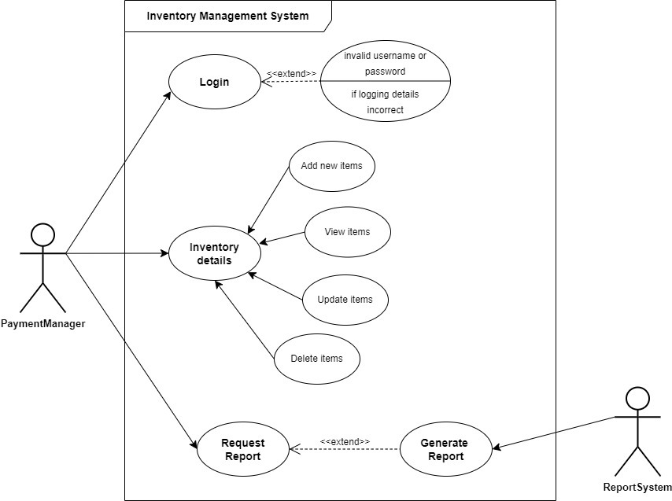

*Figure 3.3.25: Use Case Diagram in Inventory Management*

### Class Diagram

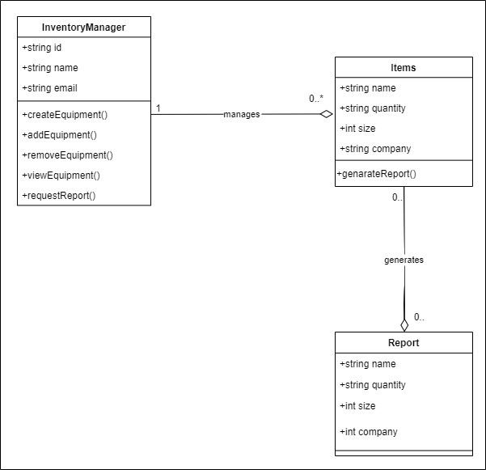

### Activity Diagram

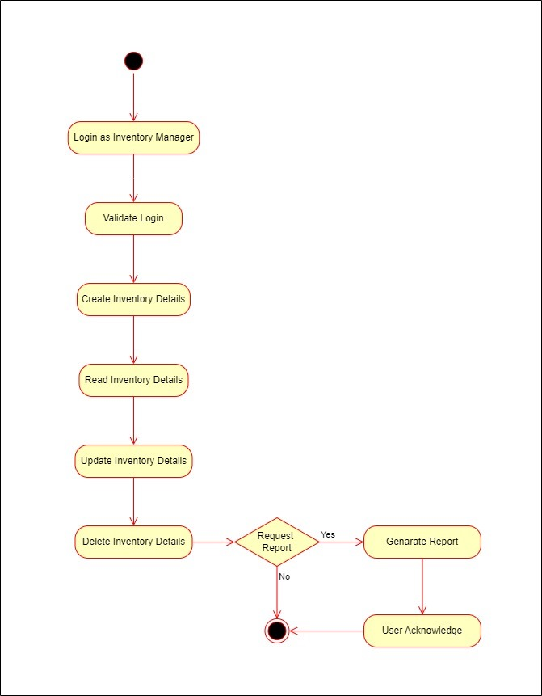

### Sequence Diagram

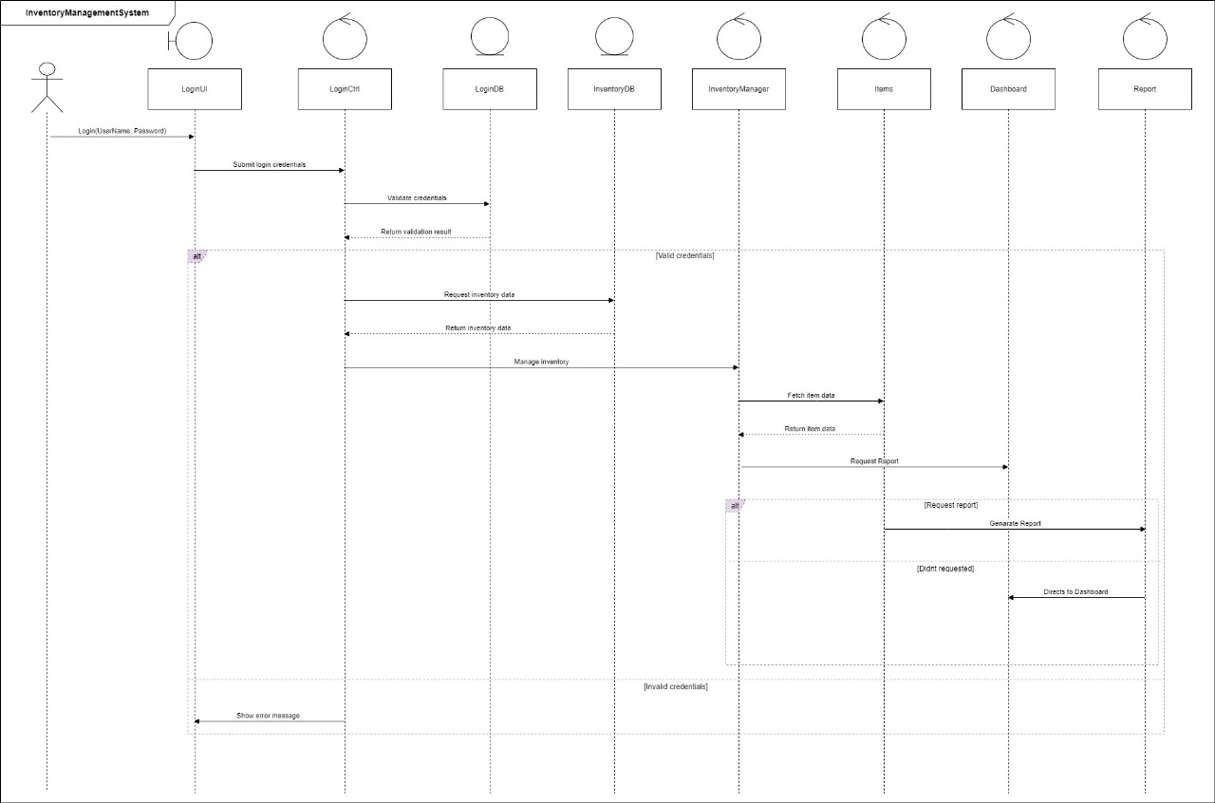

## IT22197146 – Ranasinghe R. A. R. V. C – Leave Management

### Use Case Scenario

*Table 3.3.8: Use Case Scenario in Leave Management*

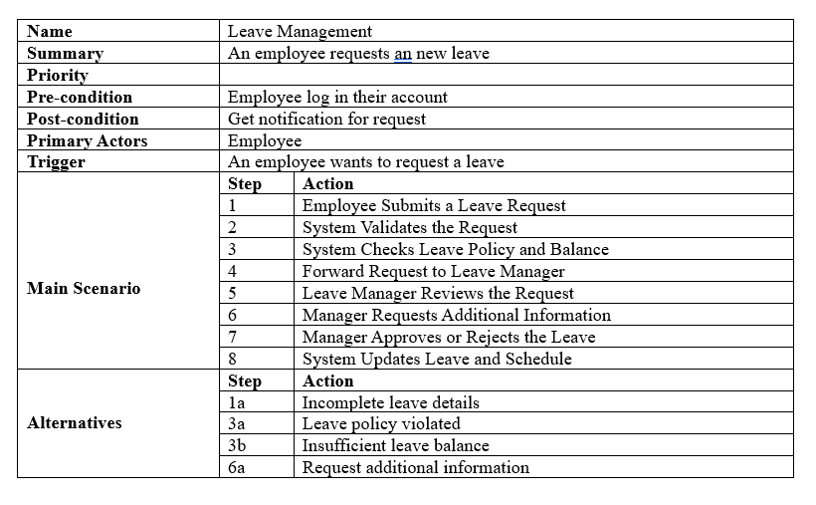

### Use Case Diagram

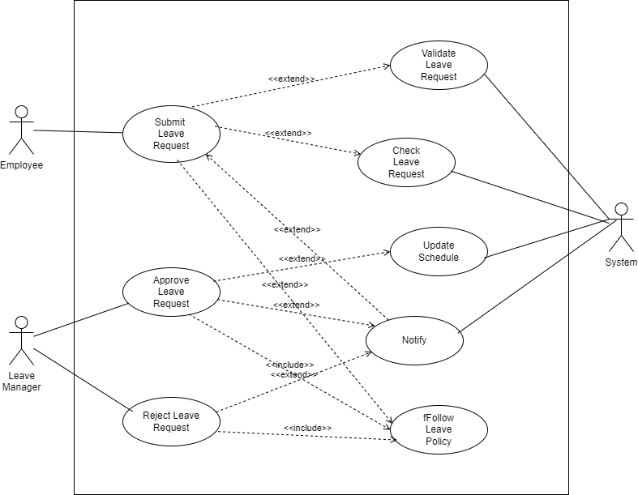

*Figure 3.3.29: Use Case Diagram in Leave Management*

### Class Diagram

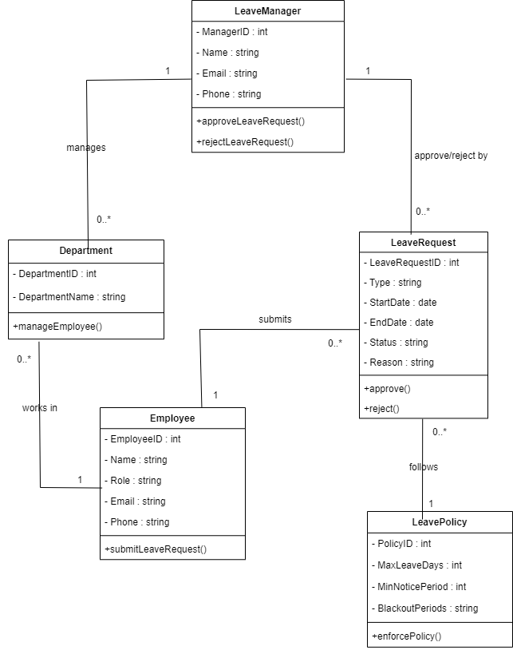

### Activity Diagram

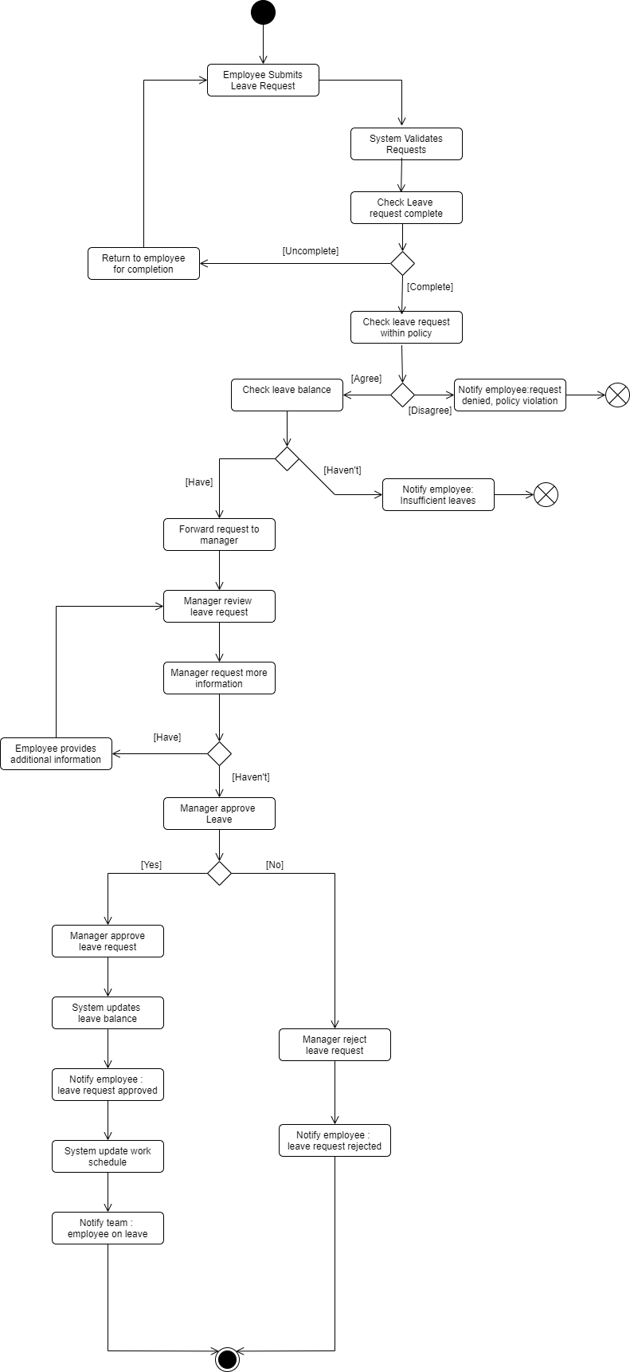

### Sequence Diagram

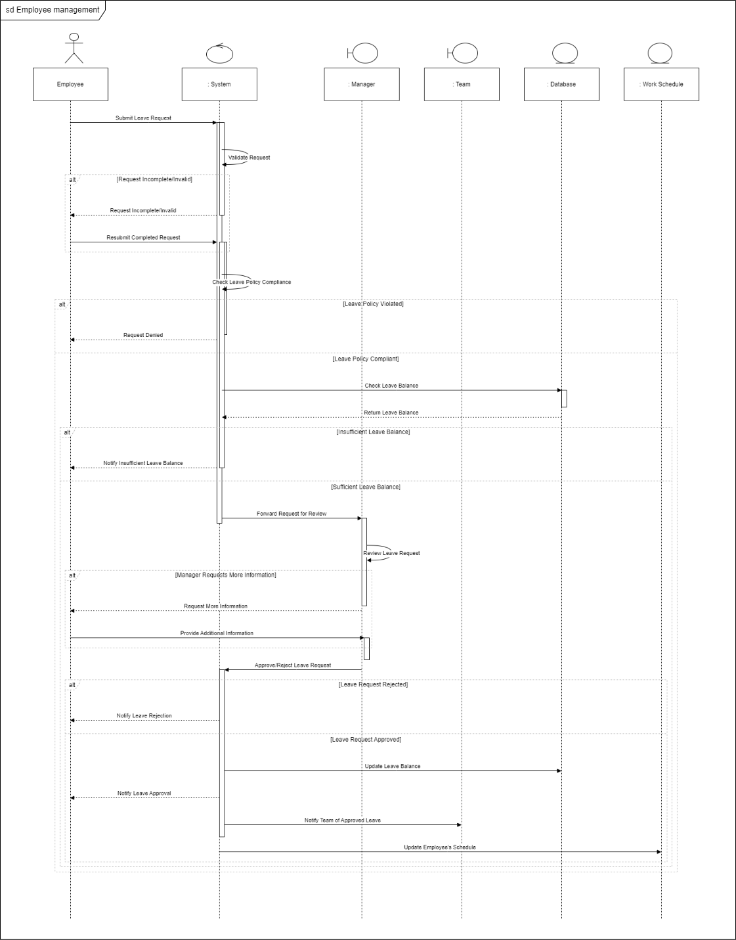

## 3.4. Non-Functional Requirements

Performance

* The system shall support at least 100 concurrent users with no significant degradation in performance.
* The system shall respond to user requests within a period of 2 seconds under normal operating conditions.
* The system shall handle booking transactions with maximum processing time of 3 seconds.

Scalability

* The system shall be designed to scale horizontally for anticipated growth in the number of users and volume.
* The system should provide maximum ability for new functionality and module addition with minimal changes on the architectural level.

Security

* The system shall provide mechanisms for secure user authentication and authorization for the protection of sensitive data.
* The system shall encrypt all sensitive data in transit and at rest, including user passwords and credit card payment information.
* The system shall introduce mechanisms preventing unauthorized access, such as session timeouts and account lockout after a number of failed attempts at login.

Usability

* The system should offer a very user-friendly interface, which will be easy for all types of users to navigate through.
* The system should have onboard and help documentation that can enable users to understand various features of the system.
* The system should provide functionality for users to personalize their dashboard.

Reliability

* The system shall achieve 99.9% uptime during operational hours.
* The system shall be backed up regularly to avoid losing data and therefore going through a recovery process in case of failure.
* The system shall provide disaster recovery and business continuity planning.

## 3.5. Performance Requirements

Refine the performance requirements of the SSMS, considering request time, response time, and client-side functions.

* The different components of the web application shall load within 1 second to ensure the user experience of the application is smooth.
* The database queries with regard to retrieving objects and records shall return results in 2 seconds to reduce wait times by the user.
* User authentication processes shall be done within less than 2 seconds to support the facility of fast access to the system for both clients and employees.
* Client-side functionality shall include form submission, data validation, and user reaction within 1 second to provide ease to the users.
* The system shall ensure that the average page load time is less than 3 seconds under normal conditions of operation to meet the user requirements.
* It should support up to 100 concurrent user sessions during peak use without exceeding the above-described response times.
* Background tasks, such as sending notifications or processing of the payment, shall be executed in 5 seconds or less to timely update users about the results

These performance requirements encompass both client-side and server-side operations of the Security Service Management System, ensuring a fast and responsive user experience. Satisfaction and efficiency of operation by users will definitely be enhanced with the meeting of these criteria.

## 3.6. High Level Architecture Diagram

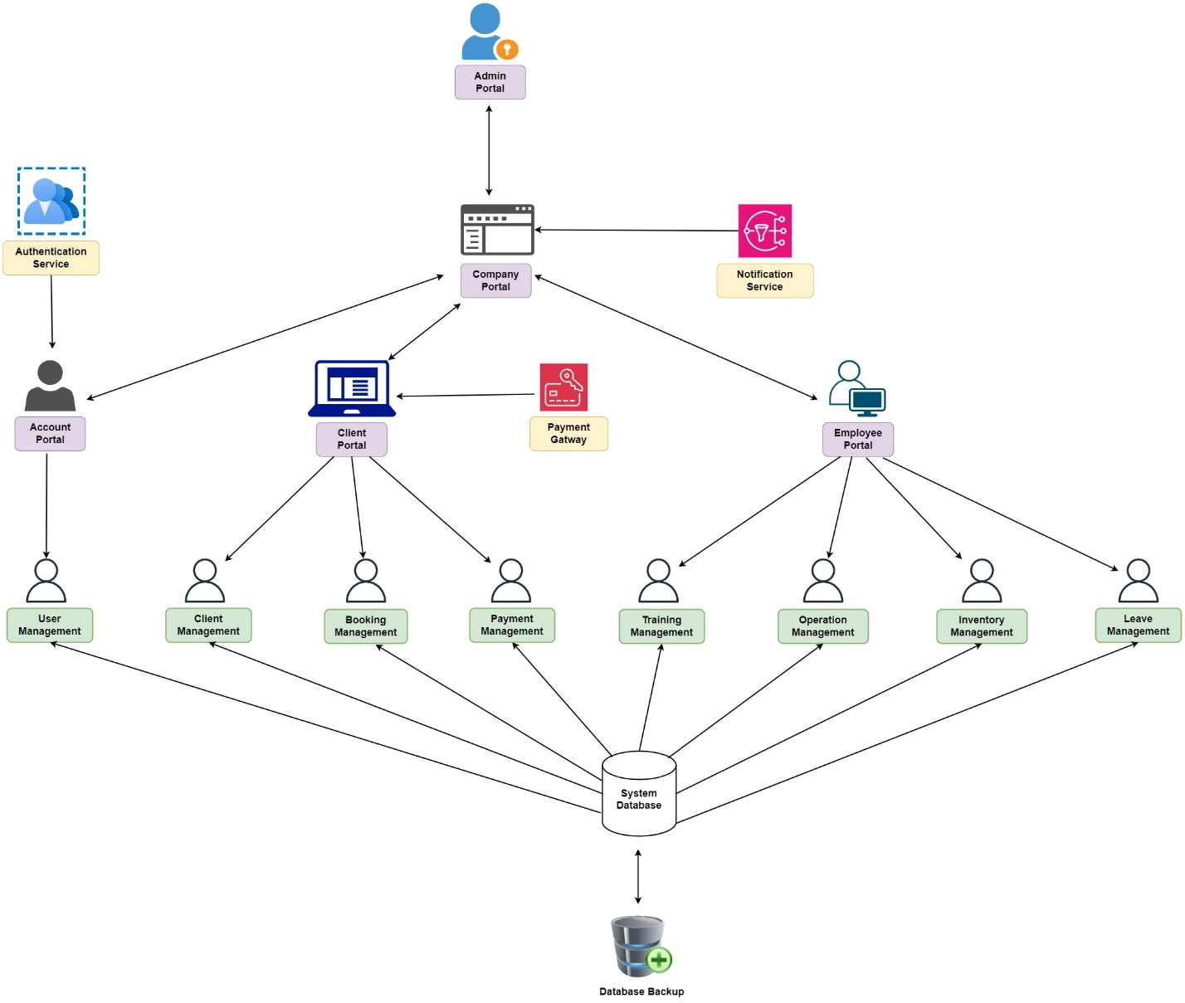

*Figure 3.6.1: High Level Architecture Diagram*

## 3.9. ER Diagram

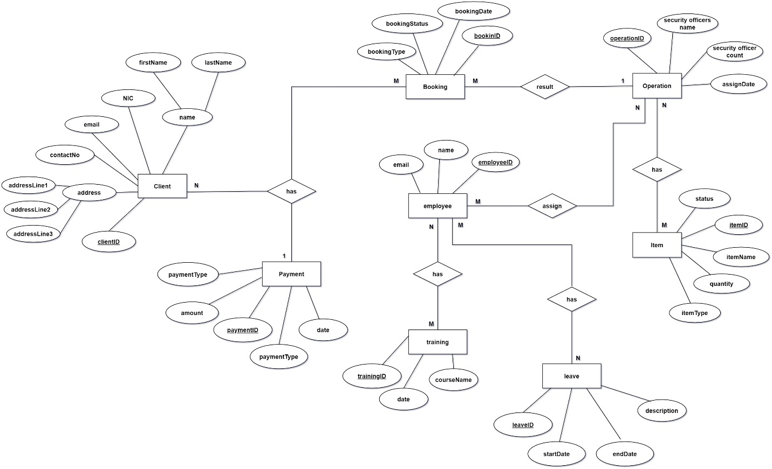

*Figure 3.9.1: ER Diagram*

## 3.10. Relational Schema

**Client** (clientID, first name, last name, nic, email, contactNo, address)

**Payment** (paymentID, paymentType, amount, date, *clientID*)

**Booking** (bookingID, bookingDate, bookingStatus, bookingType, *clientID*)

**Employee** (employeeID, name, email)

**Operation** (operationID, securityOfficerCount, assignDate, *bookingID*)

**Item** (itemID, itemName, quantity, itemType, status, *operationID*)

**Training** (trainingID, courseName, date, *employeeID*)

**Leave** (leaveID, description, startDate, endDate, *employeeID*)

## 3.11. Processes

* User Registration and Authentication
  + Users, including both clients and employees, are allowed to register by providing the necessary personal information.
  + The system validates the authenticity of the information based on a set of rules and then provides user accounts accordingly.
  + Users log in with their respective credentials, and authentication is carried out by the system.
  + Management of user sessions is done in a secure manner, and password reset, and account recovery options are provided.
* User Role Management
  + There will be different user roles defined by the system, such as manager, client, and employee.
  + Administrators are allowed to assign user roles based on responsibility.
  + Role-based access control ensures that users can only access features relevant to their roles.
* Client Management
  + Clients are allowed to create an account and manage their profiles by updating personal details as and when necessary.
  + The system allows clients to document the requirements of services, specifying the need for security.
  + Each client is able to provide feedback and ratings of the services delivered to them in order to further enhance the process.
* Booking Management
  + Clients can view the list of available security officers and book their services based on their requirements.
  + The system handles requests for booking, such as flight arrangements or confirmation of the assignee.
  + Both clients and the security personnel are informed about the bookings and changes that may occur.
* Payment Processing
  + The system will create invoices for services offered to clients.
  + In relation to this, clients can also make their payments via credit cards, online payment portals.
  + This system makes the processing of the said payments secure and performs updates in the book of accounts.
* Employee Management
  + Admins can create and manage the recruitment process, posting of job vacancies, and scheduling of interviews.
  + It allows viewing the employees' profiles and editing of personal information.
  + Leave management features allow employees to apply for leaves, which can be approved or rejected by managers.
* Training Management
  + The system manages training programs for security officers where employees may enroll in courses.
  + Admin shall maintain Training completed and certifications for employees
  + Notifications of Forthcoming Training Sessions will be made to the employees and Requirements.
* Inventory Management
  + The system keeps inventory records regarding security equipment and consumables.
  + Managers can be aware of the stocks on hand and reorder supplies when low in addition; they maintain the usage records of inventory.
  + Sending notifications when the level of stock reaches below the threshold predefined.
* Reporting and Analytics
  + Reports are generated by the system showing aspects such as bookings, payments, employee performance, and customer satisfaction.
  + Managers can then analyze such data in decision making on operations and improvements in services.
  + The visual dashboards are prepared on key metrics and trends.

## 3.12. User Interfaces

## IT22325228 – Fernando K. K. C – User Management

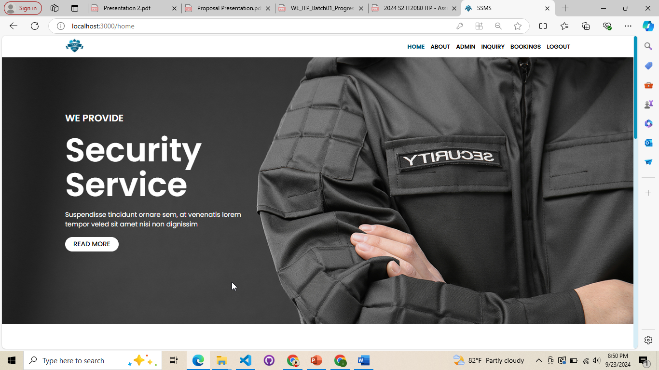

*Figure 3.12.1: Home Page*

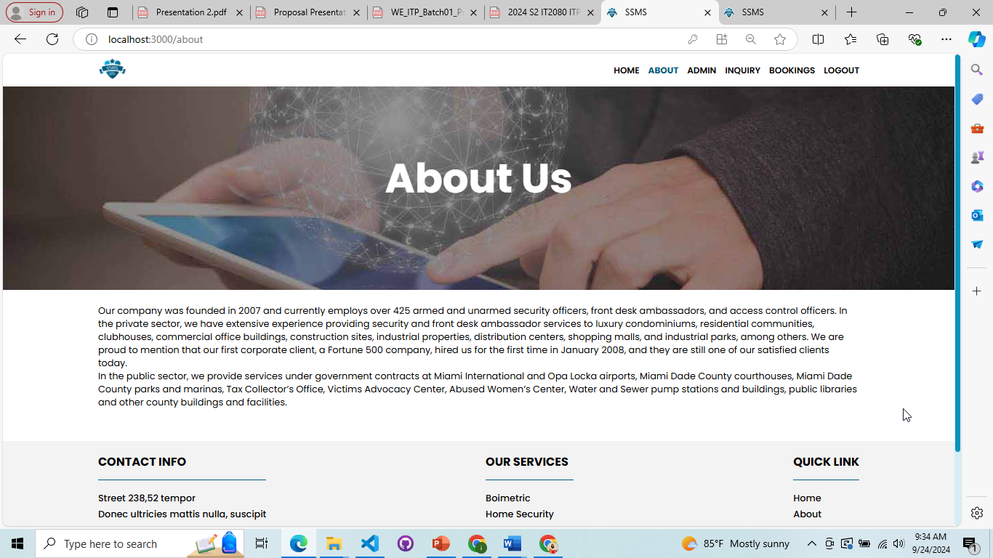

*Figure 3.12.2: About Page*

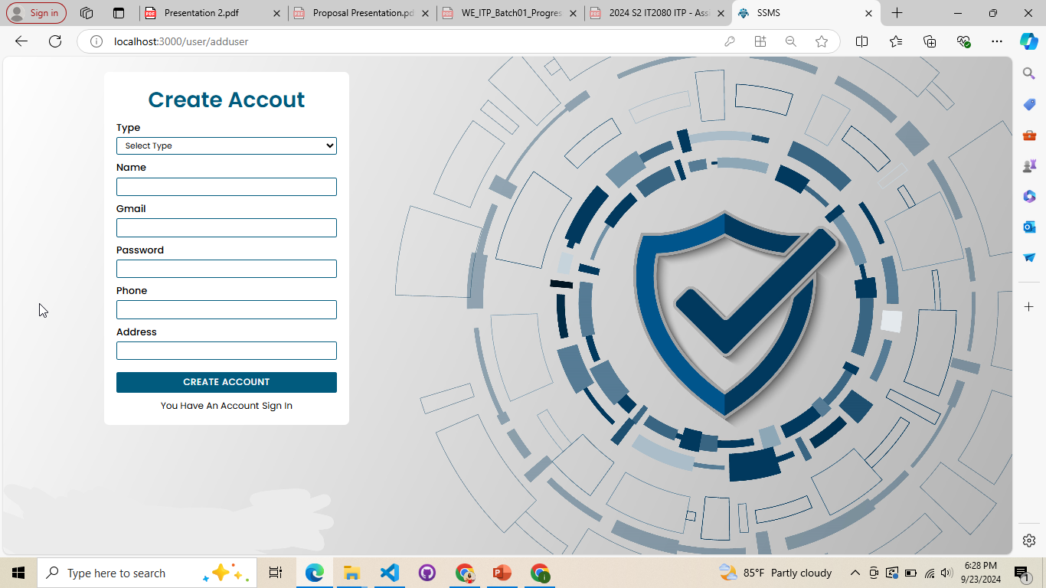

*Figure 3.12.3: User Registration*

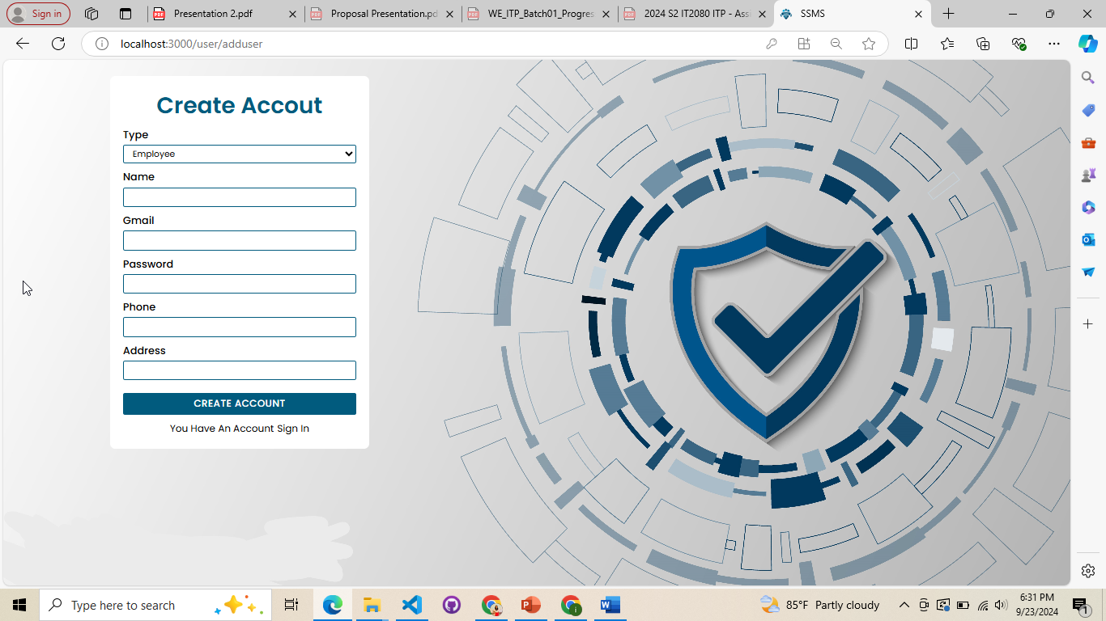

*Figure 3.12.4: Employee Registration*

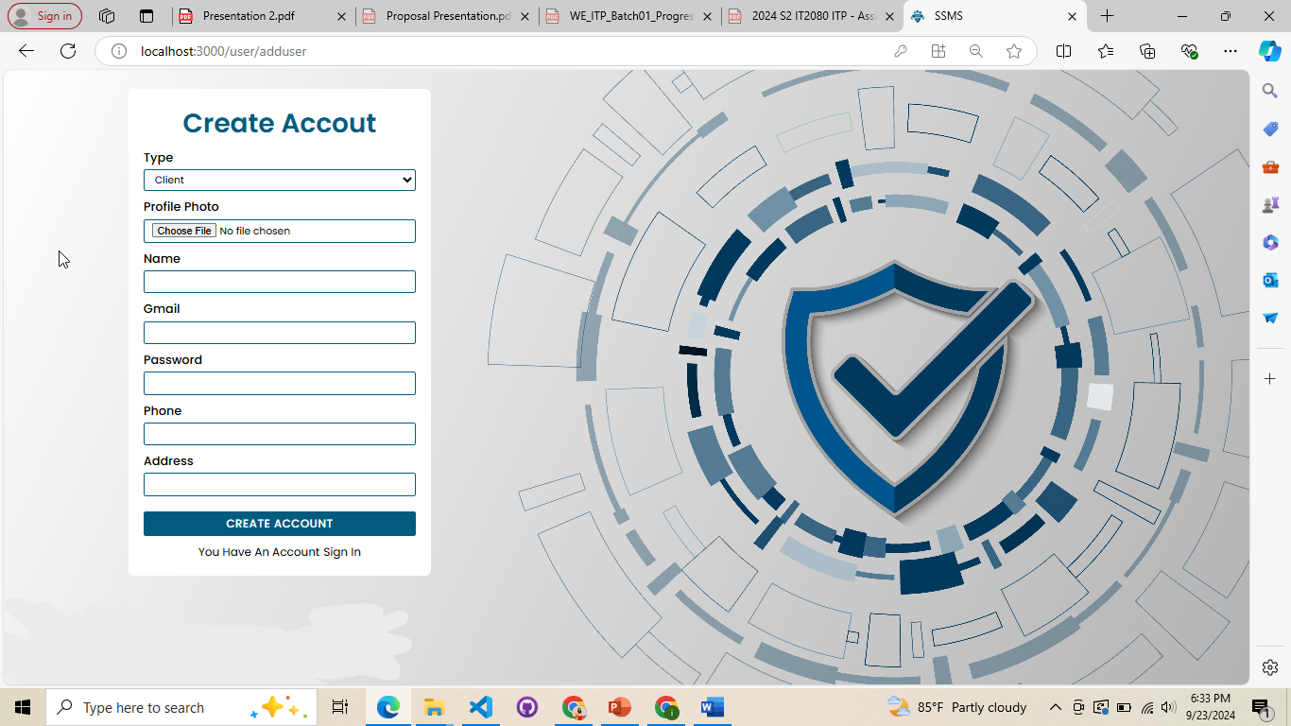

*Figure 3.12.5: Client Registration*

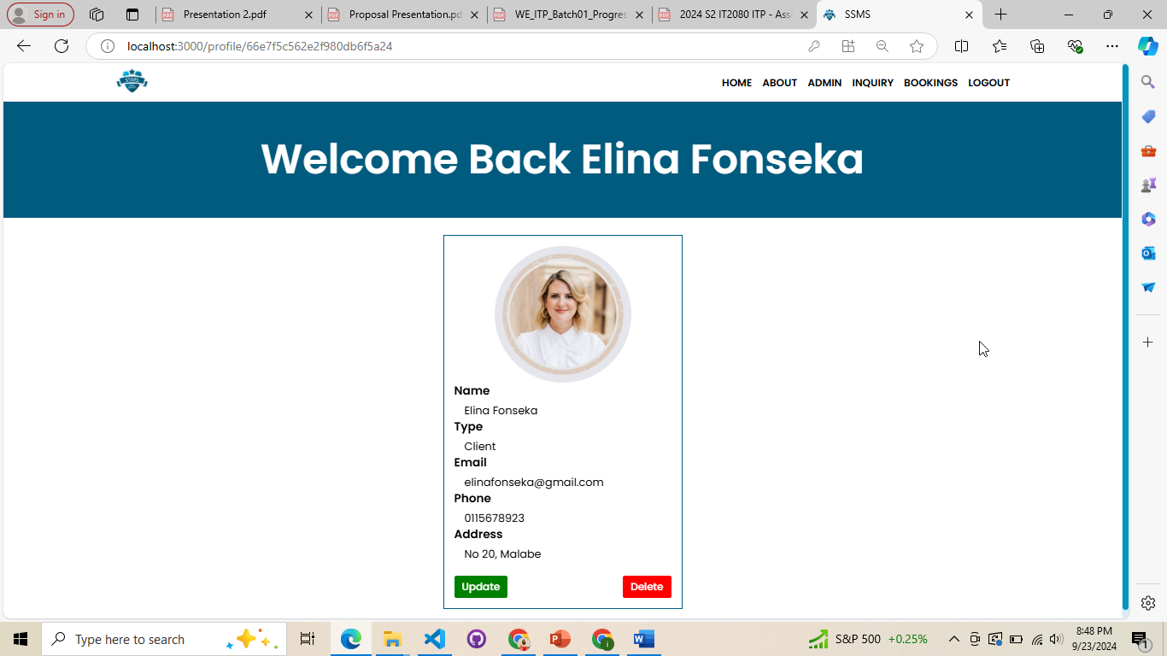

*Figure 3.12.6: Client Account*

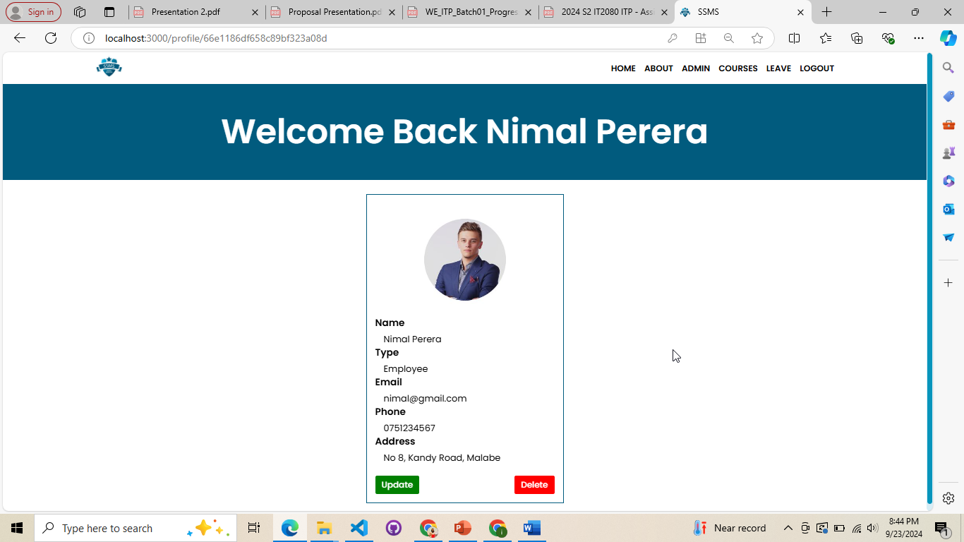

*Figure 3.12.7: Employee Account*

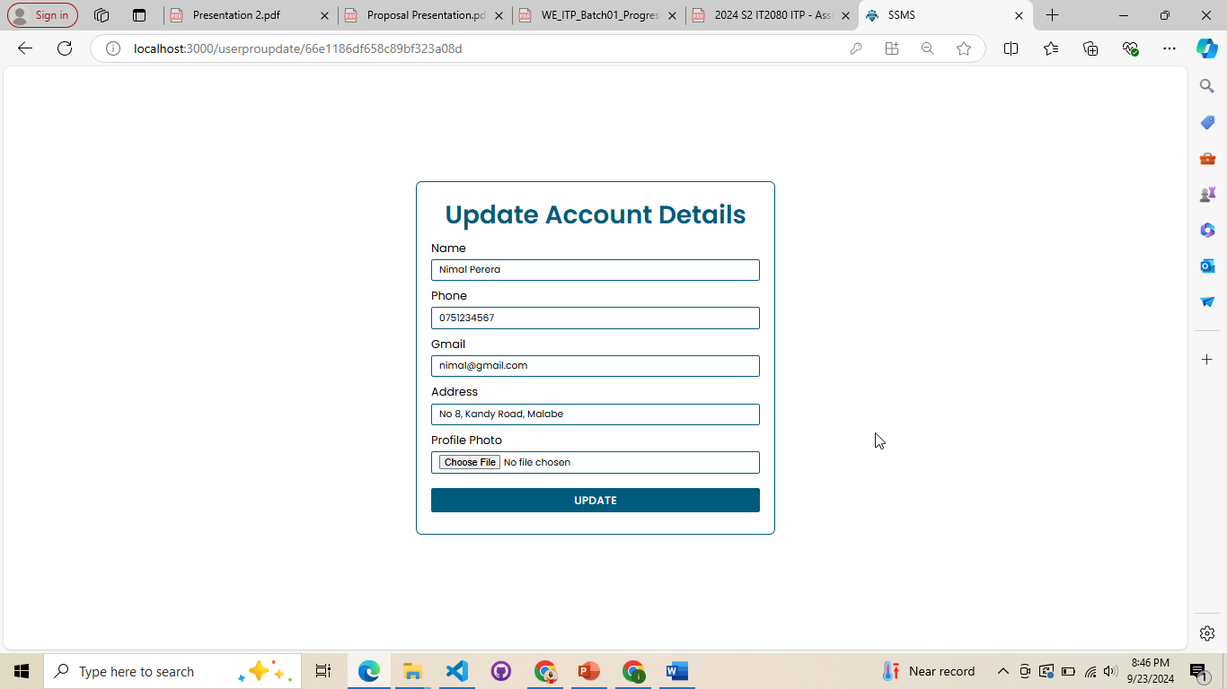

*Figure 3.12.8: User Account Update*

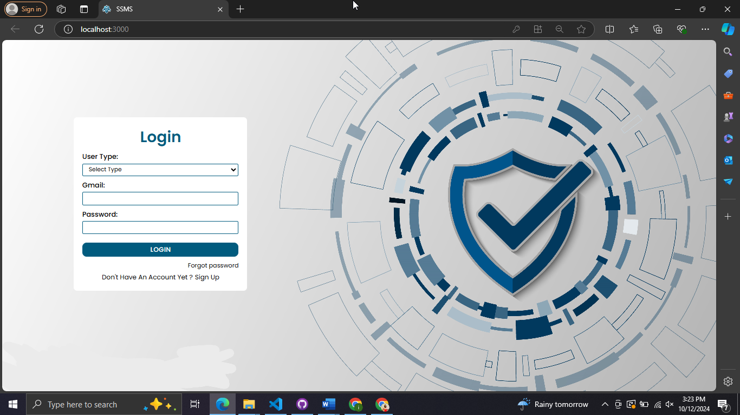

*Figure 3.12.9: User Login*

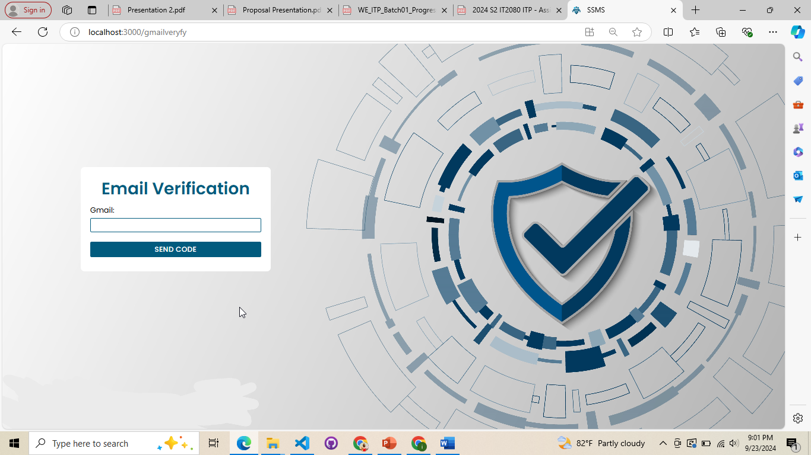

*Figure 3.12.10: User Email Verification*

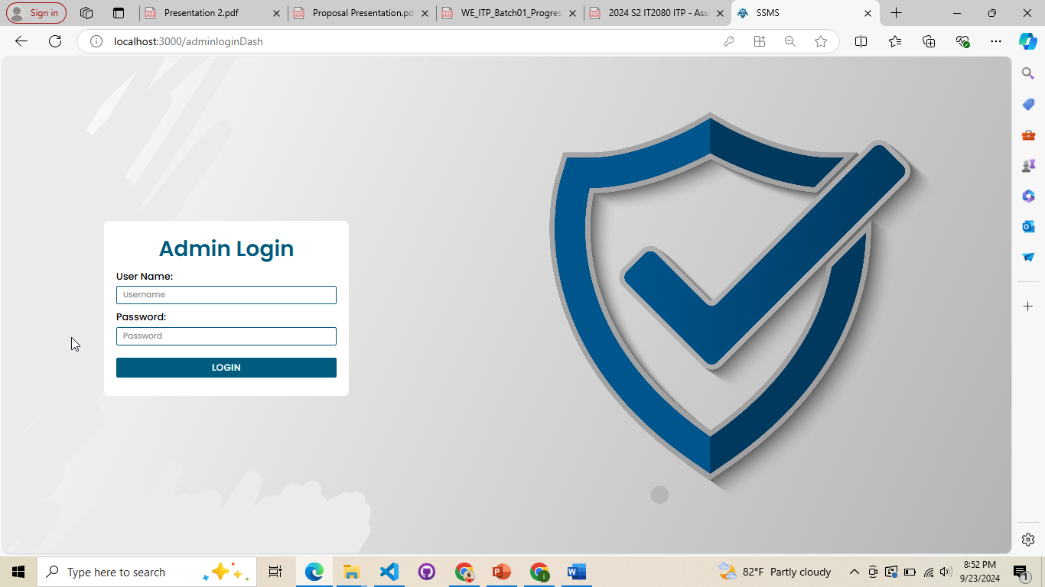

*Figure 3.12.11: Admin Login*

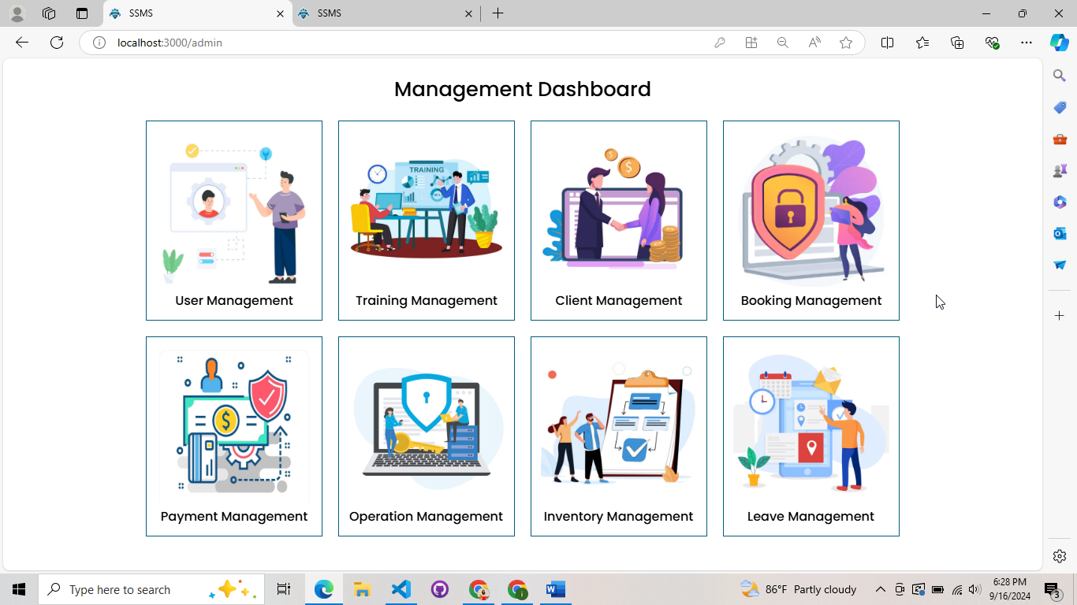

*Figure 3.12.12: Management Dashboard*

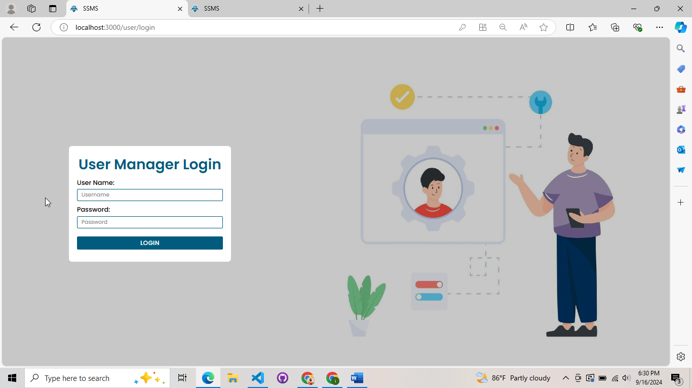

*Figure 3.12.13: User Manager Login*

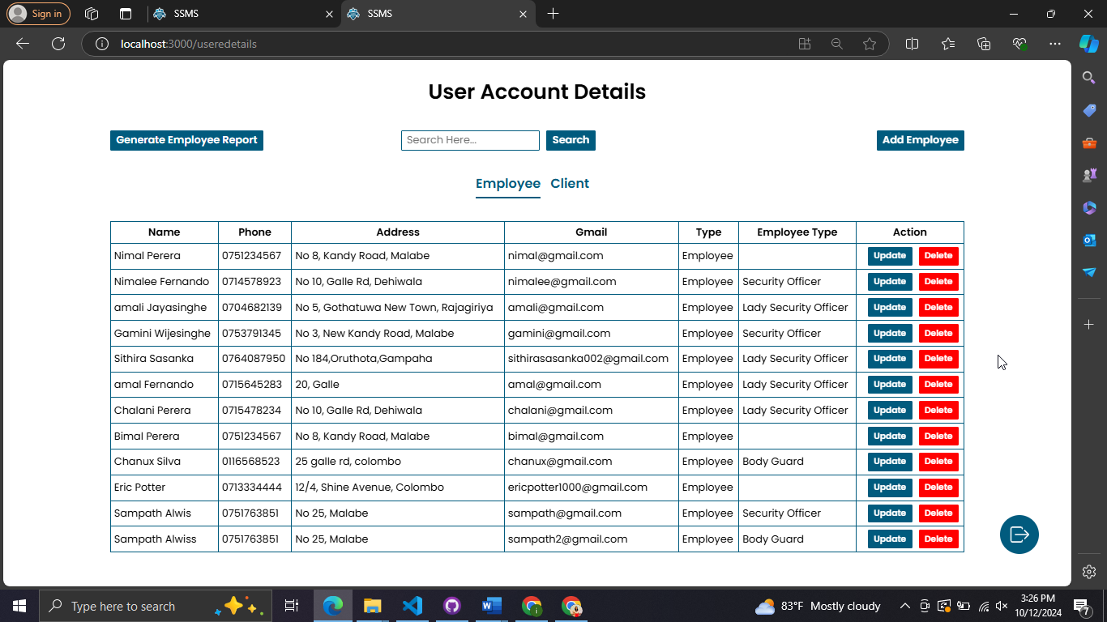

*Figure 3.12.14: Employee Account Details*

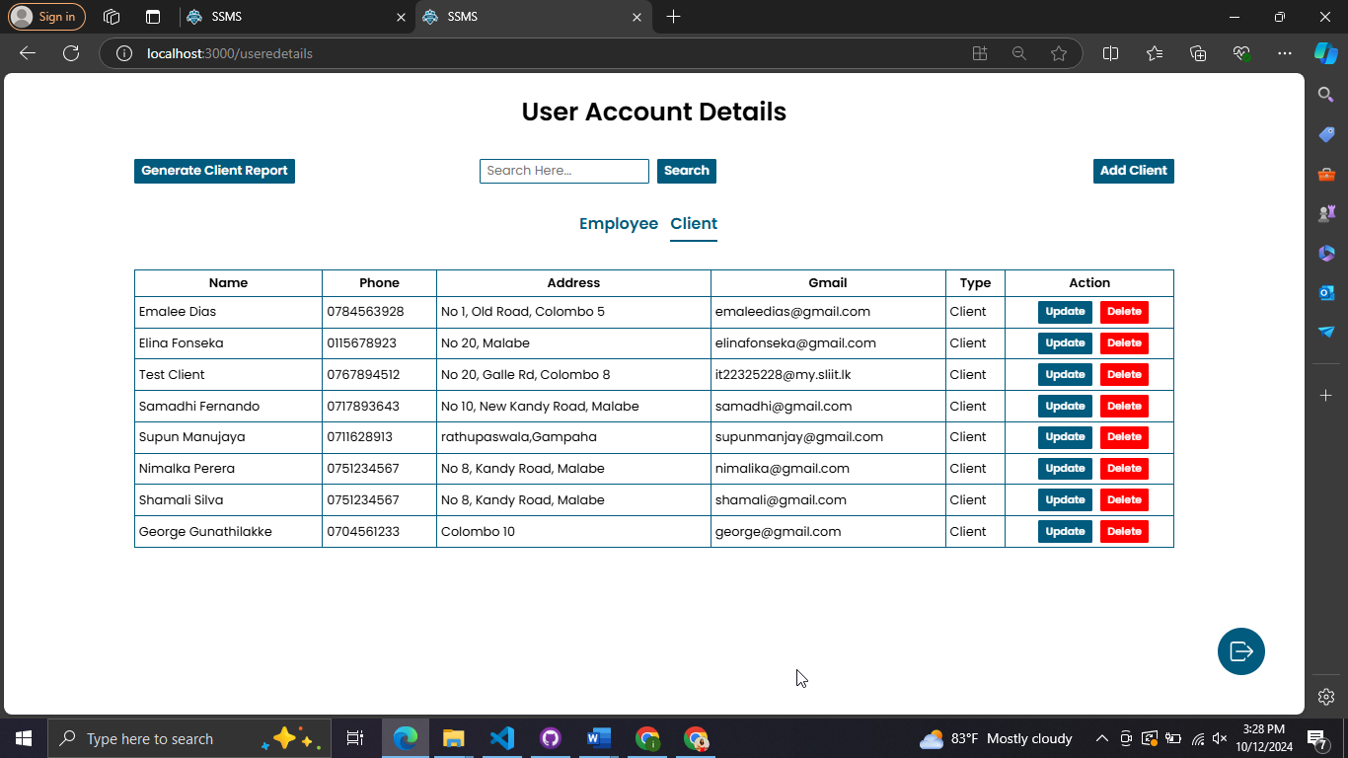

*Figure 3.12.15: Client Account Details*

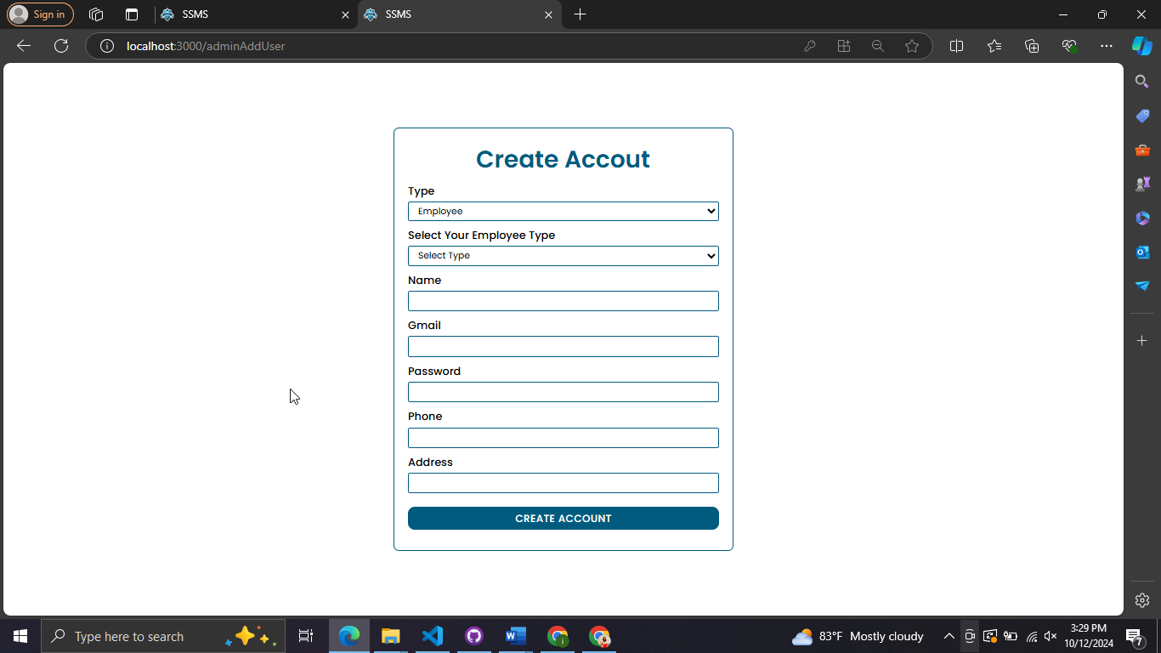

*Figure 3.12.16: Manually Add Employee*

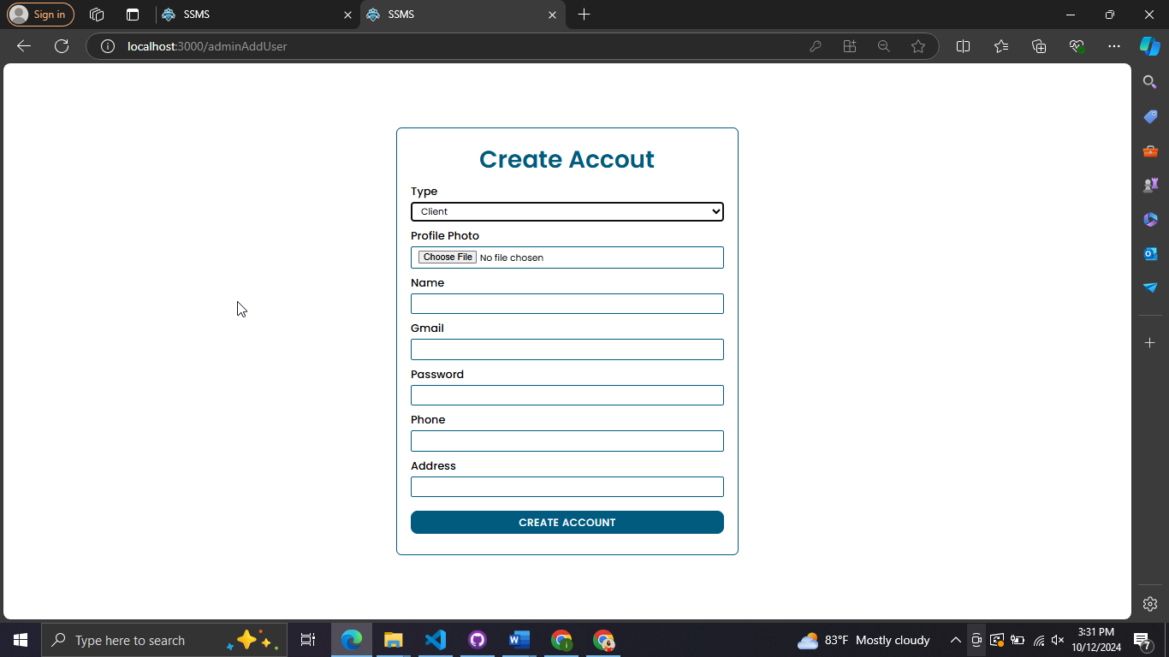

*Figure 3.12.17: Manually Add Client*

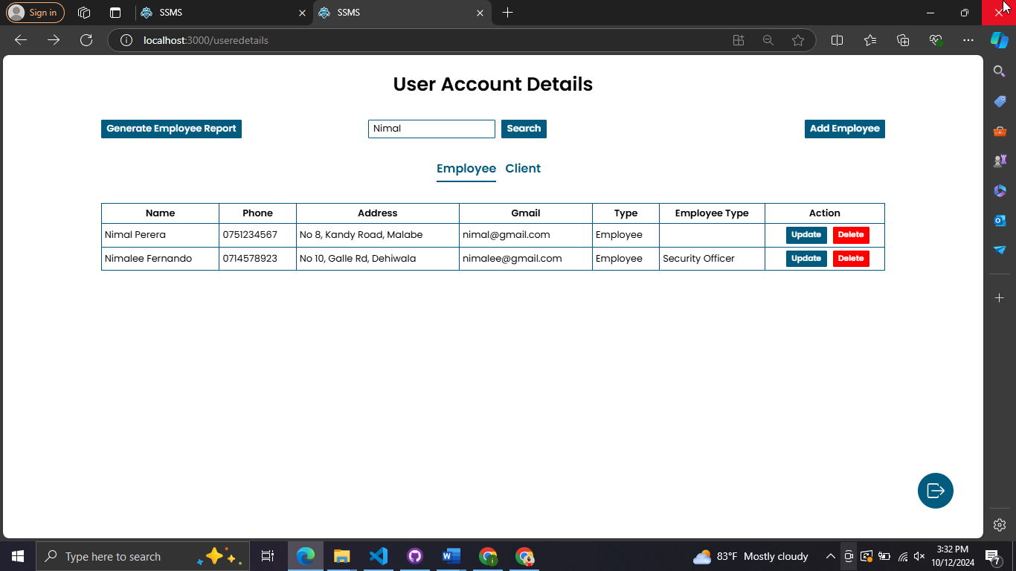

*Figure 3.12.18: Search*

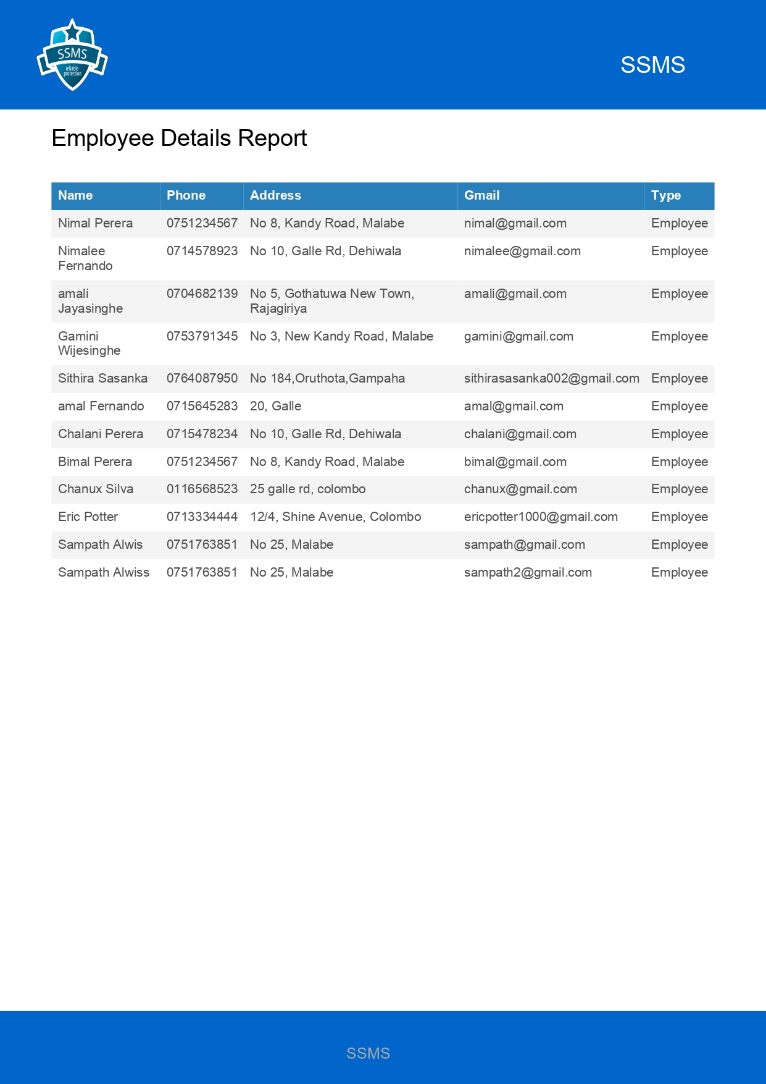*Figure 3.12.19: Generated Report*

## IT22907998 – Sadisha R. M. M – Training Management

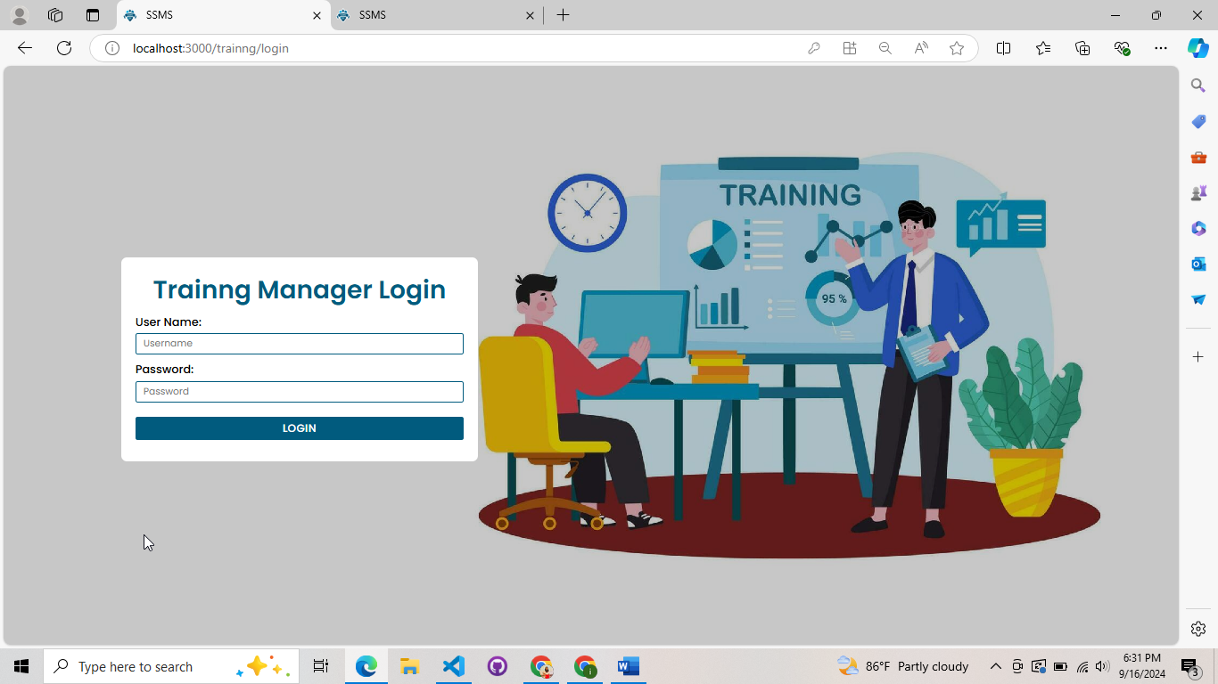

*Figure 3.12.20: Training Manager Login*

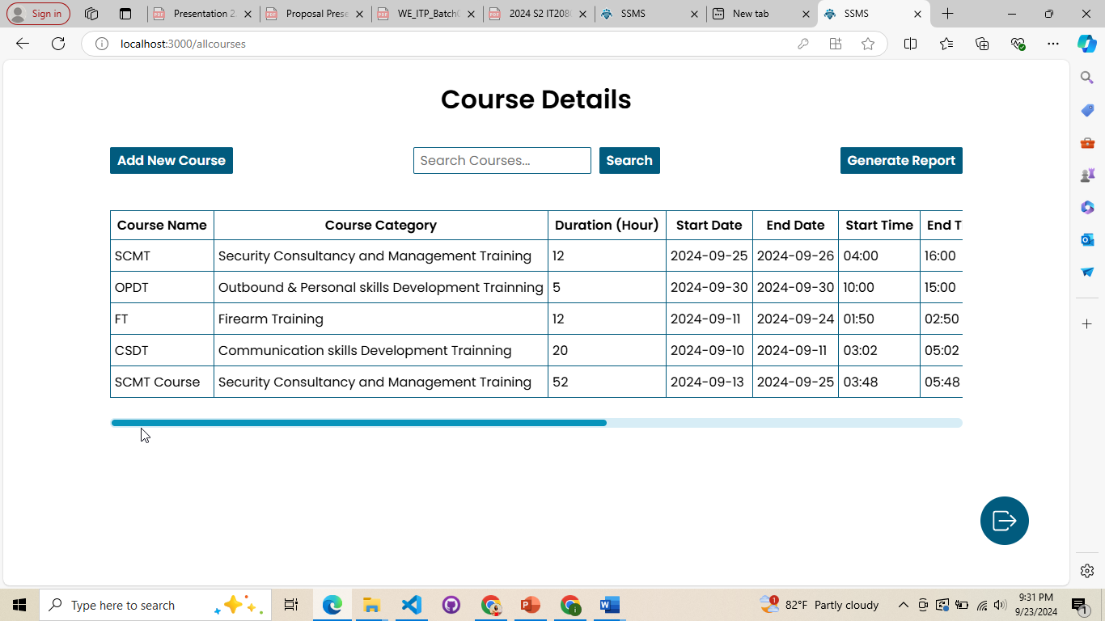

*Figure 3.12.21: Training Manager Dashboard*

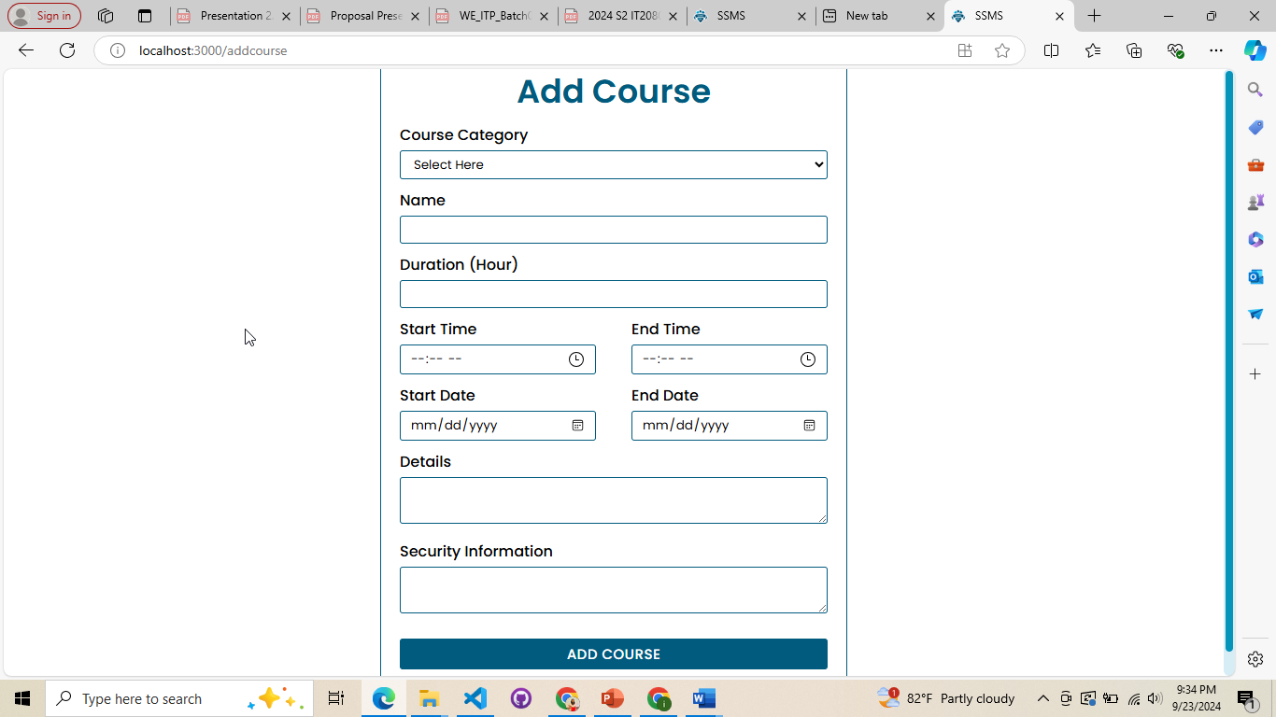

*Figure 3.12.22: Add Course*

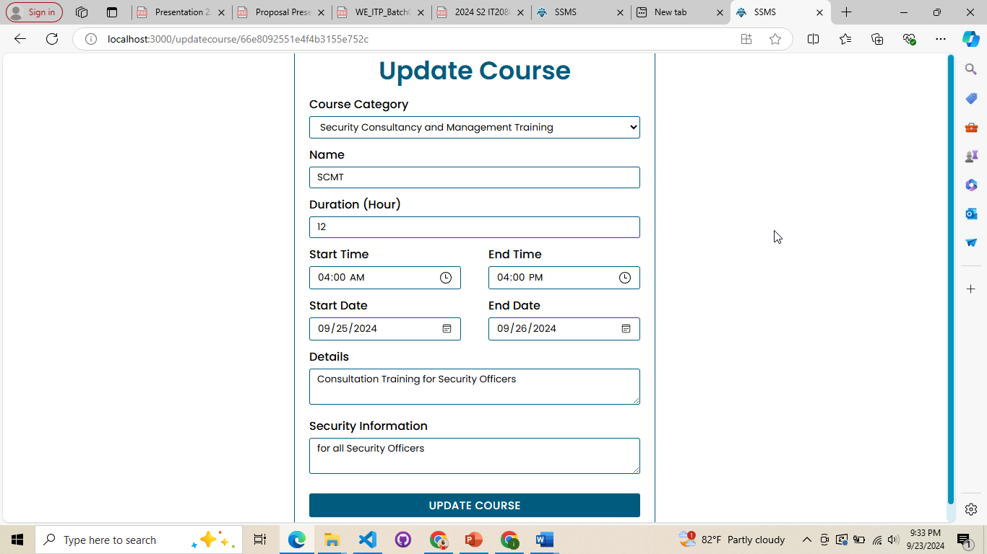

*Figure 3.12:23: Update Course*

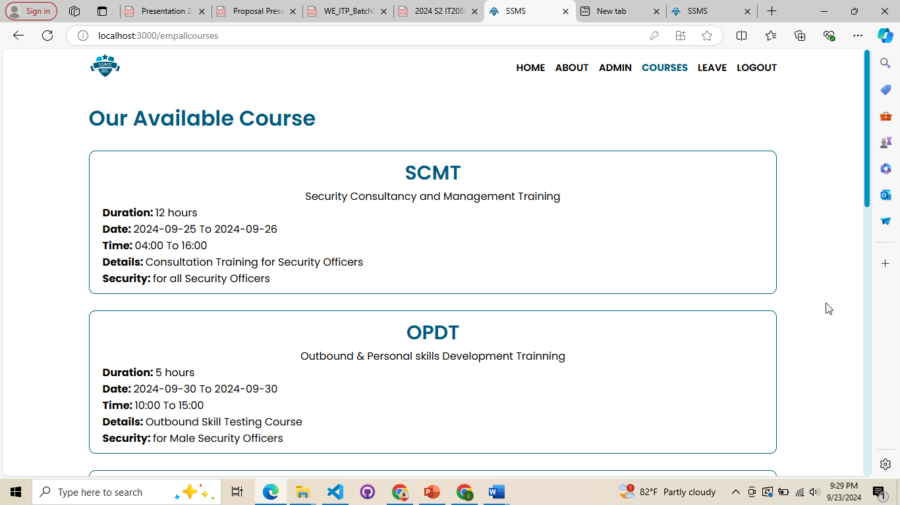

*Figure 3.12.24: View Course*

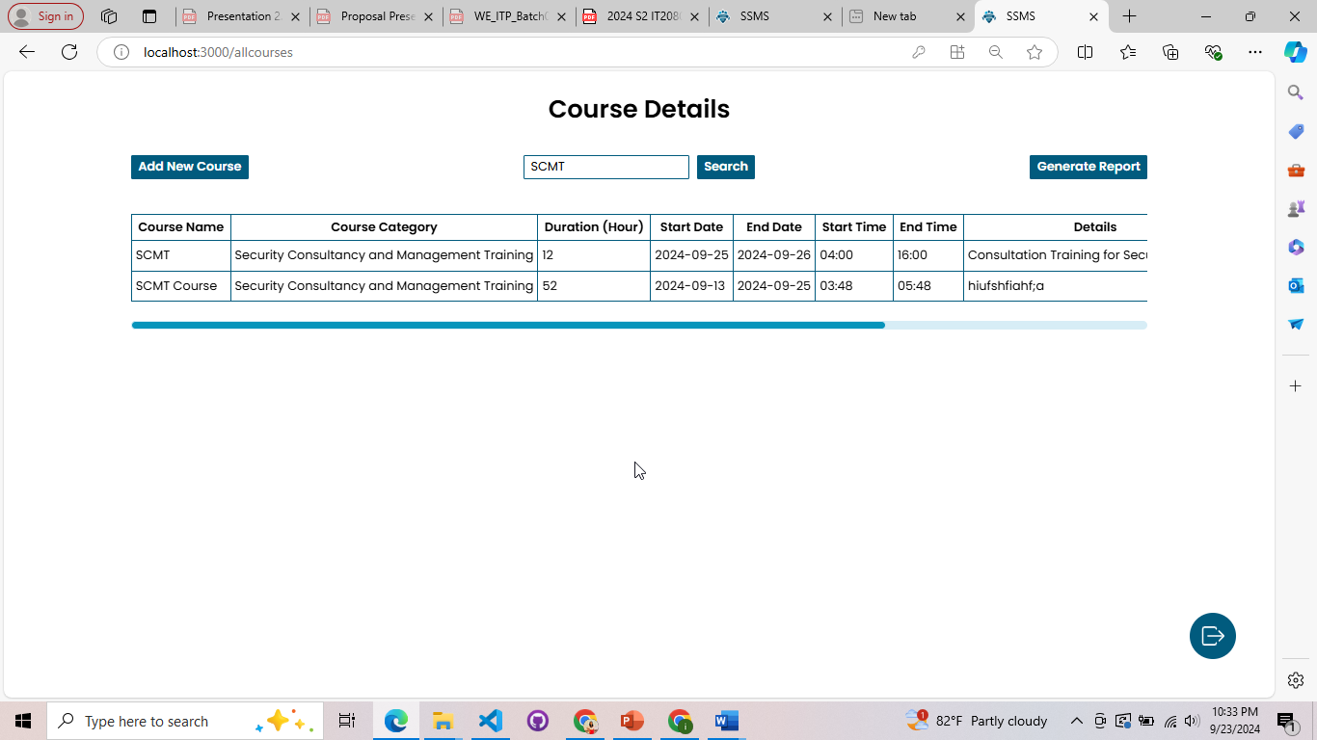

*Figure 3.12.25: Search*

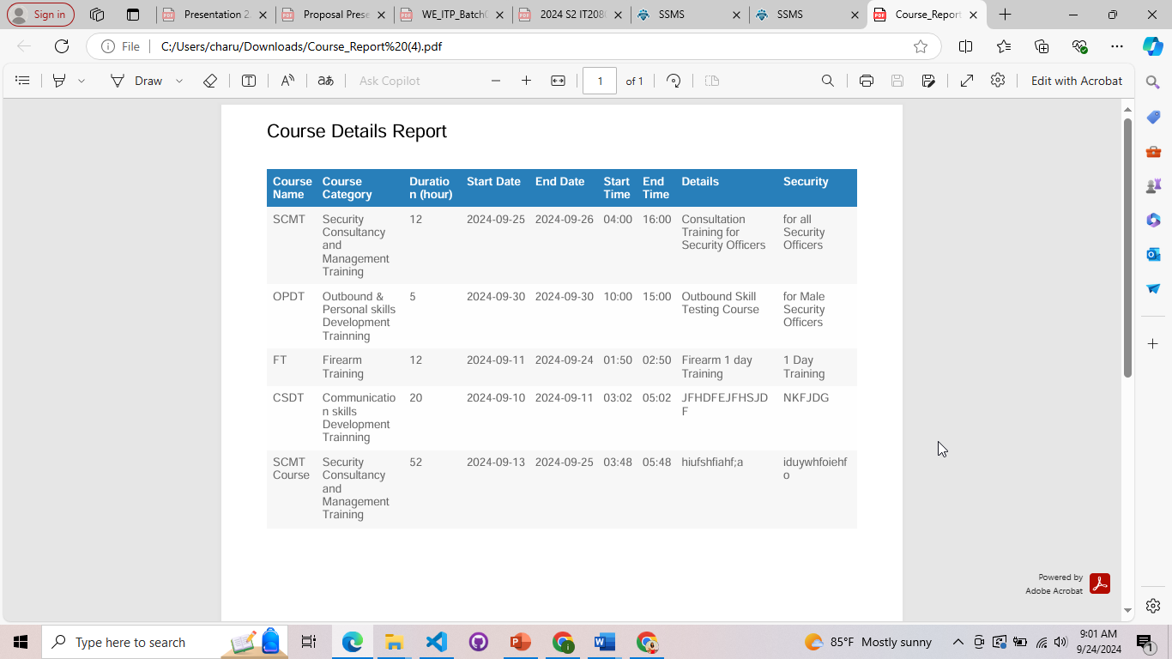

*Figure 3.12.26: Report*

## IT20145552 – Dissanayaka D. M. S. M – Client Management

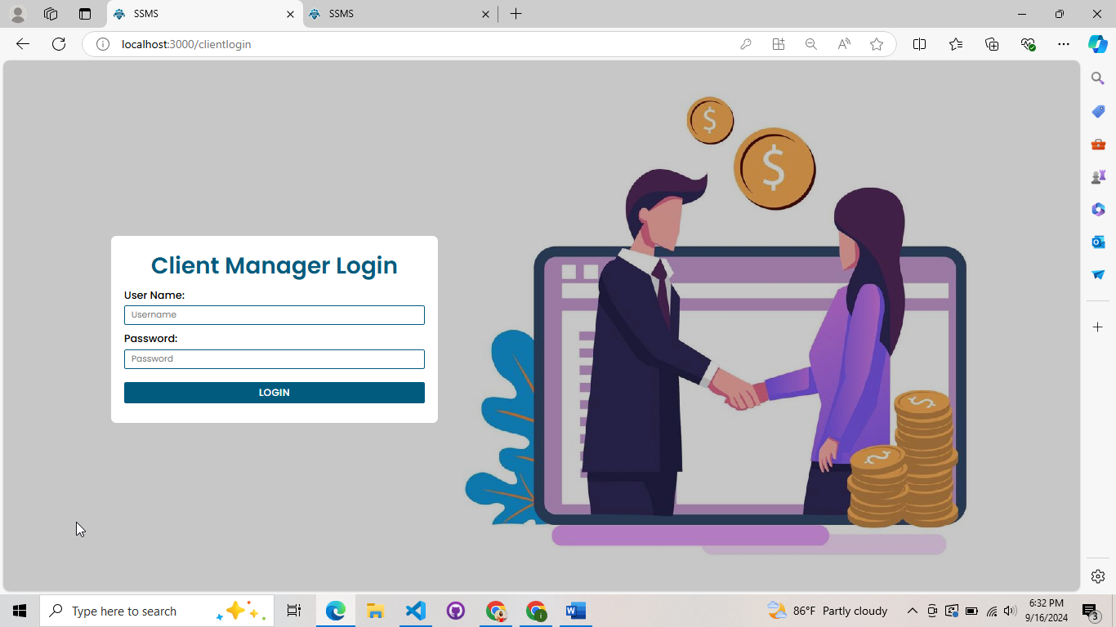

*Figure 3.12.27: Client Manager Login*

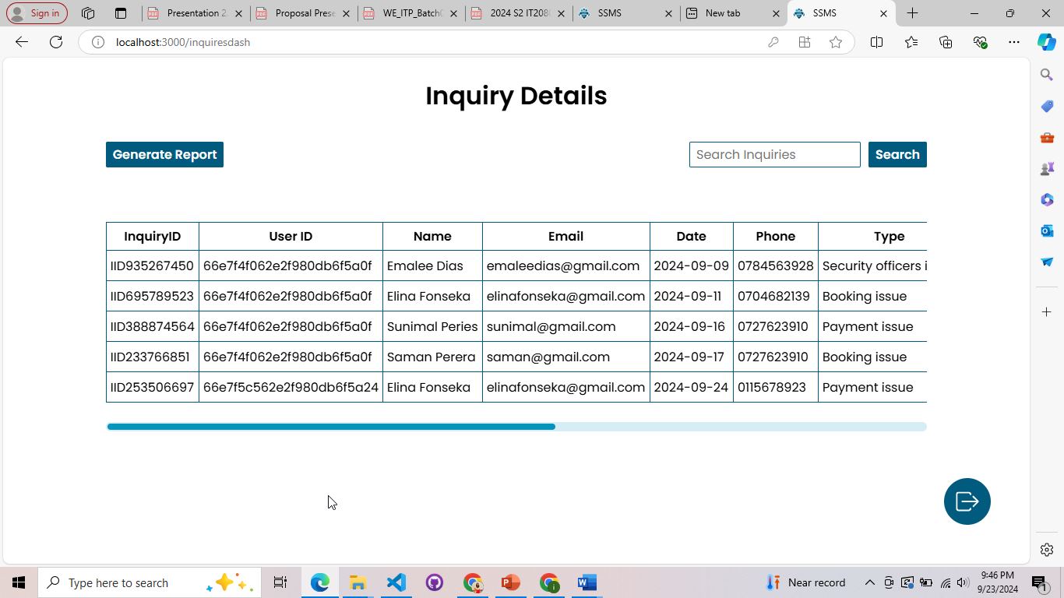

*Figure 3.12.28: Client Manager Dashboard Part I*

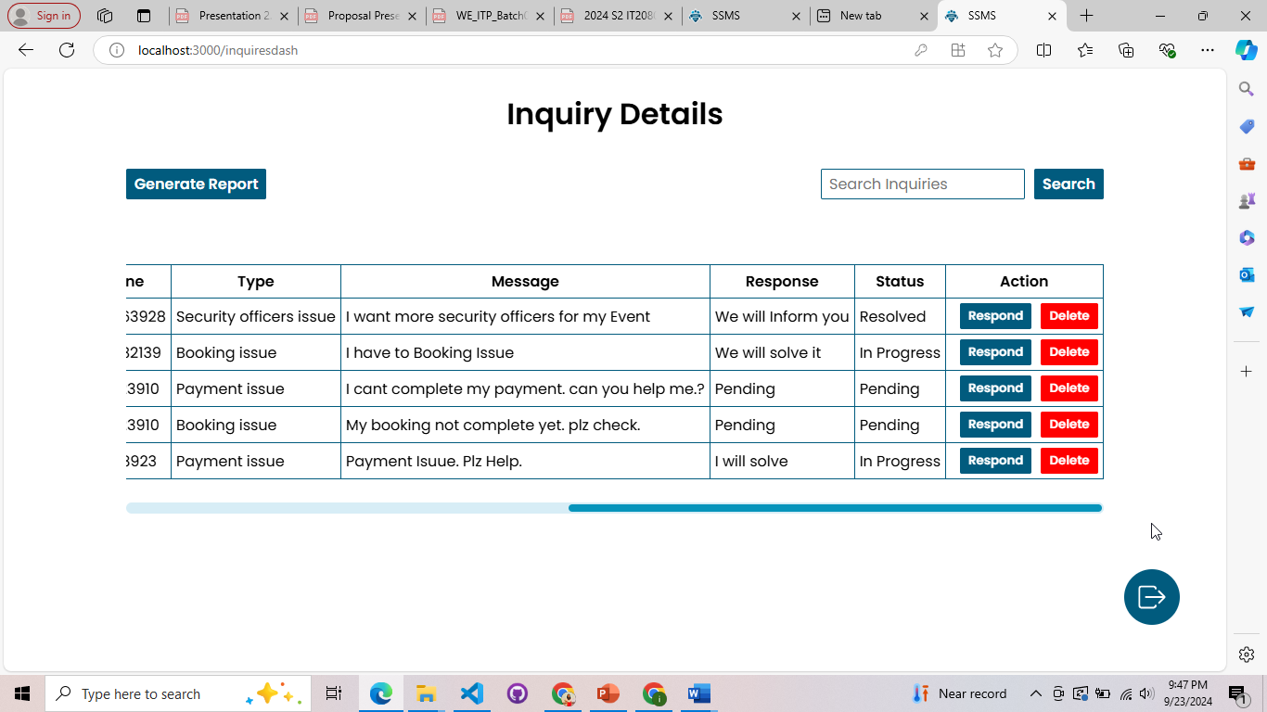

*Figure 3.12.29: Client Manager Dashboard Part II*

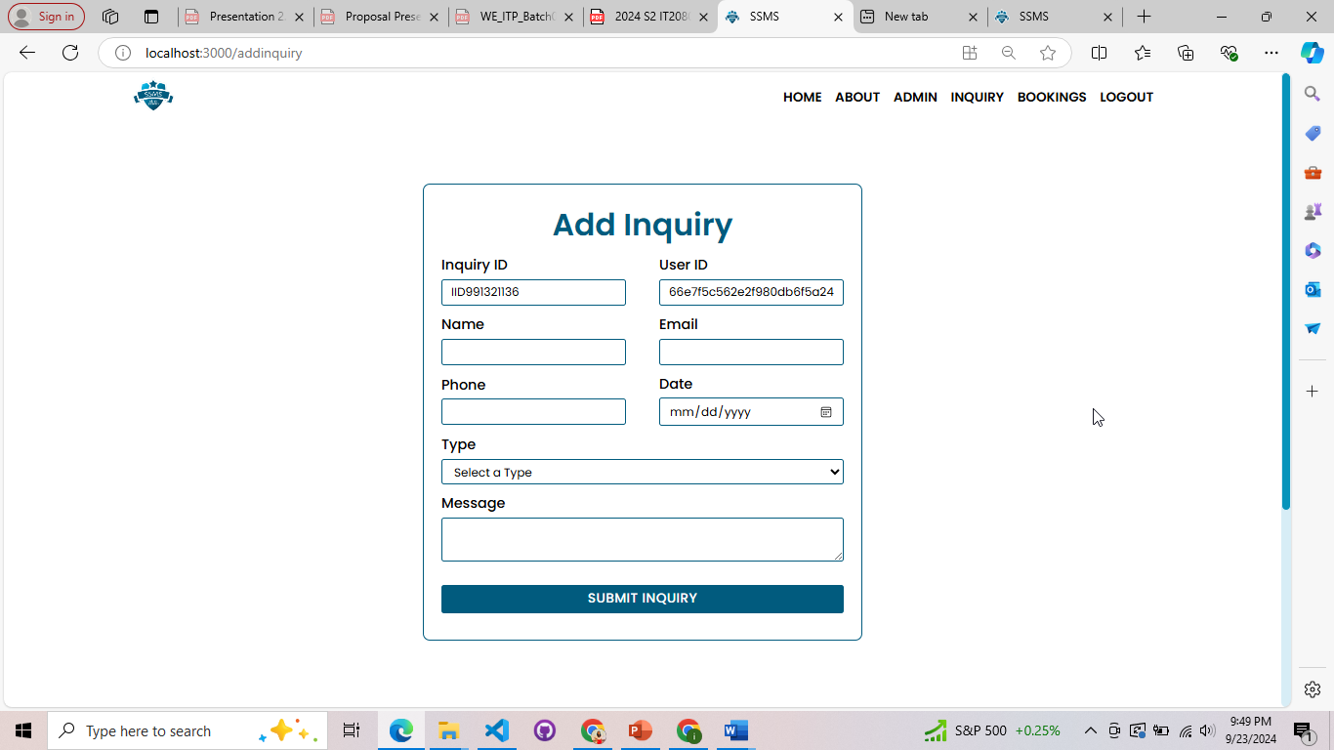

*Figure 3.12.30: Add Inquiry*

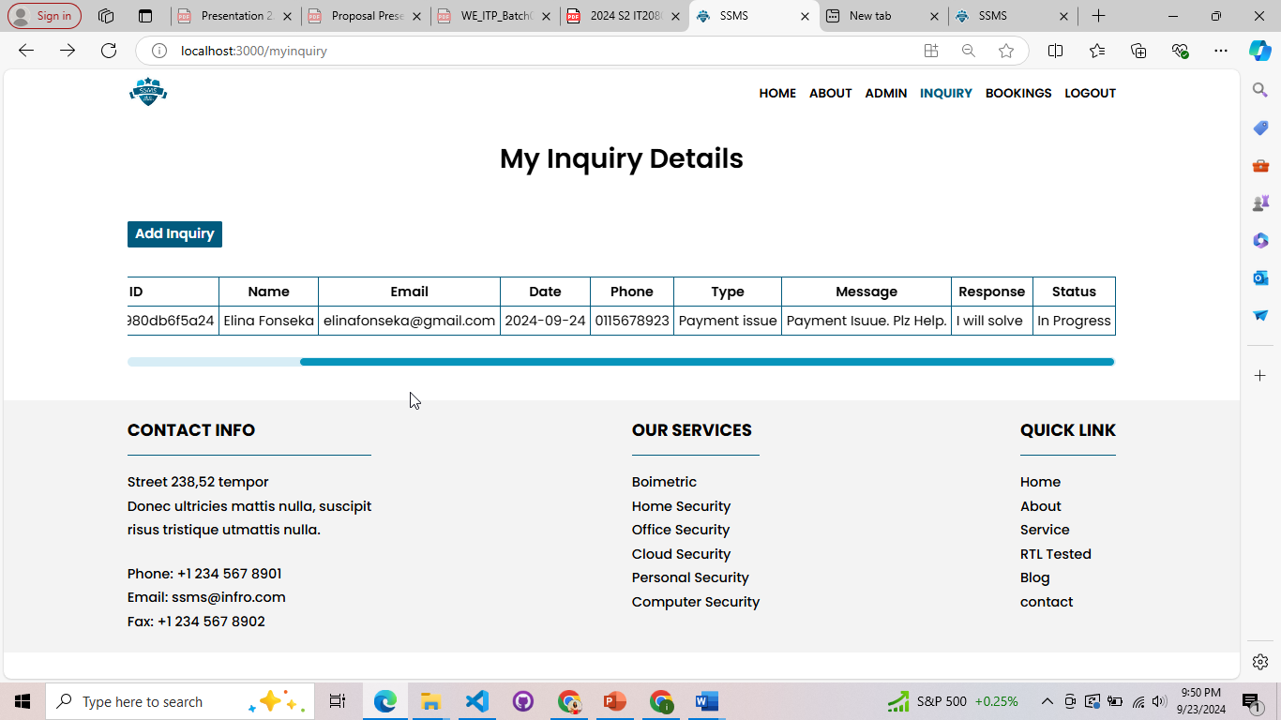

*Figure 3.12.31: View Inquiry*

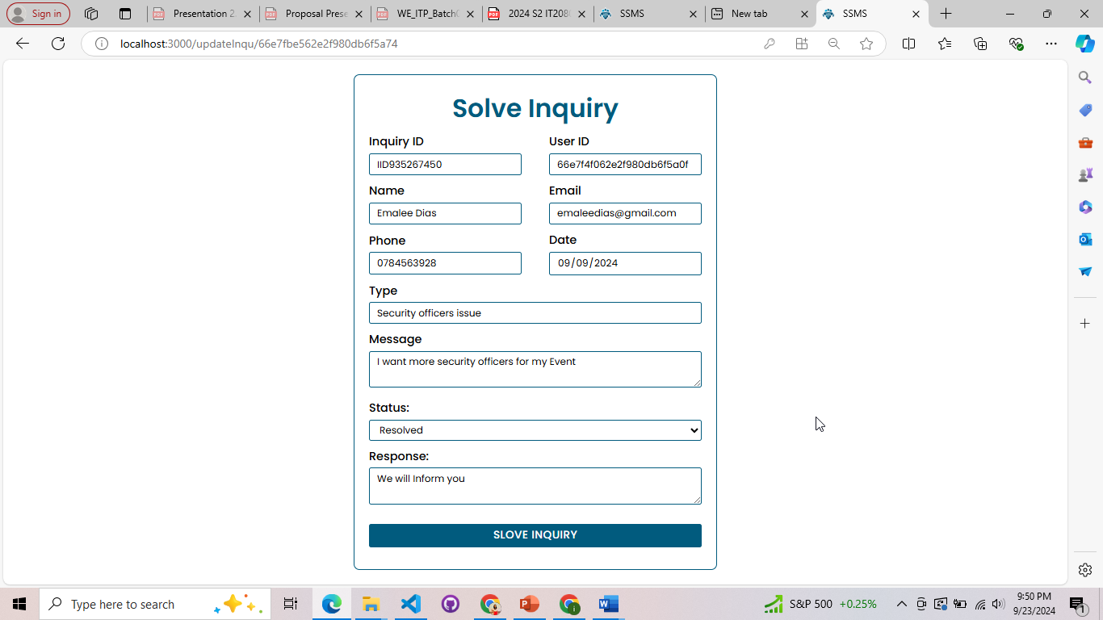

*Figure 3.12.32: Solve Inquiry*

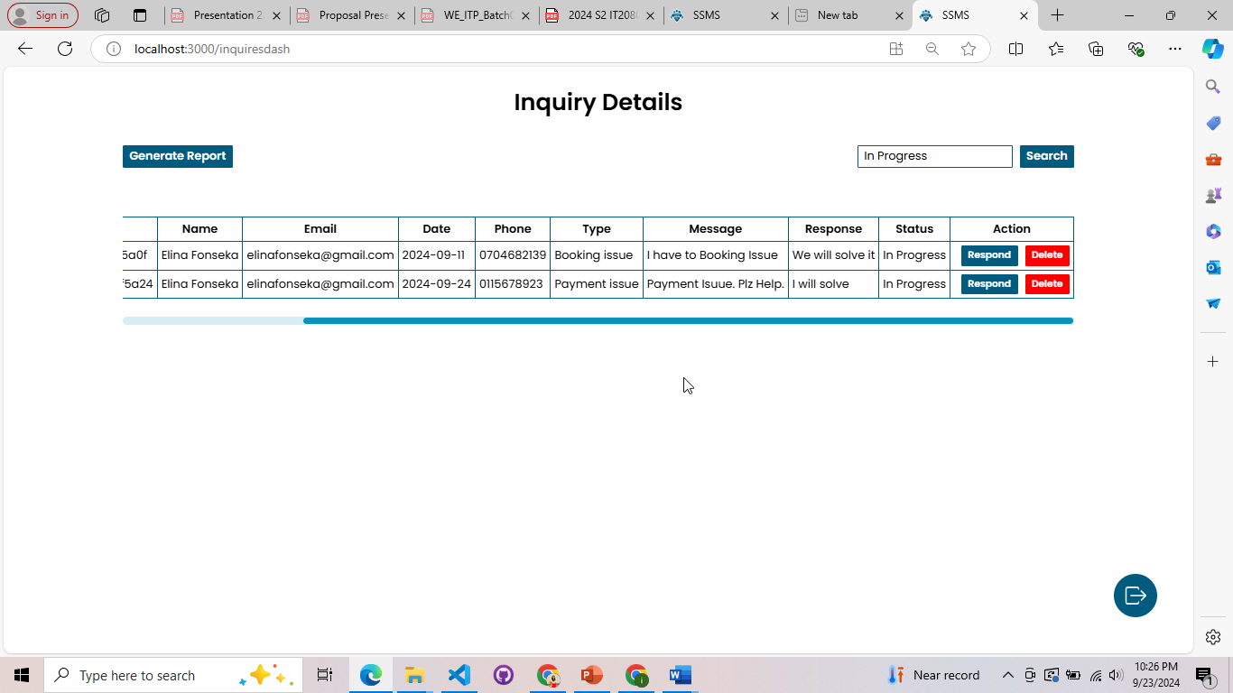

*Figure 3.12.33: Search*

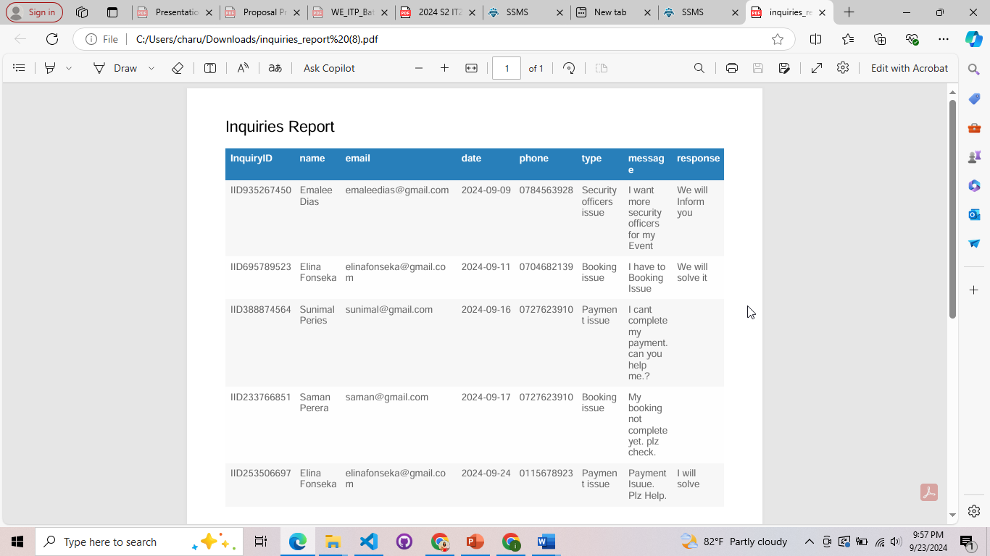

*Figure 3.12.34: Report*

## IT22257086 – Randiw E. Y – Booking Management

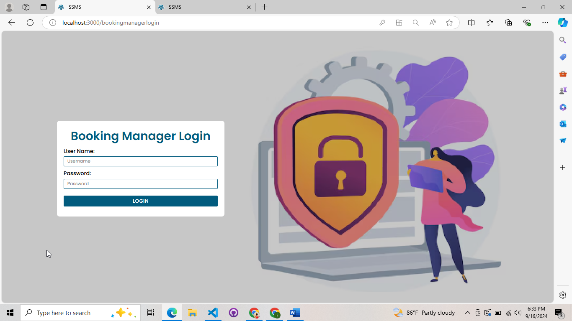

*Figure 3.12.35: Booking Manager Login*

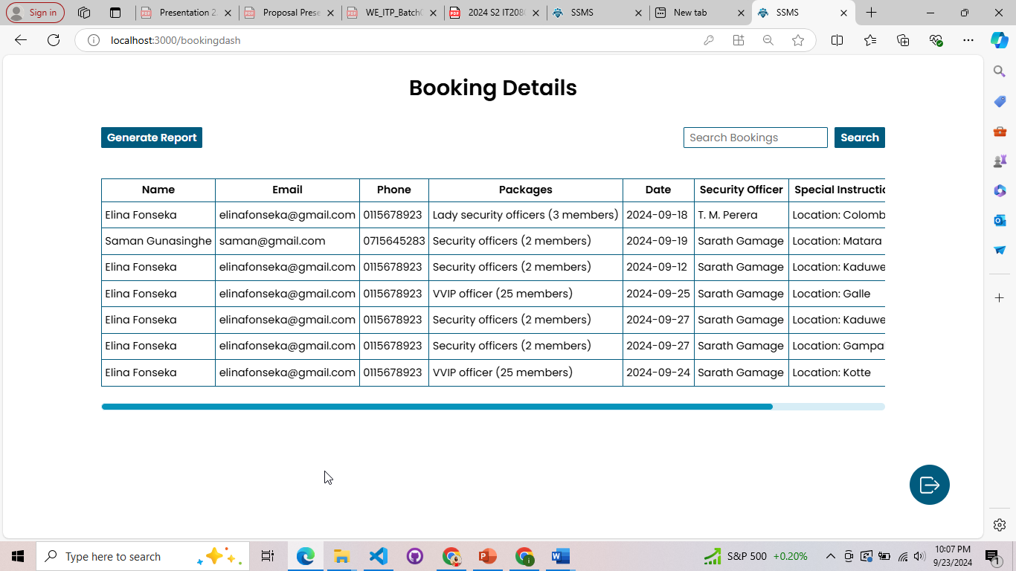

*Figure 3.12.36: Booking Manager Dashboard I*

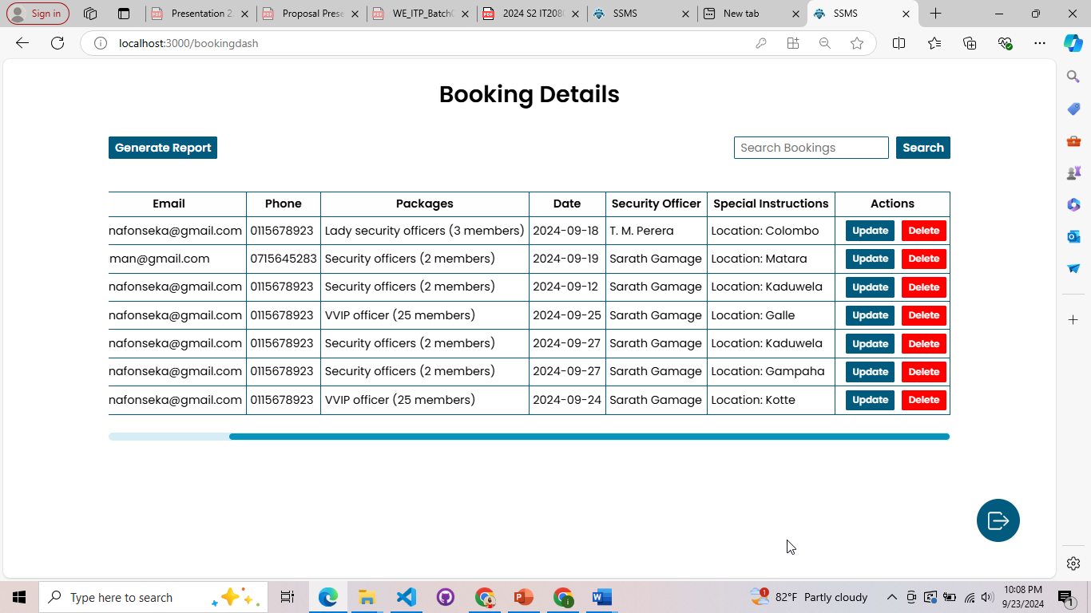

*Figure 3.12.37: Booking Manager Dashboard II*

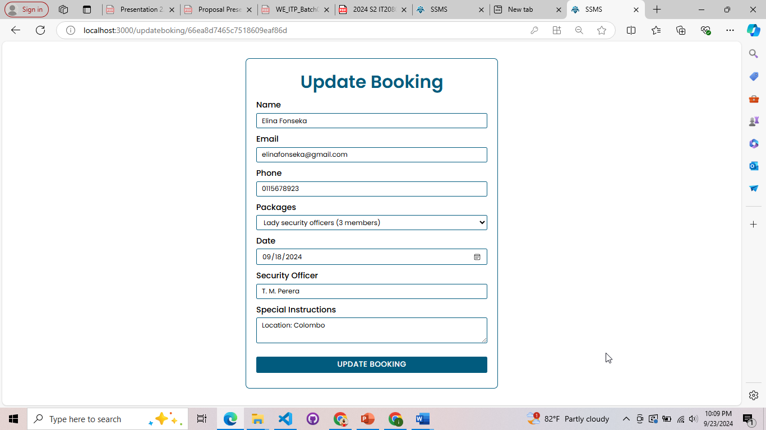

*Figure 3.12.38: Update Booking*

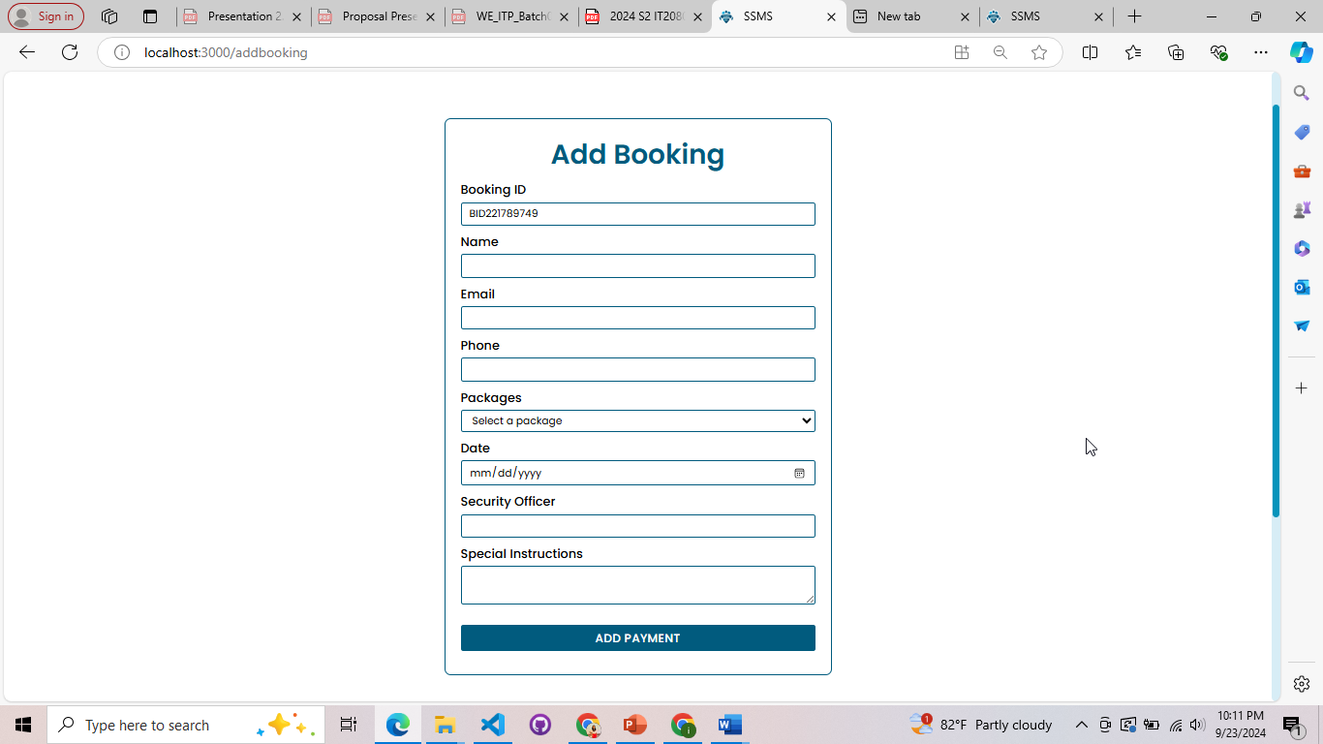

*Figure 3.12.39: Add Booking*

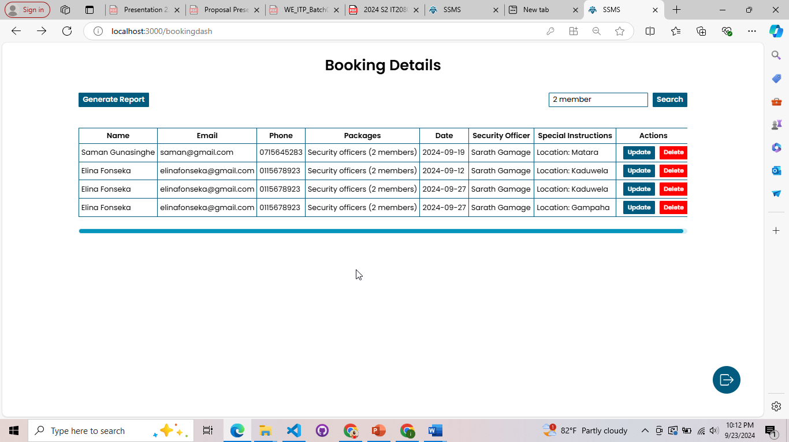

*Figure 3.12.40: Search*

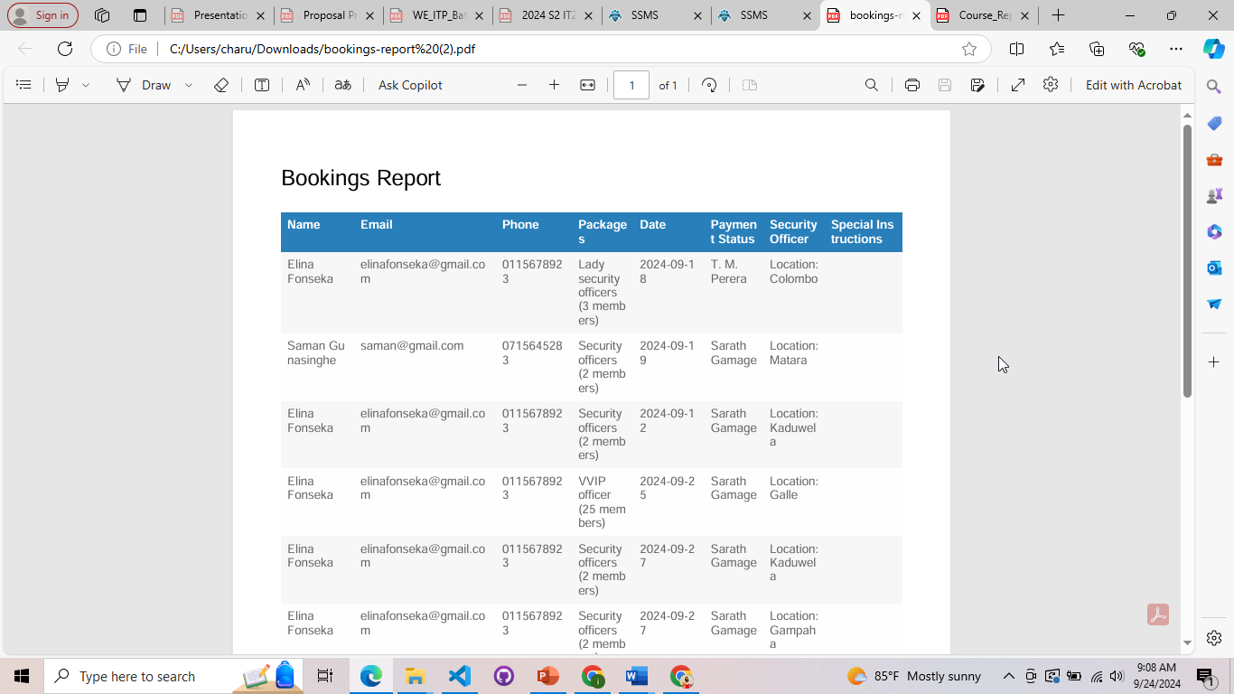

*Figure 3.12.41: Report*

## IT22293480 – Jayodhya J. D. H – Payment Management

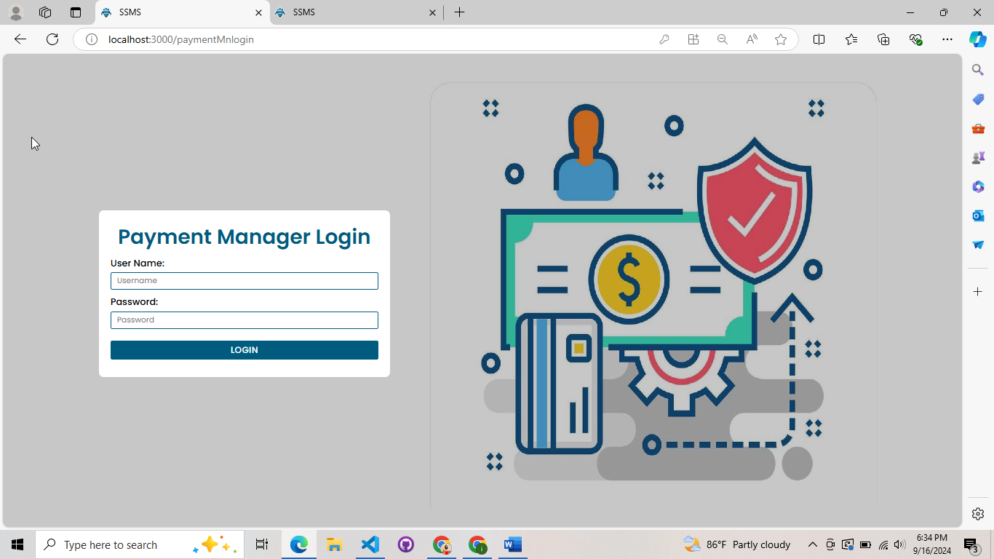

*Figure 3.12.42: Payment Manager Login*

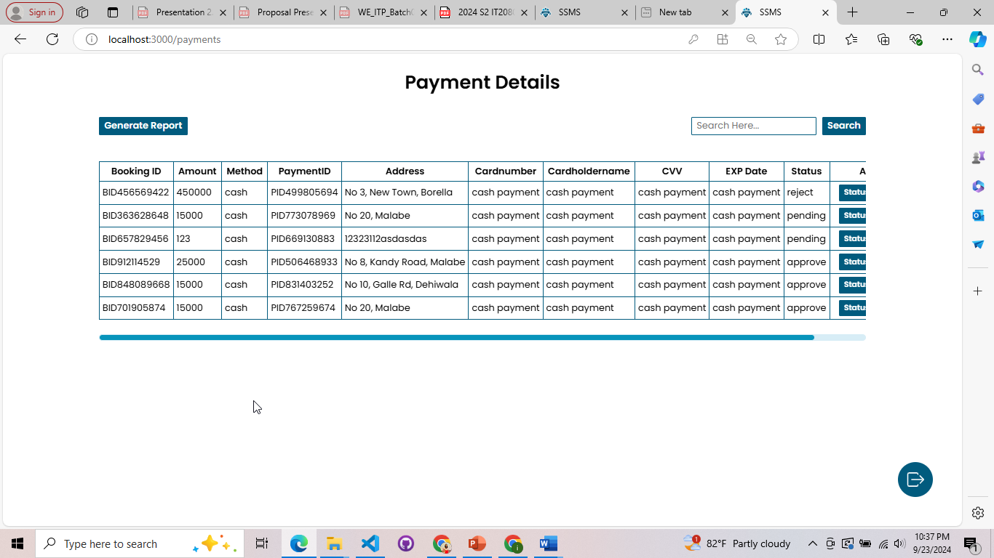

*Figure 3.12.43: Payment Manager Dashboard*

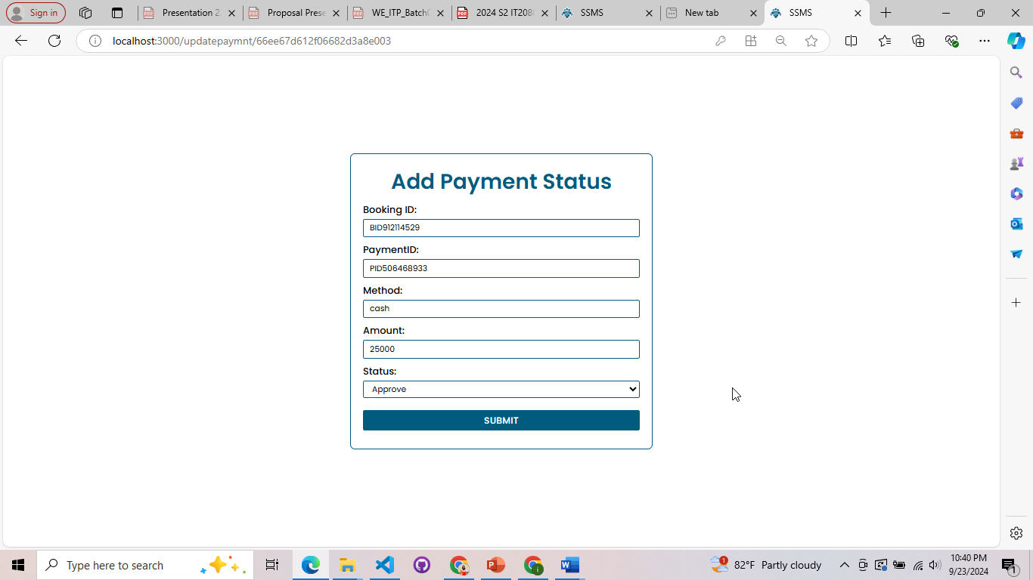

*Figure 3.12.44: Update Payment*

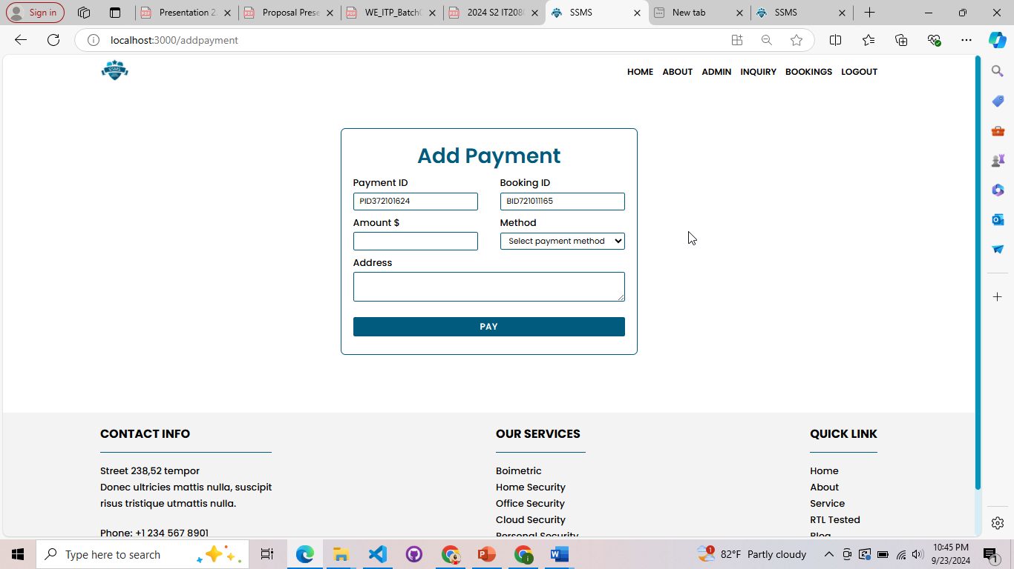

*Figure 3.12.45: Add Payment*

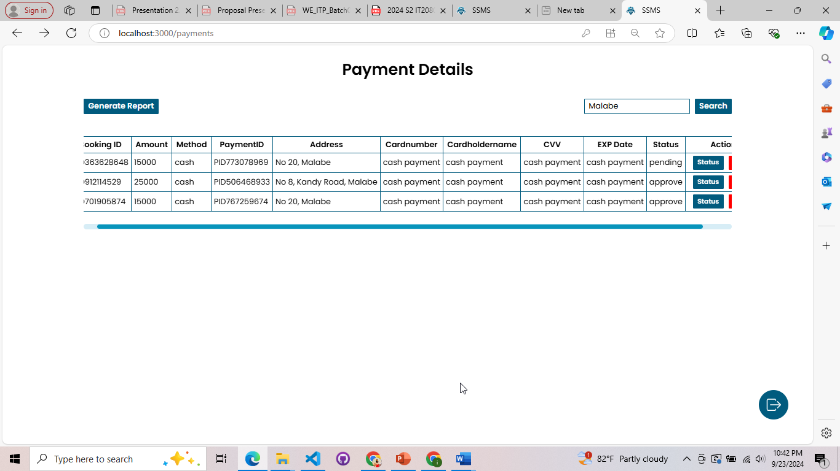

*Figure 3.12.46: Search*

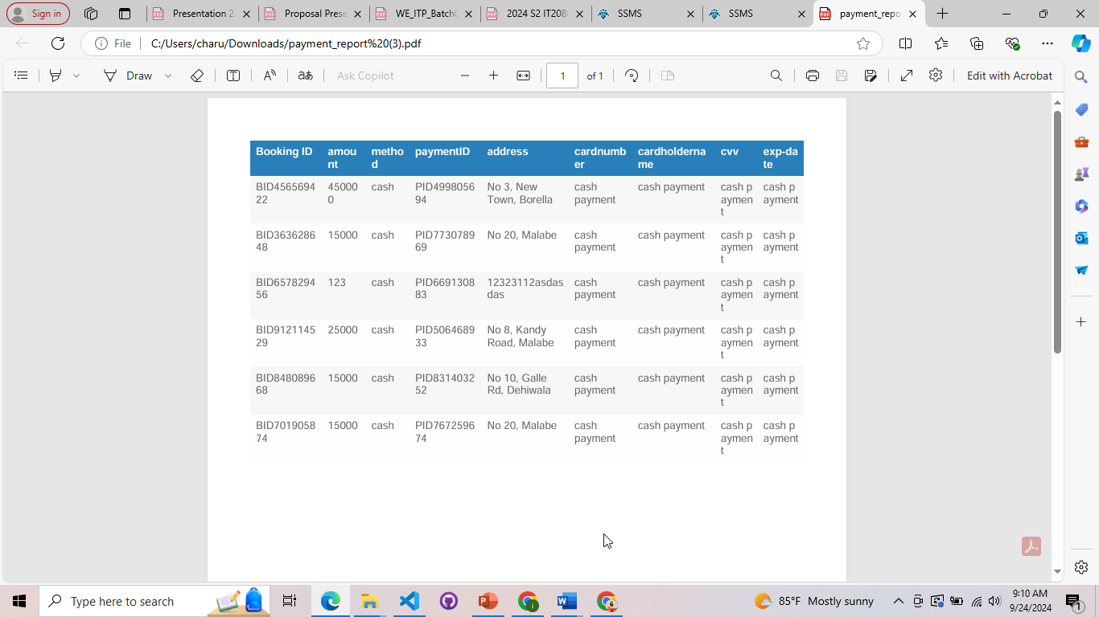

*Figure 3.12.47: Report*

## IT22127082 – Medawatte W. W. M. T. N. B – Operation Management

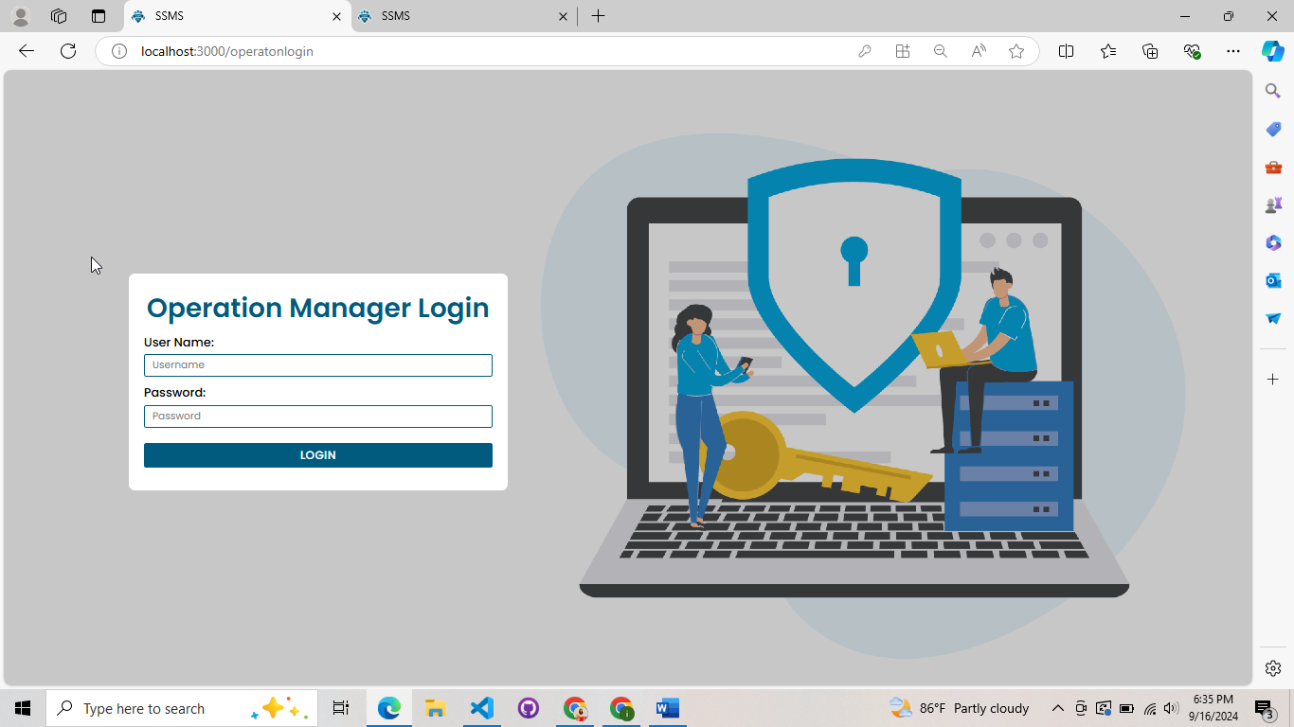

*Figure 3.12.48: Operation Manager Login*

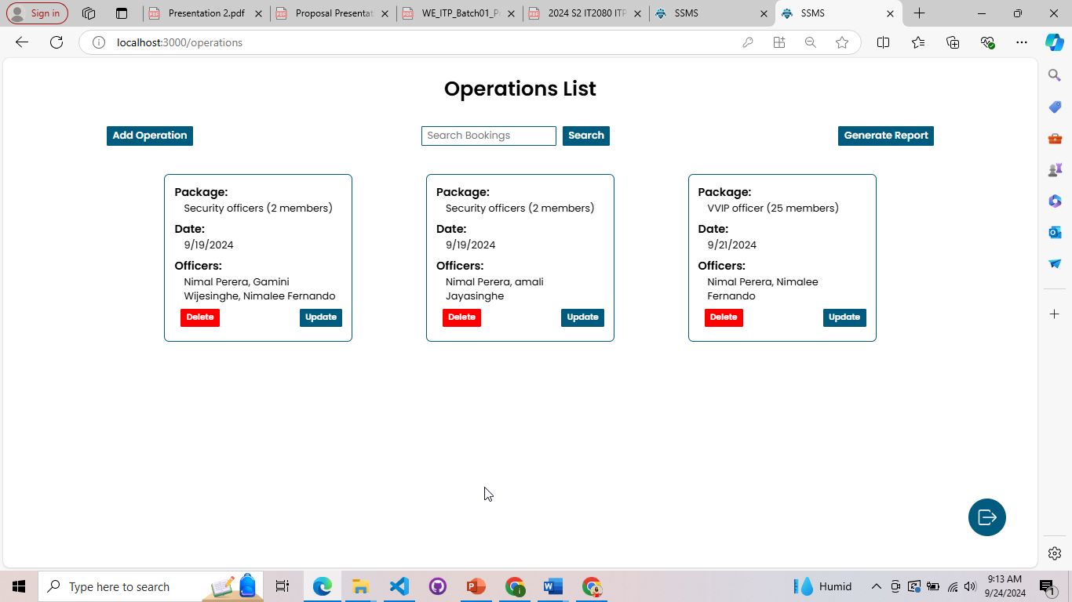

*Figure 3.12.49: Operation Manager Dashboard*

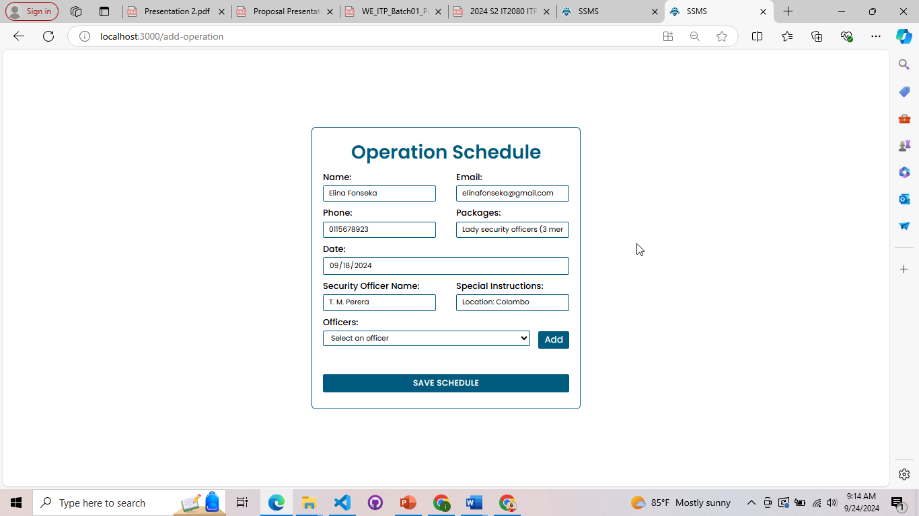

*Figure 3.12.50: Add Operation*

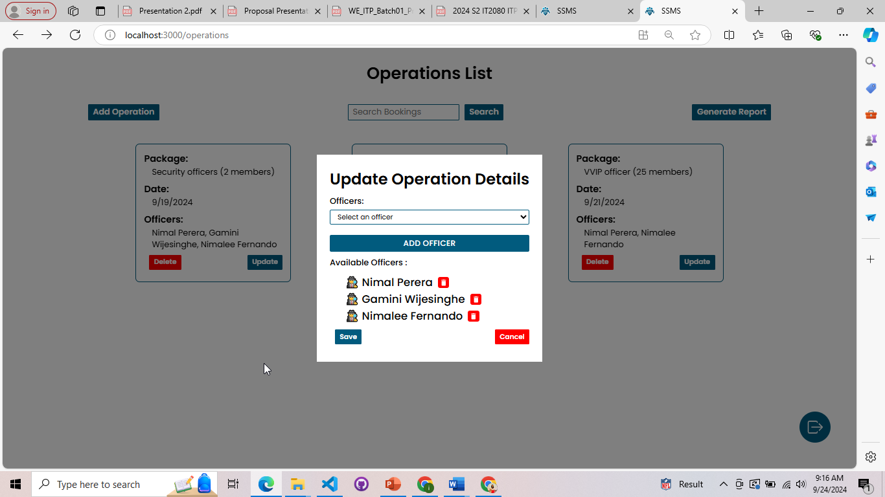

*Figure 3.12.51: Update Operation*

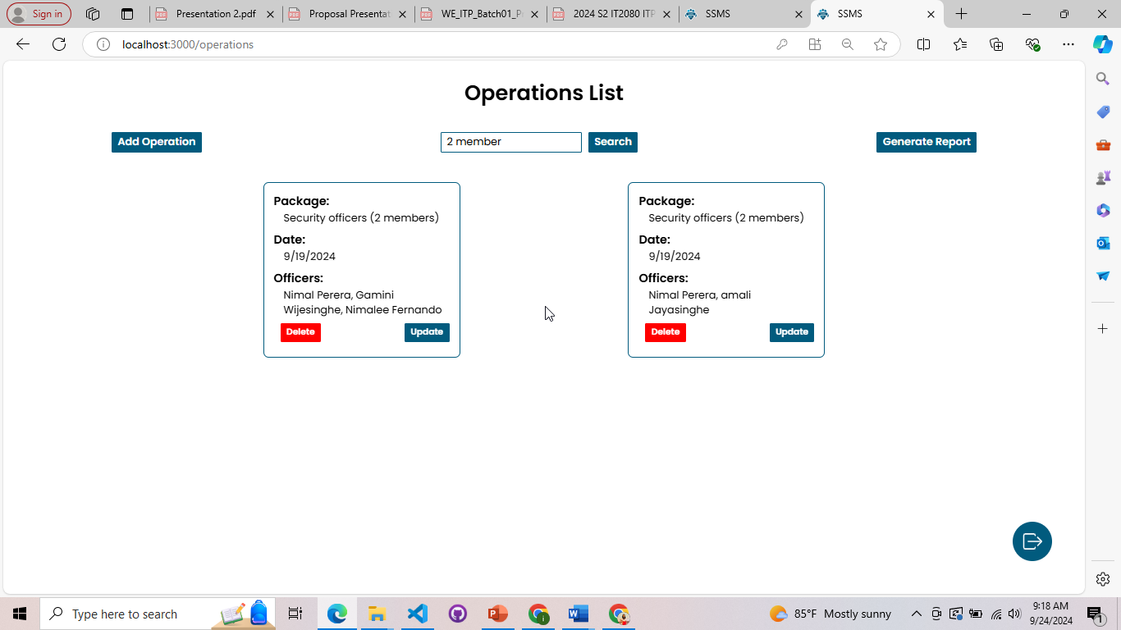

*Figure 3.12.52: Search*

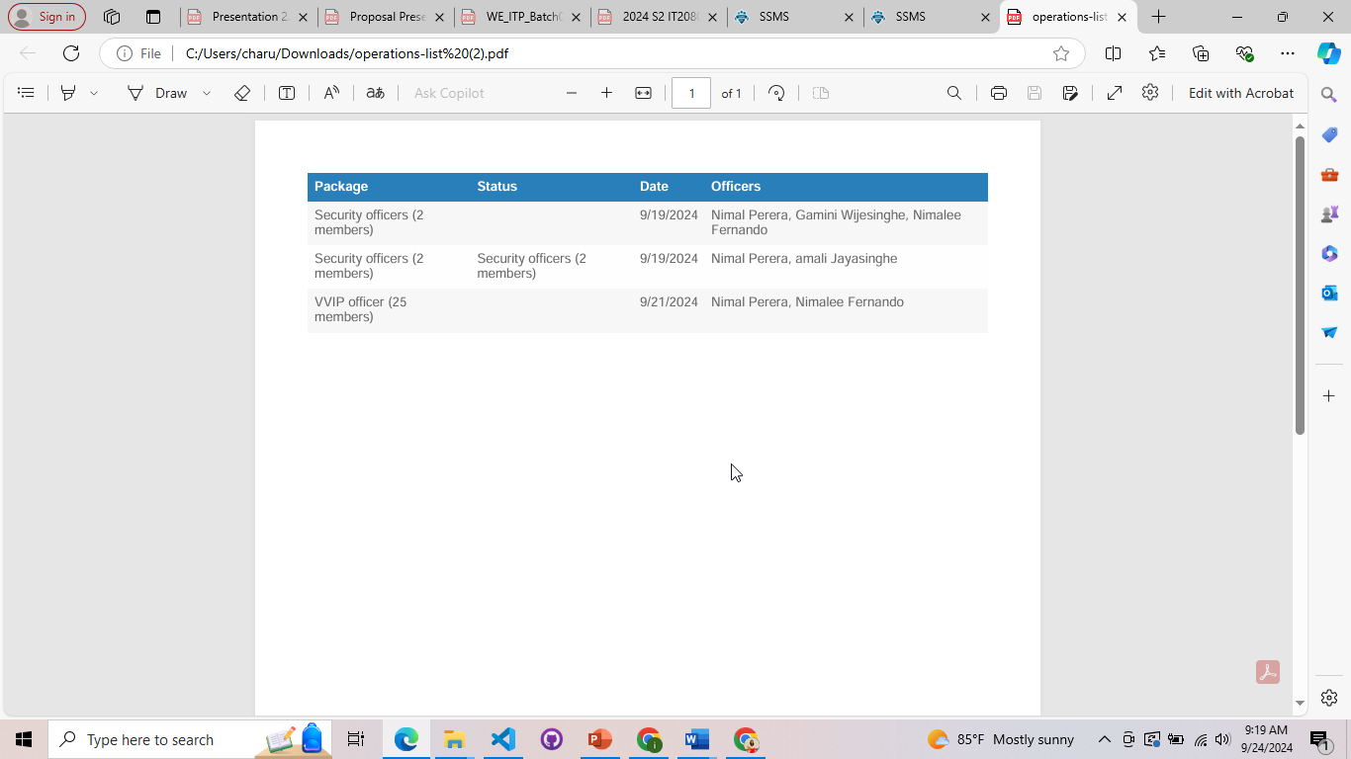

*Figure 3.12.53: Report*

## IT22132628 – Kusumsiri P. A. S. S – Inventory Management

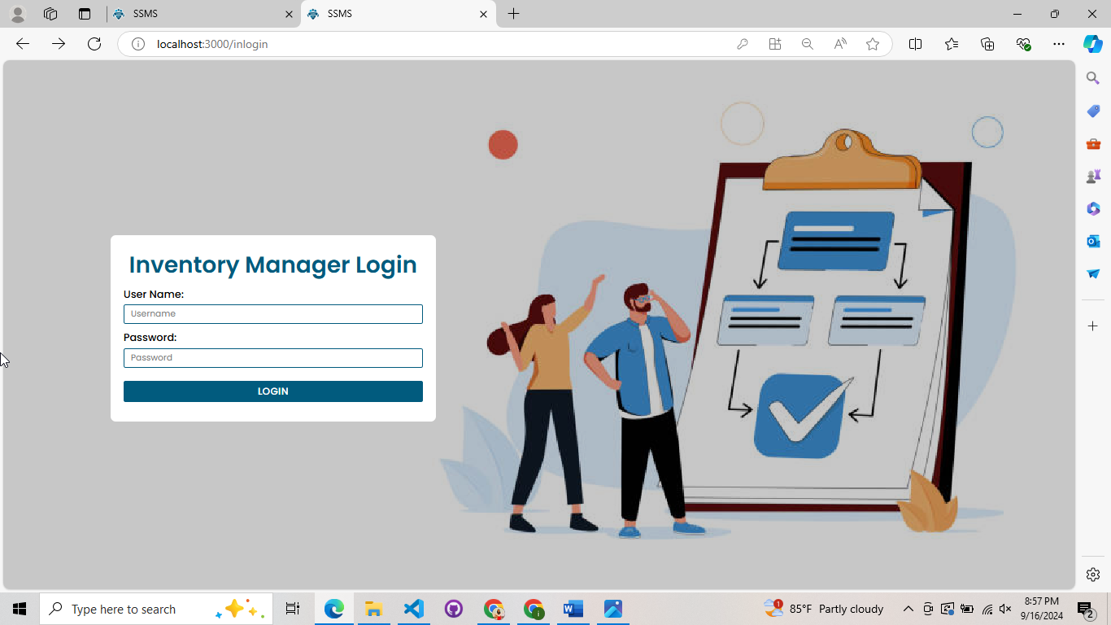

*Figure 3.12.54: Inventory Manager Login*

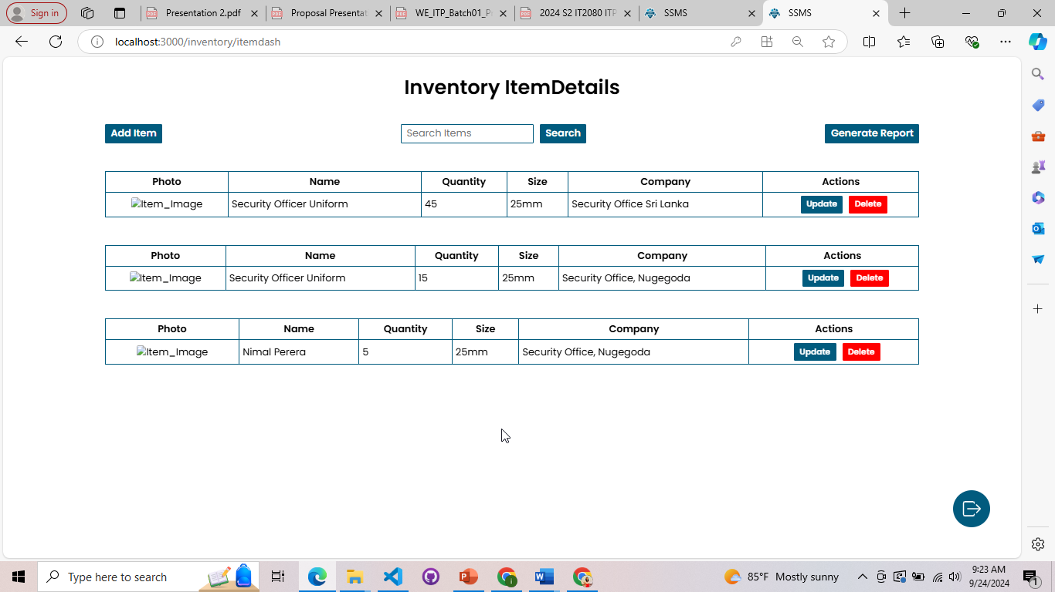

*Figure 3.12.55: Inventory Manager Dashboard*

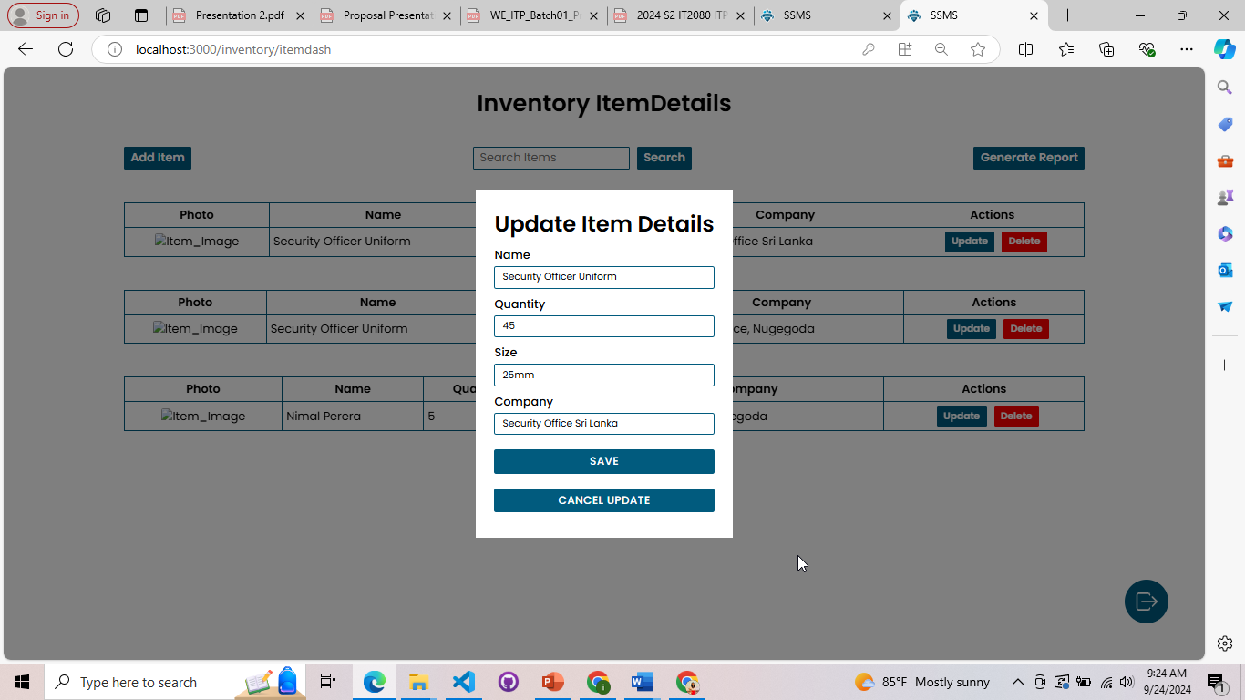

*Figure 3.12.56: Update Item*

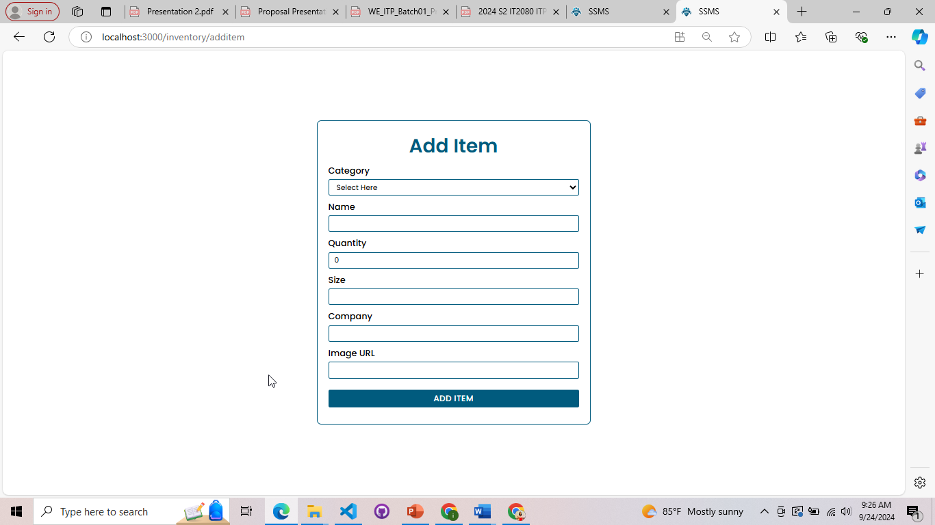

*Figure 3.12.57: Add Item*

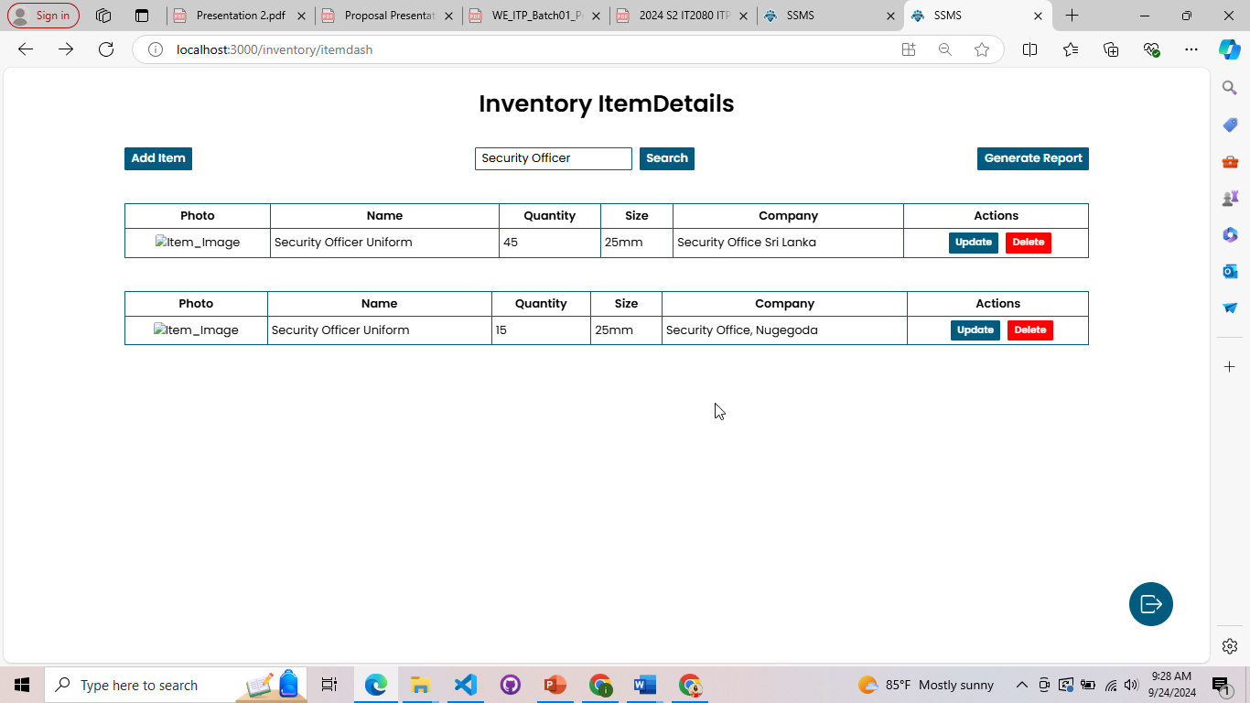

*Figure 3.12.58: Search*

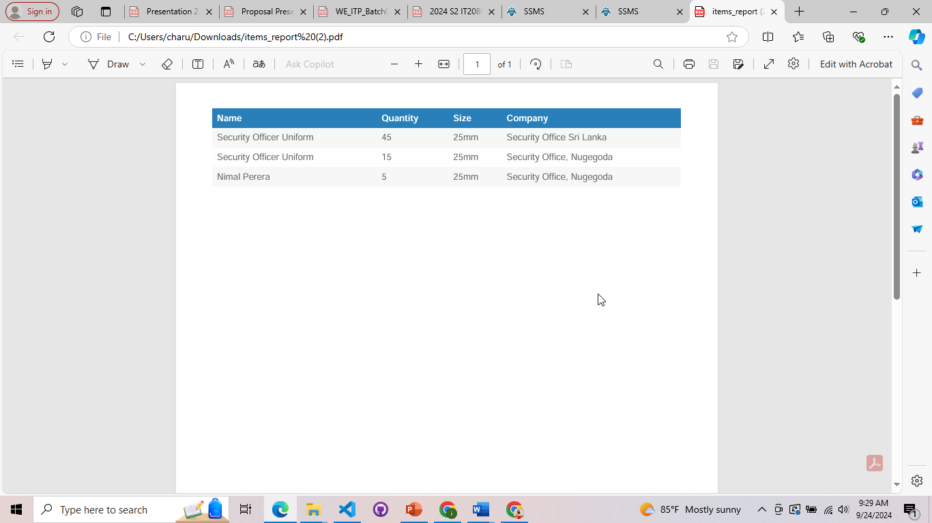

*Figure 3.12.59: Report*

## IT22197146 – Ranasinghe R. A. R. V. C – Leave Management

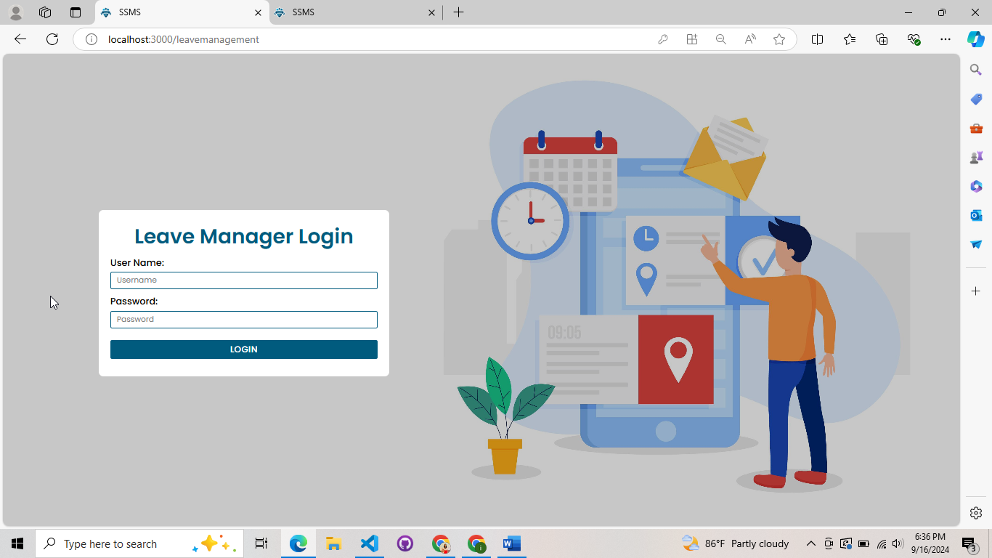

*Figure 3.12.60: Leave Manager Login*

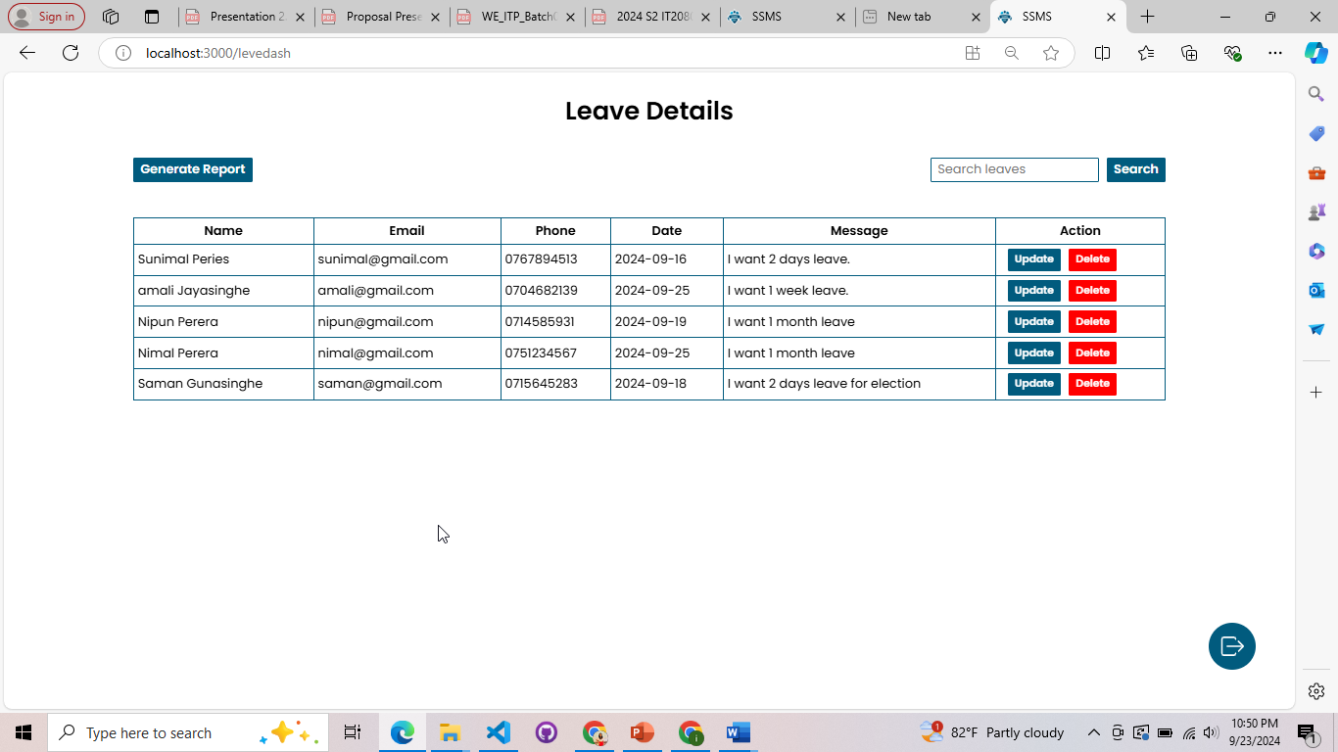

*Figure 3.12.61: Leave Manager Dashboard*

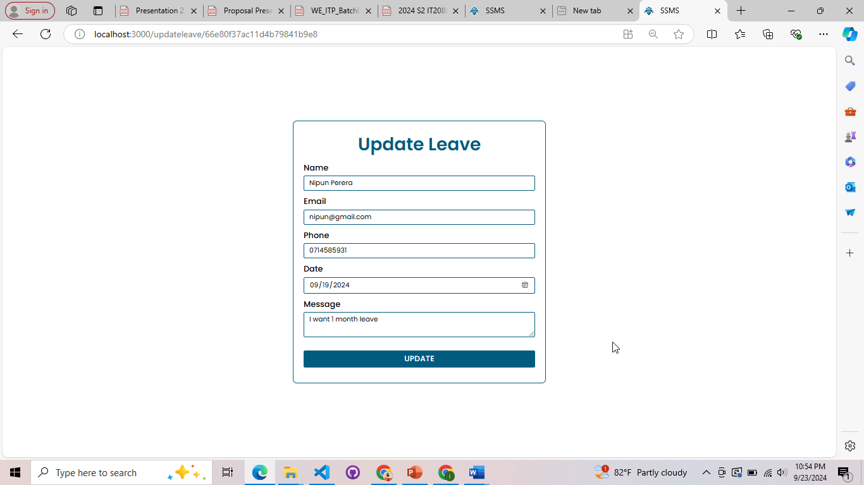

*Figure 3.12.62: Update Leave*

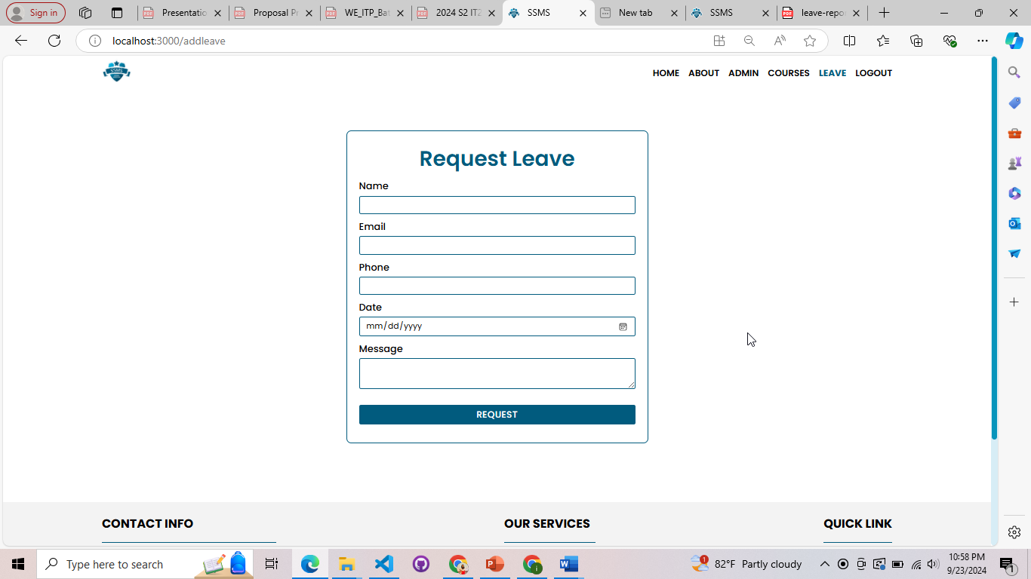

*Figure 3.12.63: Request Leave*

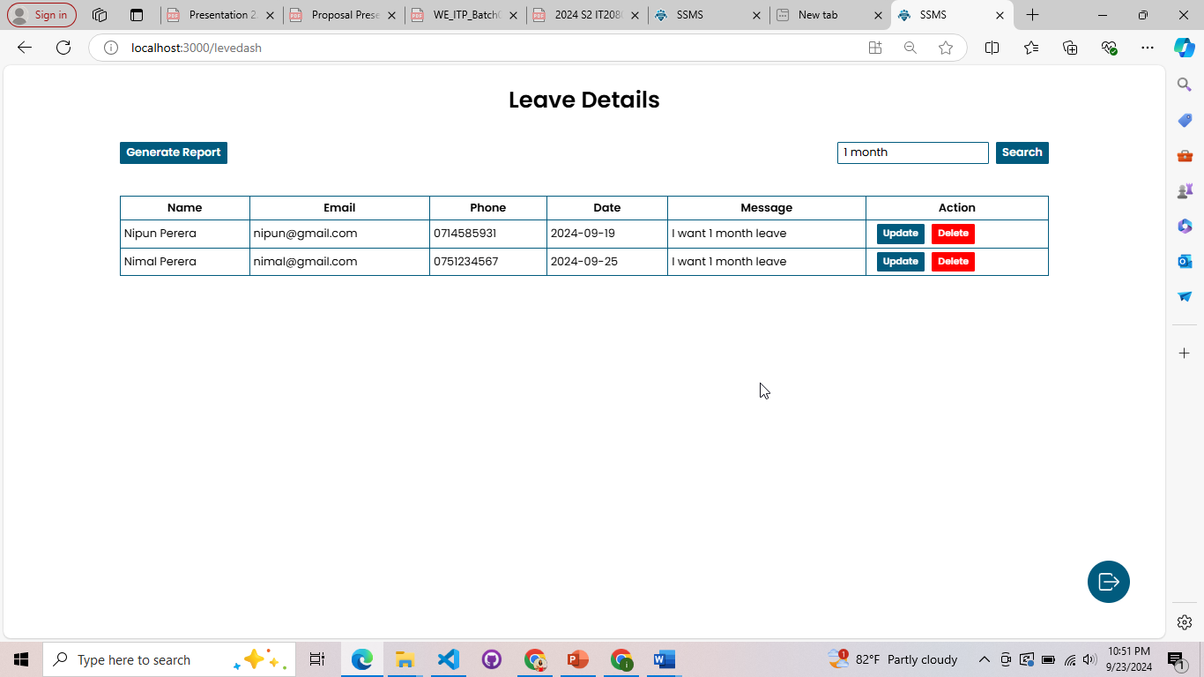

*Figure 3.12.64: Search*

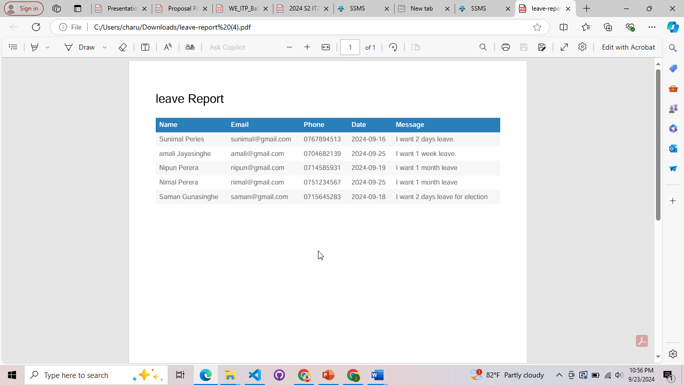

*Figure 3.12.65: Report*

# Chapter 4: Testing

## 4.1. Test Cases and Results

## IT22325228 – Fernando K. K. C

*Table 4.1. 1: Test Case in User Management*

|  |  |
| --- | --- |
| **Project ID:** | |
| **Project Name:** Security Service Management System | |
| **Testing Function:** User Authentication | |
| **Test ID:** Test_001 | **Test case designed and executed by:**  Reg No. – IT22325228  Name – Fernando K. K. C |
| **Test Priority** | High |
| **Test Description:** The User Authentication testing functionality provides the validation of how users, either clients or employees, log in to the Security Service Management System. | |
| **Pre-Conditions:**   * User needs to have an already created account in the system with a valid username and password. * The internet connection should be on. * The Security Service Management System is started, and accessible. * Valid test data usernames and password for different roles should be available. | |
| **Test Steps:**  Step 01: Navigate to Login Page  Step 02: Enter valid credentials  Step 03: Click the login button  Step 04: Assert Successful Login | |
| **Pass-Conditions:**   * Users are successfully redirected to their respective dashboard after entering valid credentials. * A welcome message or notification is displayed upon successful login. | |

*Table 4.1.2: Test Case Result in User Management*

|  |  |  |  |  |  |
| --- | --- | --- | --- | --- | --- |
| **Test ID** | **Test Inputs** | **Expected Outputs** | **Actual Output** | **Result (Pass/Fail)** | **Comment** |
| Test_001 | Valid Username and Password | User is redirected to dashboard; welcome message displayed | User redirected successfully; welcome message displayed. | Pass | Successful login test. |

## IT22907998 – Sadisha R. M. M

*Table 4.1:3: Test Case*

*Table 4.1.4: Test Case* Result

## IT20145552 – Dissanayaka D. M. S. M

*Table 4.1.5: Test Case*

*Table 4.1.6: Test Case* Result

## IT22257086 – Randiw E. Y

*Table 4.1:7: Test Case*

*Table 4.1.8: Test Case* Result

## IT22293480 – Jayodhya J. D. H

*Table 4.1.9: Test Case*

*Table 4.1.10: Test Case* Result

## IT22127082 – Medawatte W. W. M. T. N. B

*Table 4.1.11: Test Case*

*Table 4.1.12: Test Case* Result

## IT22132628 – Kusumsiri P. A. S. S

*Table 4.1.13: Test Case*

*Table 4.1.14: Test Case* Result

## IT22197146 – Ranasinghe R. A. R. V. C

*Table 4.1.15: Test Case*

|  |  |
| --- | --- |
| **Project ID:** | |
| **Project Name:** | |
| **Testing Function:** Leave Management – Request leave | |
| **Test ID: Test_008** | **Test case designed and executed by:**  **Reg No. – IT22197146**  **Name – Ranasinghe R.A.R.V.C.** |
| **Test Priority** | Medium |
| **Test Description:**  When an employee requests leave, it should ensure that leave is according to leave policies and has sufficient leave balance. | |
| **Pre-Conditions:**  When leave manager logged their system an employee should request a leave | |
| **Test Steps:**  Step 1: Employee request new leave  Step 2: Manager should be logged into leave system  Step 4: navigate to leave dashboard  Step 3: update leave and give notification | |
| **Pass-Conditions:** Display notifications for results | |

*Table 4.1.16: Test Case Result*

|  |  |  |  |  |  |
| --- | --- | --- | --- | --- | --- |
| **Test ID** | **Test Inputs** | **Expected Outputs** | **Actual Output** | **Result (Pass/Fail)** | **Comment** |
| Test_008a | Employee request a  Leave  **Name-Eric Potter**  **Email-ericpotter1000**  **@gmail.com**  **Phone-0714447777**  **Date-10/10/2024**  **Massage-2Day leave** | Display  Operation  Success  Massage | Display” Your leave  Submission is success” Notification | Pass | Leave submission  works without an error |

# Chapter 5: Evaluation and Conclusion

The implementation of SSMS has been effective in managing quite a few operations of a security service provider in an efficient manner. This evaluation and conclusion provides an overview of the performance of the system, operational efficiency, and overall benefits derived from this system by the organization.

It caters considerably to different security management requirements. The SSMS is quite effective in managing user management, client interaction, booking processes, and tracking of payments, along with the management of inventory. The system also provides for efficient tracking of attendance and dealing with the leaves of the security officers. All in all, SSMS was turning out to be the promise of automation of security service management and making life easier.

The Security Service Management System at Rakna Arakshaka Lanka Ltd has proved itself in automating and managing security management efficiently. The functionality of the solution, ease of use, reliability, and smooth integration contribute to better operational efficiency. The SSMS manages customer accounts efficiently, provides a facility of booking security officers, processes payments, and generates reports, enabling the staff to offer quality services to the clients.

Secondly, the periodic renovation and upkeep of the system will make the SSMS continuous success. This will involve fixing bugs and performance issues once they are noticed without wasting any time. Moreover, feedback can be sought from security personnel and clients for valuable input that can be used for further improvements.

Overall, the Security Service Management System has greatly enhanced effectiveness and efficiency in security operations within RALL. It proved to be an indispensable tool in managing the assignment of security officers, administrative tasks, and improving overall service delivery to clients requesting security services.

# Individual Contribution

|  |  |  |
| --- | --- | --- |
| **Student ID** | **Name with Initials** | **Tasks** |
| IT22325228 | Fernando K. K. C | * Chapter 1 * Chapter 2 * Chapter 3 – User Management * Chapter 4 – User Management * Chapter 5 |
| IT22907998 | Sadisha R. M. M | * Chapter 3 – Training Management * Chapter 4 – Training Management |
| IT20145552 | Dissanayaka D. M. S. M | * Chapter 3 – Client Management * Chapter 4 – Client Management |
| IT22257086 | Randiw E. Y | * Chapter 3 – Booking Management * Chapter 4 – Booking Management |
| IT22293480 | Jayodhya J. D. H | * Chapter 3 – Payment Management * Chapter 4 – Payment Management |
| IT22127082 | Medawatte W. W. M. T. N. B | * Chapter 3 – Operation Management * Chapter 4 – Operation Management |
| IT22132628 | Kusumsiri P. A. S. S | * Chapter 3 – Inventory Management * Chapter 4 – Inventory Management |
| IT22197146 | Ranasinghe R. A. R. V. C | * Chapter 3 – Leave Management * Chapter 4 – Leave Management |

# References